Contents

Durga soft 2

Assertion: 36

Wrapper classes: 36

Wildcards 36

Access Modifiers 36

Introduction 42

Encapsulation 43

Inheritance 43

Polymorphism 44

Static Polymorphism (compile time polymorphism/ Method overloading): 45

Output : 45

Dynamic Polymorphism (run time polymorphism/ Method Overriding) 46

Abstraction 46

Output : 48

Summary 48

Multi Threading 49

Serialization 72

# Durga soft

1. 24 What is difference between **new** operator and **newInstance()** method
   1. Both are used to create new instance
   2. 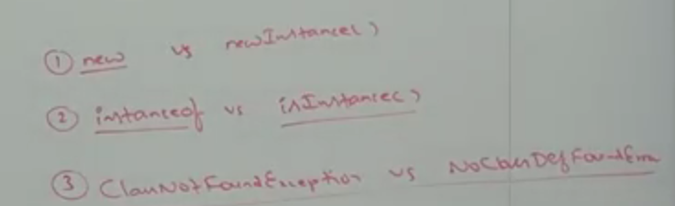

|  |  |
| --- | --- |
| **New** | **newInstance** |
| If class name available at compile time | If the class name available only at run time |
|  | In real time, in servlet when the request comes the only the container knows the exact servlet to which the object needs to be created. |
| New can be created for any constructor | Only default constructor with no args will be called. Other args cannot be called and if the class doesn't contain no args constructor java.lang.instantiationException will be thrown |
|  |  |

* 1. 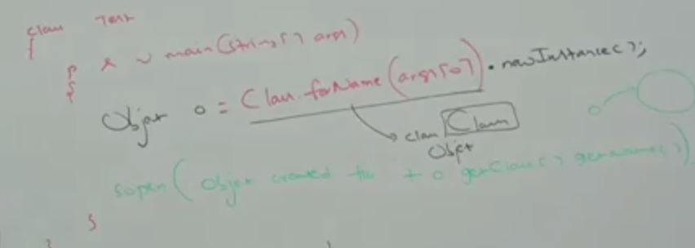
  2. ClassNotFoundException and NoClassDefFoundException

|  |  |
| --- | --- |
| **ClassNotFoundException** | **NoClassDefFoundException** |
| When creating a new class using newInstance, if the class is not found the this exception is thrown | When creating a new class using new operator, if the class is not found the this exception is thrown |
| This is a checked exception | This is a un-checked exception |

1. Access Specifiers vs Access Modifiers
   1. 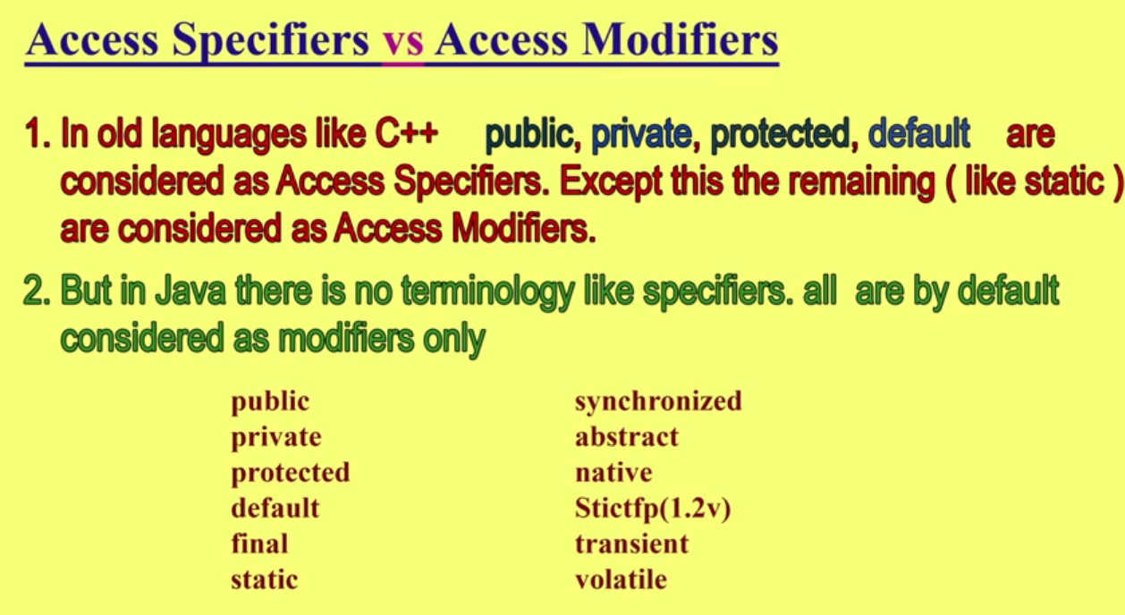
   2. 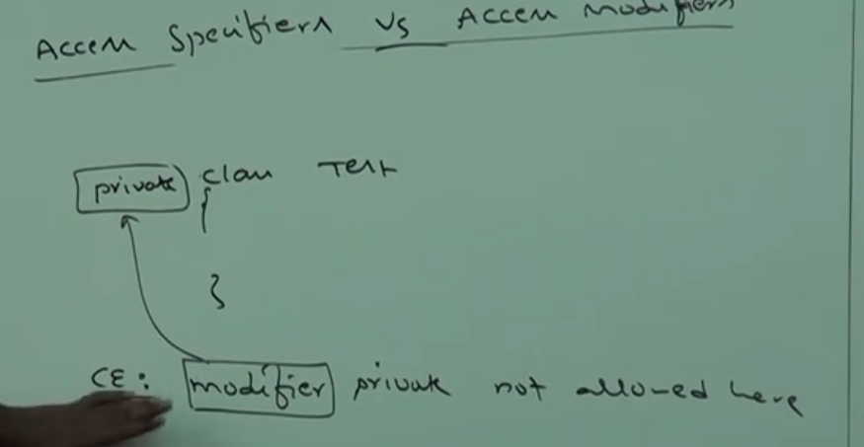
2. Difference between b++ and b=b++
   1. 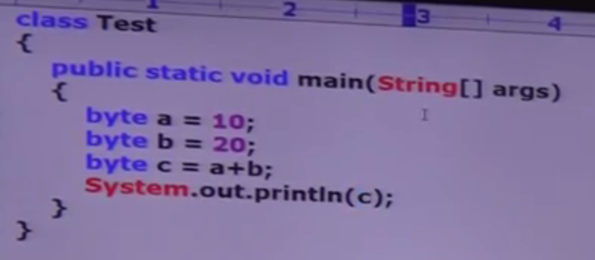
   2. 
   3. Can be resolved by casting into byte
   4. In case of increment and decrement operator internal type casting will be performed
3. Command line arguments - CASE – 1
   1. 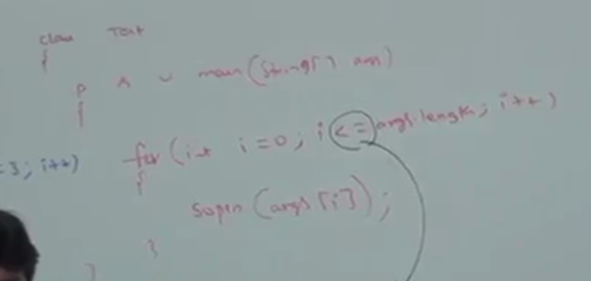
   2. Array out of bound exception
4. Command line arguments in SCJP – normal ex of cmd line args
5. Command line arguments - CASE – 2
   1. Example of array pointing
6. Command line arguments - CASE – 3
   1. Cmd line onle available in string
7. Command line arguments - CASE – 4
   1. Quotes to pass the space in between string in Cmd line args
8. Control flow in try - catch ( Java Exception Handling)
9. Control flow in try catch finally (Java Exception Handling)
10. Difference between == operator and equals() method in java
    1. == - meant for reference comparison
    2. Equals() –meant for content comparison
11. Difference between == operator and equals() method
    1. Null==null -> always true
    2. 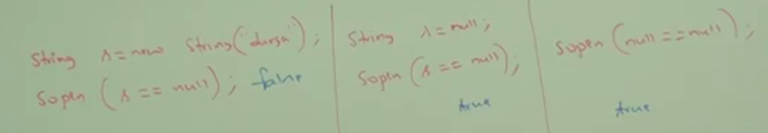
12. Difference between Checked exceptions and Unchecked exceptions
    1. Checked exception are checked by the compiler and unchecked exceptions are not checked by the compiler
    2. UnChecked exception
       1. [ArrayIndexOutOfBoundsException](http://docs.oracle.com/javase/8/docs/api/java/lang/ArrayIndexOutOfBoundsException.html)
       2. [ClassCastException](http://docs.oracle.com/javase/8/docs/api/java/lang/ClassCastException.html)
       3. [IllegalArgumentException](http://docs.oracle.com/javase/8/docs/api/java/lang/IllegalArgumentException.html)
       4. [IllegalStateException](http://www.coderanch.com/how-to/java/IllegalStateException)
       5. [NullPointerException](http://docs.oracle.com/javase/8/docs/api/java/lang/NullPointerException.html)
       6. [NumberFormatException](http://docs.oracle.com/javase/8/docs/api/java/lang/NumberFormatException.html)
       7. [AssertionError](http://docs.oracle.com/javase/8/docs/api/java/lang/AssertionError.html)
       8. [ExceptionInInitializerError](http://docs.oracle.com/javase/8/docs/api/java/lang/ExceptionInInitializerError.html)
       9. [StackOverflowError](http://docs.oracle.com/javase/8/docs/api/java/lang/StackOverflowError.html)
       10. [NoClassDefFoundError](http://docs.oracle.com/javase/8/docs/api/java/lang/NoClassDefFoundError.html)
    3. Checked exception
       1. Exception
       2. [IOException](http://docs.oracle.com/javase/8/docs/api/java/io/IOException.html)
       3. [FileNotFoundException](http://docs.oracle.com/javase/8/docs/api/java/io/FileNotFoundException.html)
       4. [ParseException](http://docs.oracle.com/javase/8/docs/api/java/text/ParseException.html)
       5. [ClassNotFoundException](http://docs.oracle.com/javase/8/docs/api/java/lang/ClassNotFoundException.html)
       6. [CloneNotSupportedException](http://docs.oracle.com/javase/8/docs/api/java/lang/CloneNotSupportedException.html)
       7. [InstantiationException](http://docs.oracle.com/javase/8/docs/api/java/lang/InstantiationException.html)
       8. [InterruptedException](http://docs.oracle.com/javase/8/docs/api/java/lang/InterruptedException.html)
       9. [NoSuchMethodException](http://docs.oracle.com/javase/8/docs/api/java/lang/NoSuchMethodException.html)
       10. [NoSuchFieldException](http://docs.oracle.com/javase/8/docs/api/java/lang/NoSuchFieldException.html)
13. Difference between ClassNotFoundException and NoClassDefFoundError
    1. ClassNotFoundException and NoClassDefFondException

|  |  |
| --- | --- |
| **ClassNotFoundException** | **NoClassDefFoundException** |
| When creating a new class using newInstance, if the class is not found the this exception is thrown | When creating a new class using new operator, if the class is not found the this exception is thrown |
| This is a checked exception | This is a un-checked exception |

1. Difference between Exception and Error
   1. Exception is Recoverable
   2. Error is not recoverable
2. Difference between Interface and Abstract Class
   1. 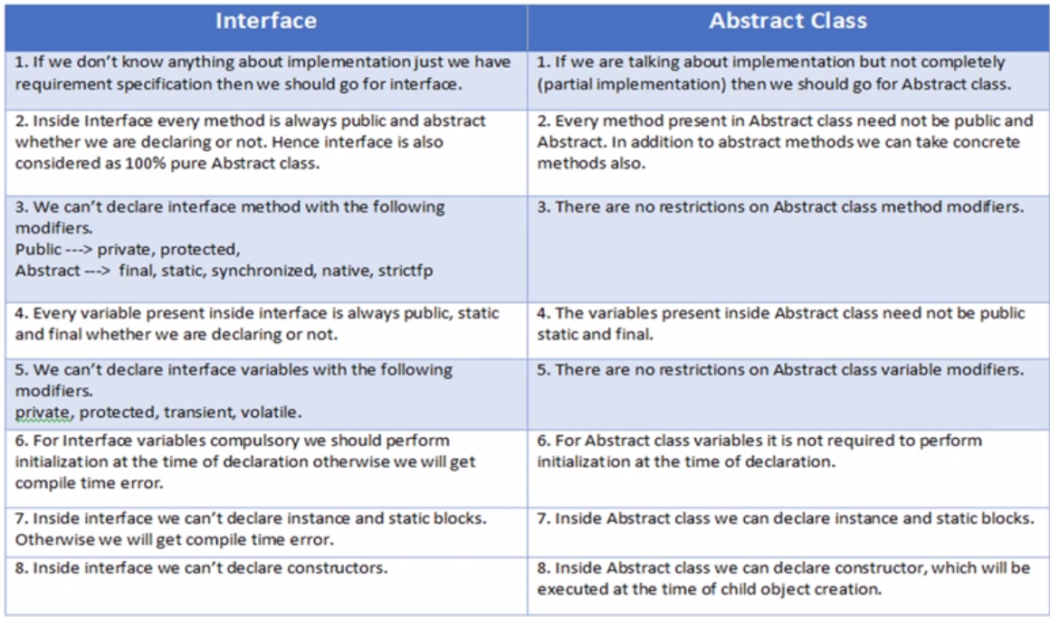
3. Difference between Java vs Javaw vs Javaws
   1. Java- to run java class file
   2. Javaw – to run java class without console
   3. Javaws – Java web start utility. This is used to download a java app from a web location and execute it in local.
4. Difference between Parent p = new Child(); and Child c = new Child();
   1. 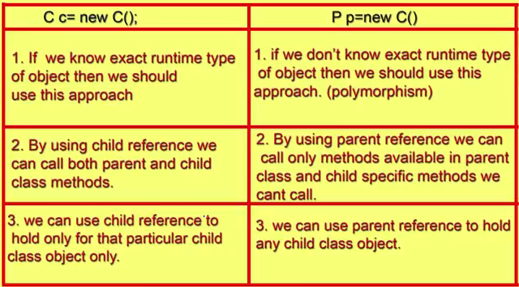
5. Difference between Overloading and Overriding (part-I)
   1. 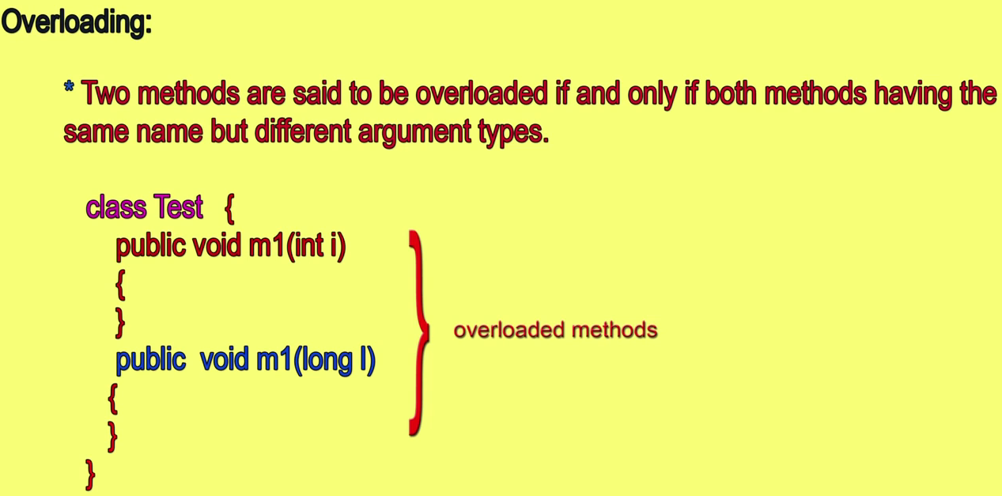
   2. Overriding
   3. 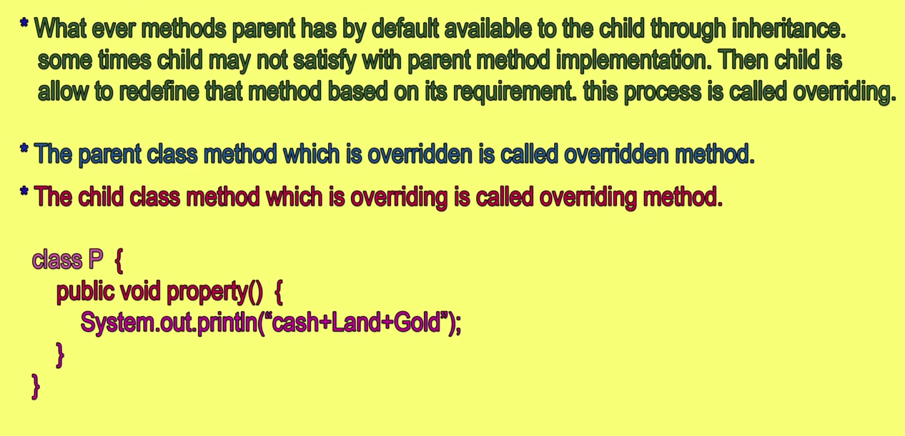
6. Difference between Overloading and Overriding (part-II)
   1. Co-Variant return type
   2. 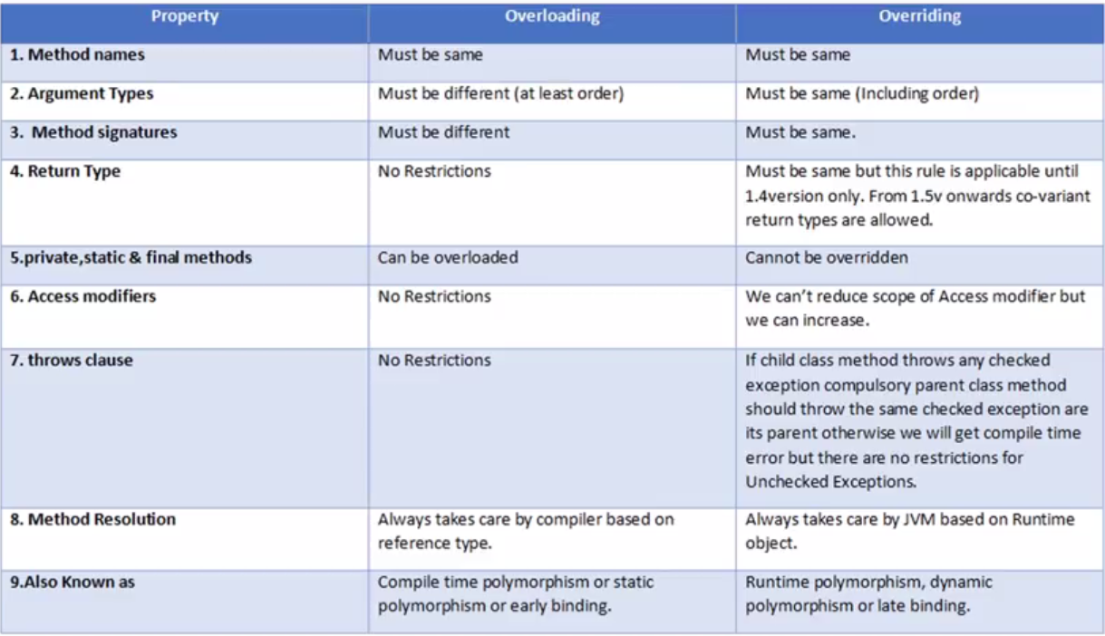
   3. 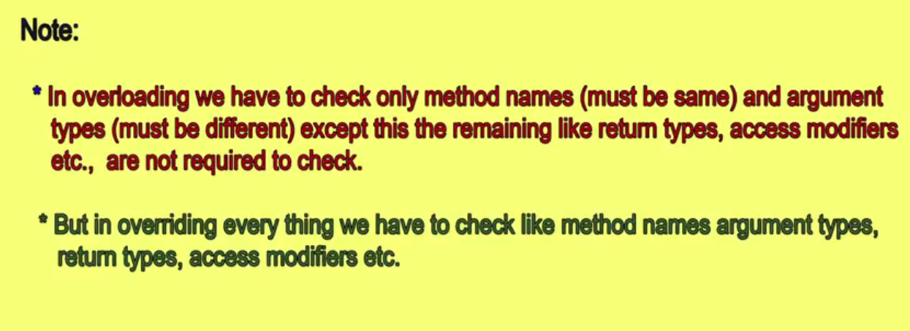
7. Difference between path and class path
   1. Path: location where binary executable are available. Ex: Javac.exe
   2. Classpath : describes the location where required .class files are available. Java compiler and JVM will use to locate the .class file. This path is used to compile and run the java program.
8. Difference between StringBuffer and StringBuilder
   1. Both are Mutable
   2. StringBuffer every method is synchronized and StringBuilder is not synchronized.
   3. 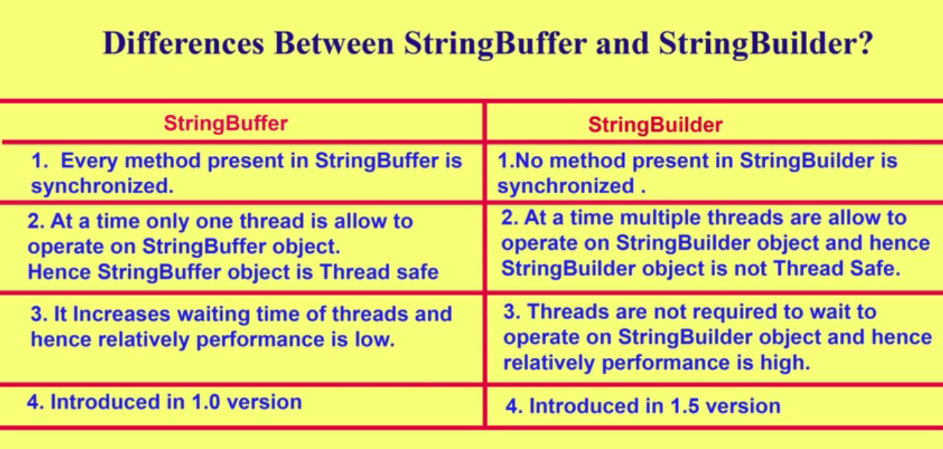
9. Differences between String and StringBuffer
   1. String is immutable and StringBuffer is mutable.
   2. 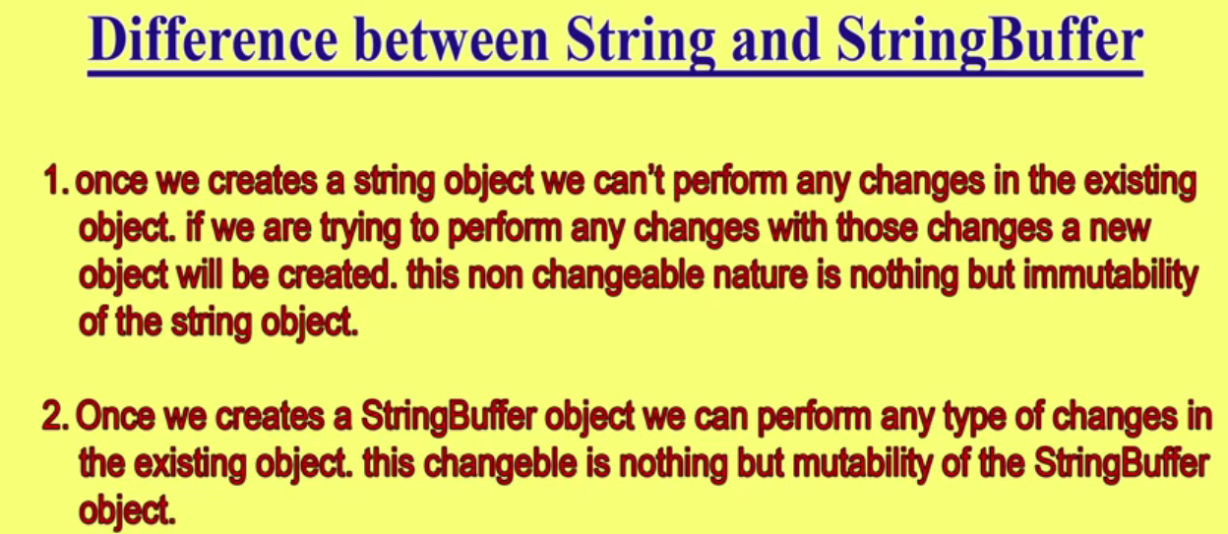
10. Differences between fully checked exceptions and partially checked exceptions
    1. 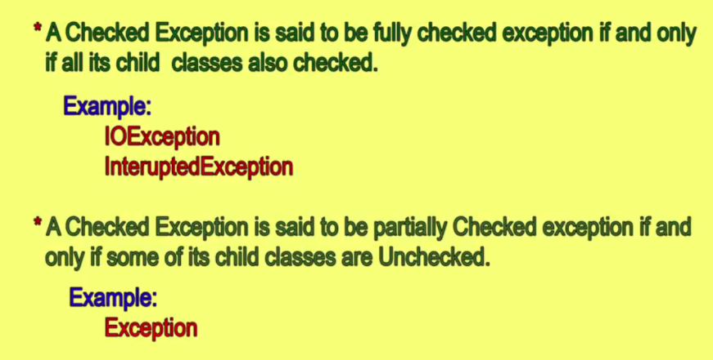
    2. 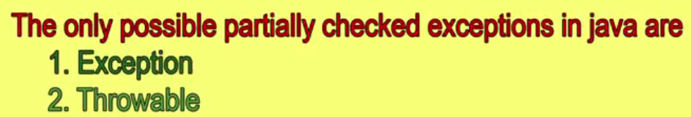
11. Differences between Normal ArrayList and Generic ArrayList
    1. 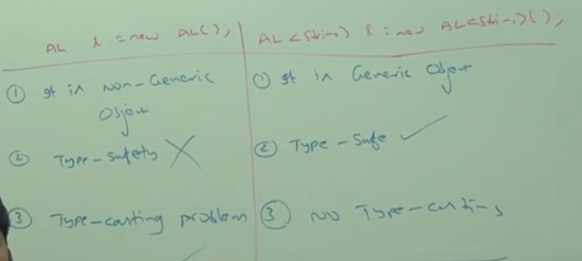
12. Explain about public static void main(String[] args); ( PART- I )
    1. 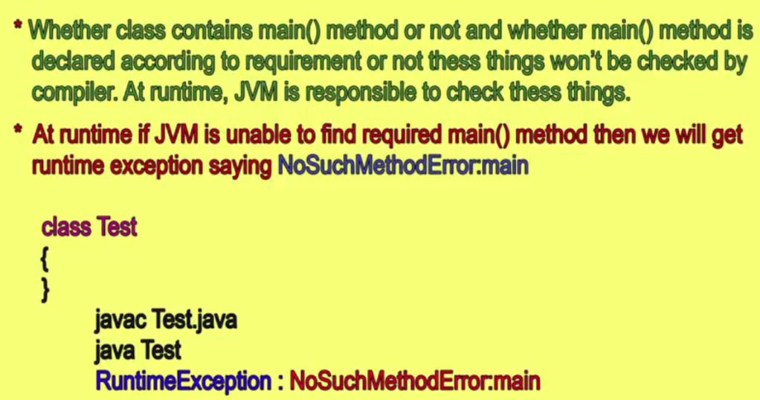
    2. 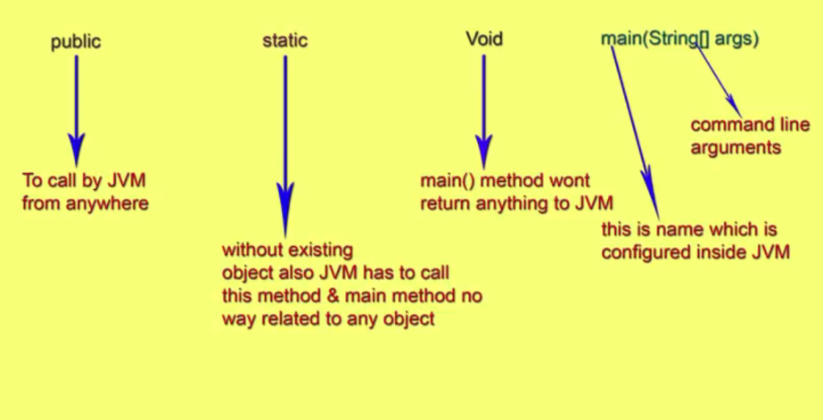
    3. 
    4. Following modification are accepted.
    5. 
    6. 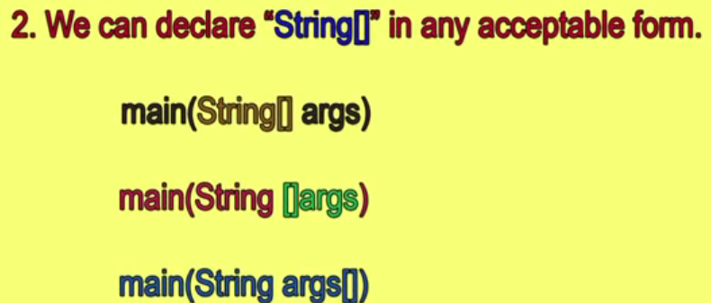
    7. 
    8. 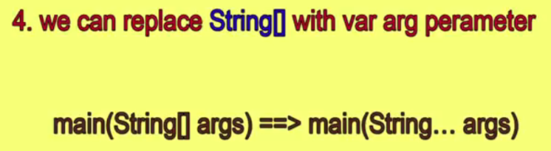
    9. 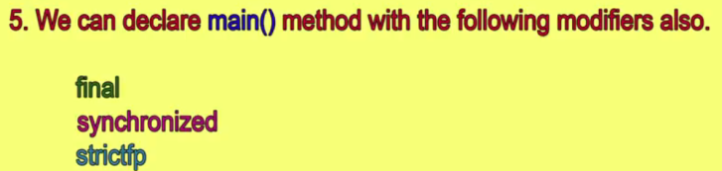
    10. The following are valid main syntax
    11. 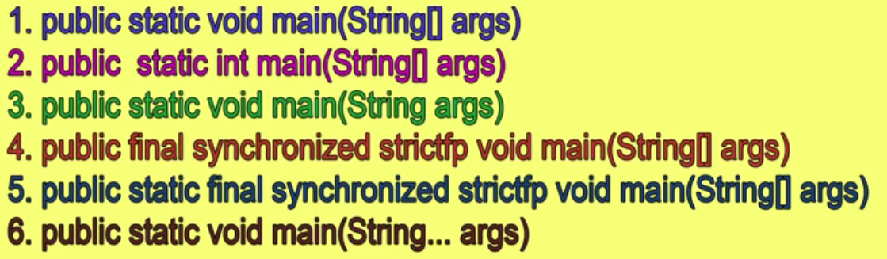
    12. 
13. Explain about public static void main(String[] args); ( PART- II )
    1. 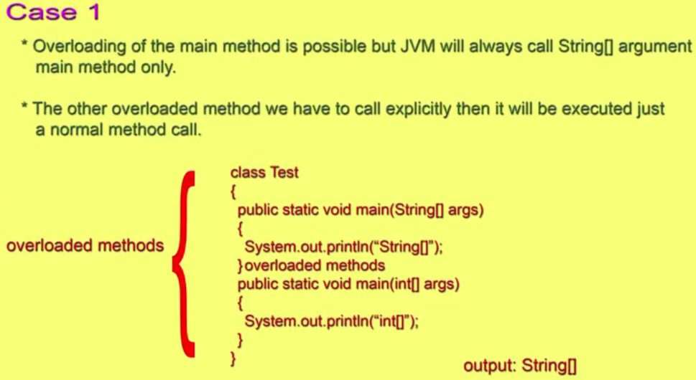
    2. 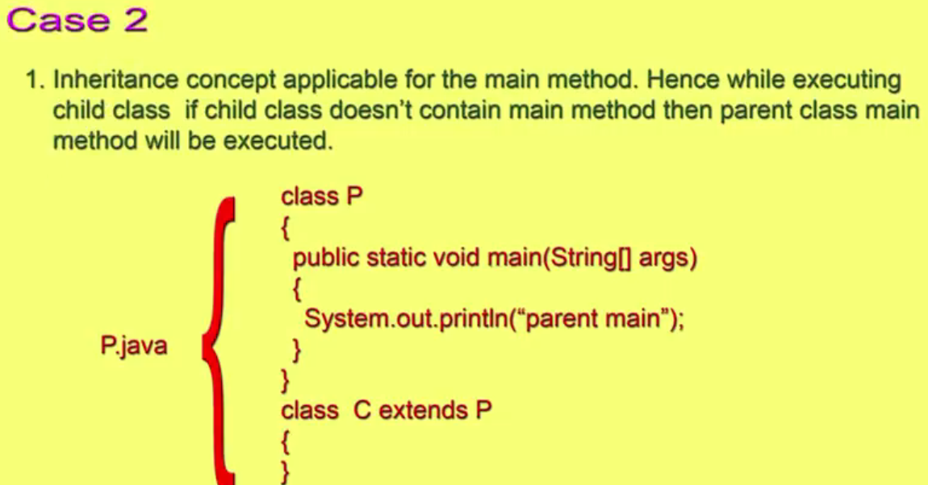
    3. 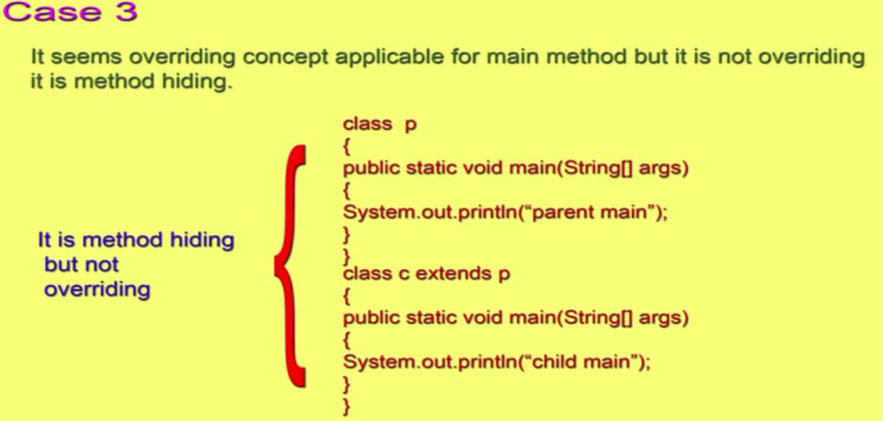
14. Explain about public static void main(String[] args); ( PART- III )
    1. 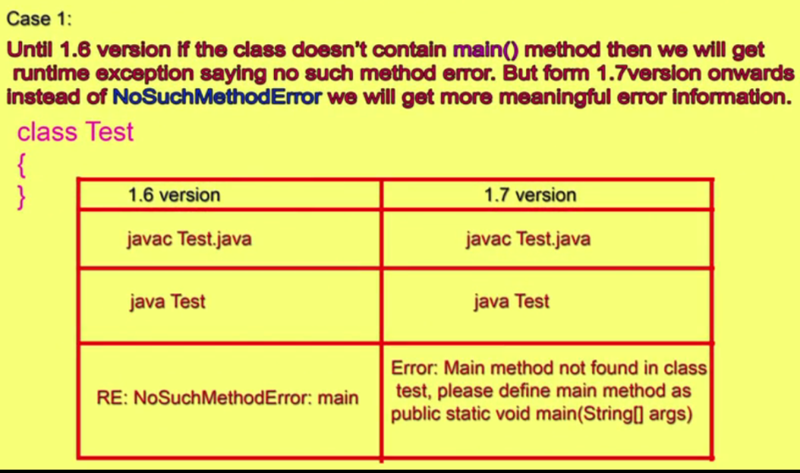
    2. 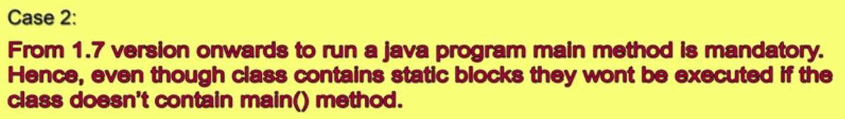
    3. 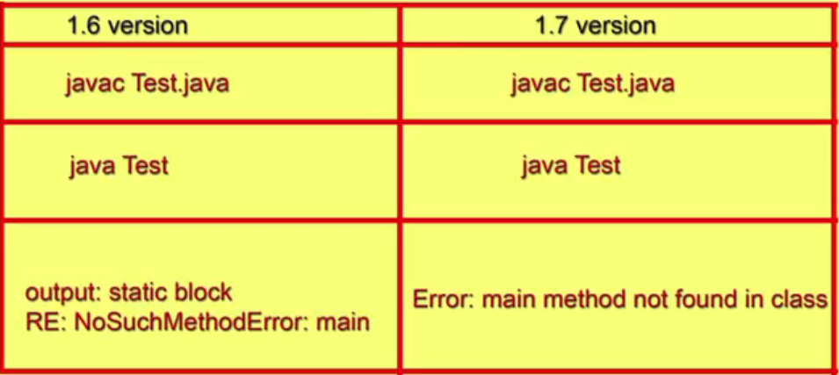
    4. 
15. Explain about System.out.println();
    1. 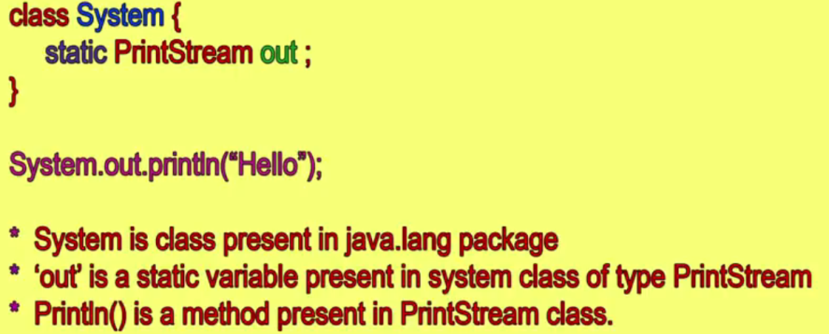
16. How Many Ways to Run a Java Program
    1. 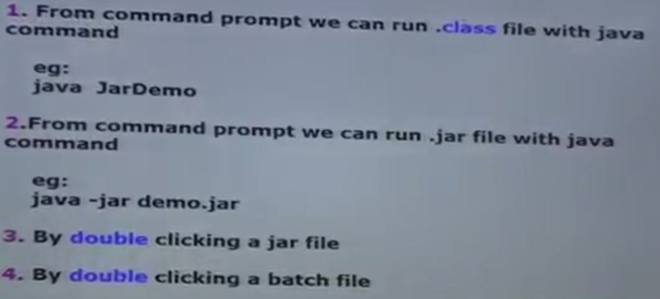
    2. 
17. How to Create jar file and various commands related jar
    1. 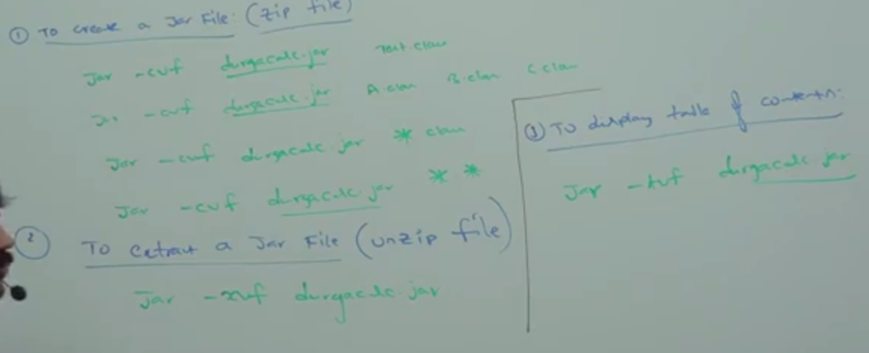
18. Increment and Decrement Operators Conclusion – 1
    1. 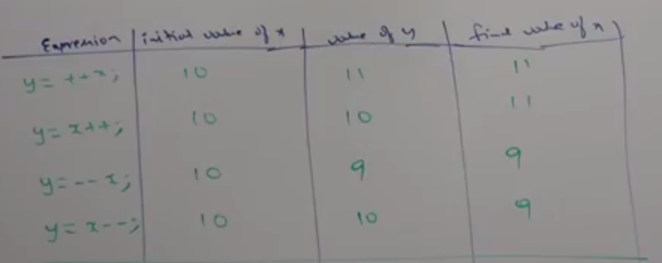
19. Increment and Decrement Operators Conclusion –2&3
    1. 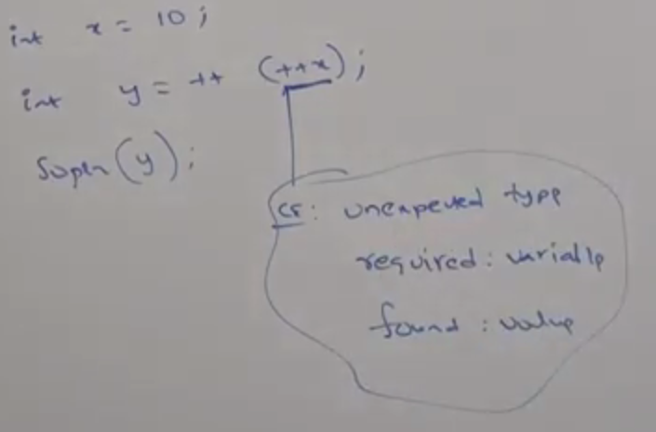
    2. For FINAL var we cannot apply increment and decrement operators
20. Increment and Decrement Operators - Conclusion 4
    1. Increment and Decrement cannot be applied only to Boolean
    2. Increment and Decrement can be applied to char, int, float or any primitive type.
21. Interface vs abstract class vs concrete class
    1. 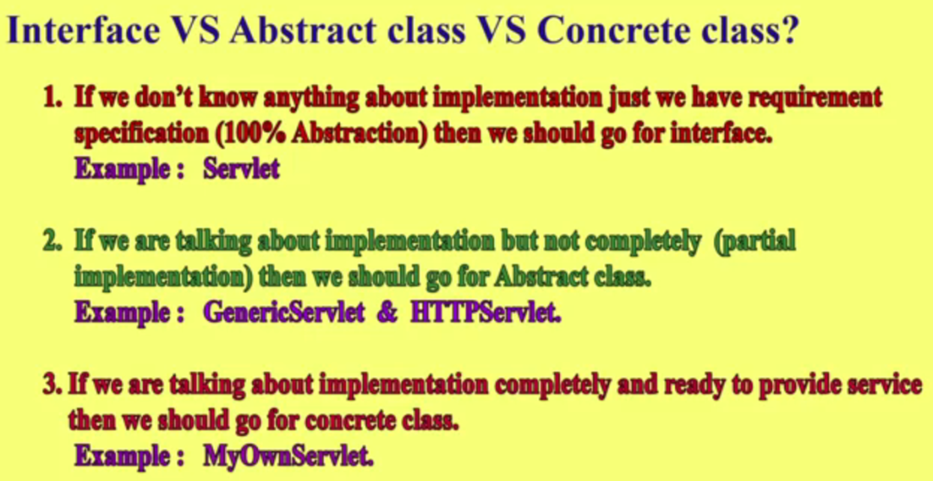
22. Jar vs war vs ear
    1. JAR - Java Archive. It contains a group of .class files
    2. WAR –Web Archive. It contains .class, jsp, Html, CSS etc
    3. EAR – Enterprise archive. It contains the components for enterprise application.
    4. 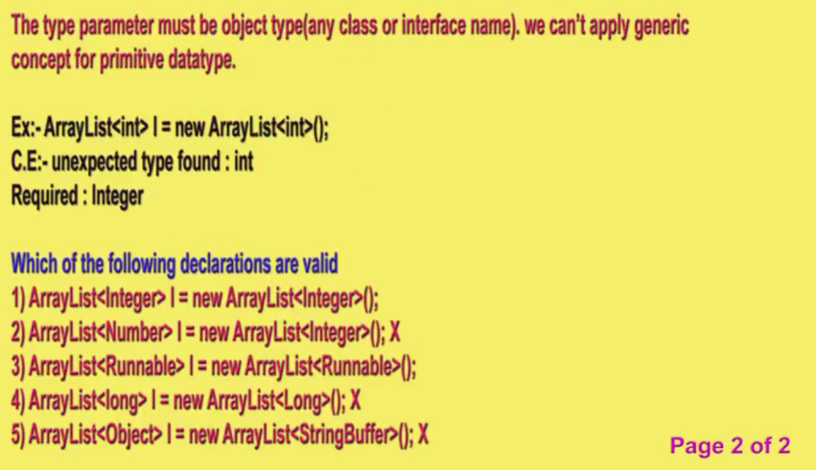
23. Introduction to Generics (Type Safety)
    1. 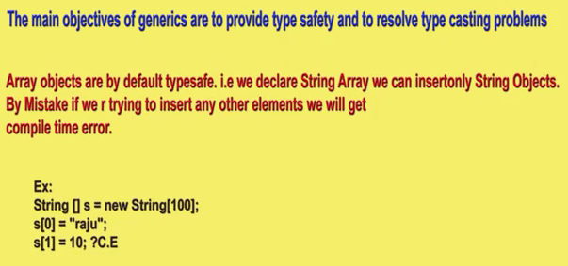
    2. 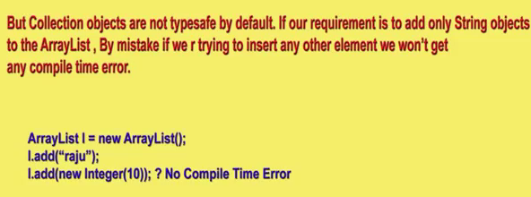
24. Introduction to Generics (Type - Casting)
    1. Type Casting is not needed for Arrays. But it is needed for arrayList.
    2. 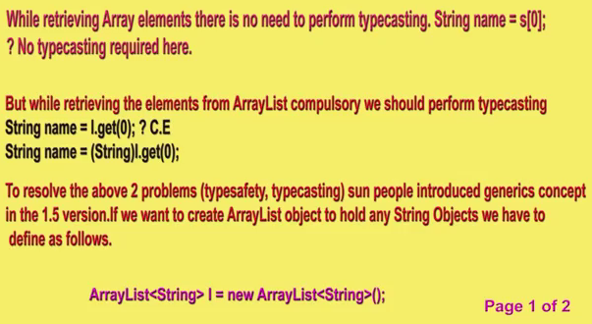
    3. 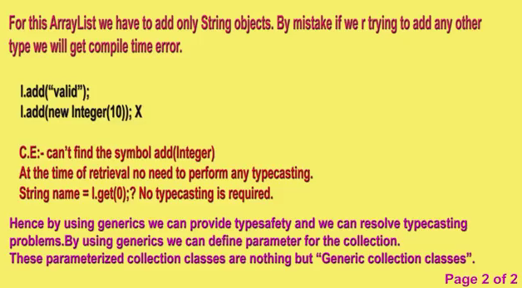
25. Introduction to Generics (Conclusions)
    1. Polymorphism is applicable for only for base type and not for parameterized type.
    2. 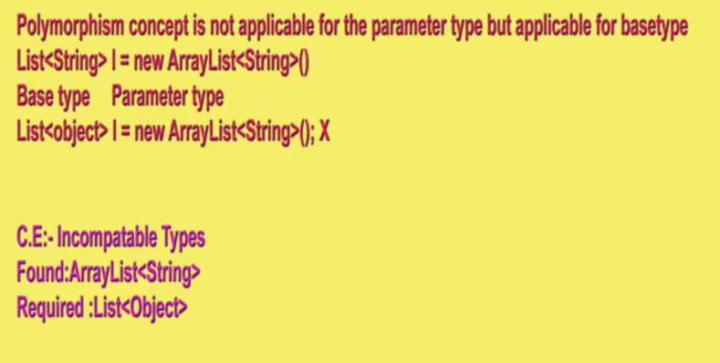
26. Java Coding Standards for classes, interfaces and methods,variables,constants
    1. **Classes** – first caps and every next word will be caps
    2. **Interface** - first caps and every next word will be caps
    3. **Methods** - first Small and every next word will be caps
    4. **Variable** - first Small and every next word will be caps
    5. **Constants –** All Caps
27. JAVA CODING STANDARDS
28. Java System Properties
    1. 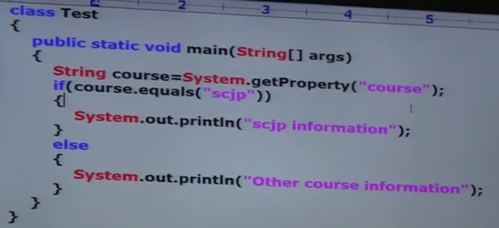
    2. 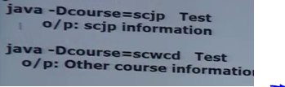
29. Short cut way to place jar file in classpath
    1. 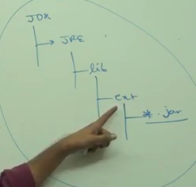
30. String vs StringBuffer vs StringBuilder
    1. 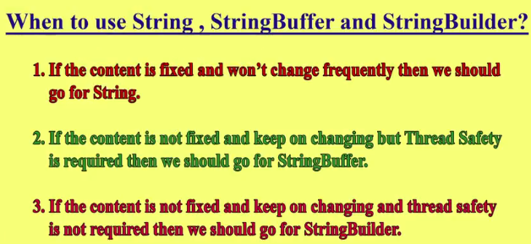
31. What is the difference between JDK,JRE and JVM
    1. JDK provides environment to develop and run java application.
    2. JRE is used to run java application.
    3. JVM is an interpreter to execute java program line by line.
    4. 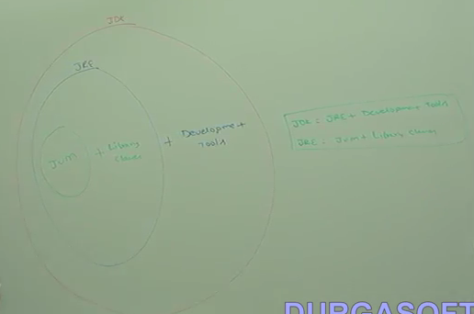
32. Web Server vs Application Server
    1. 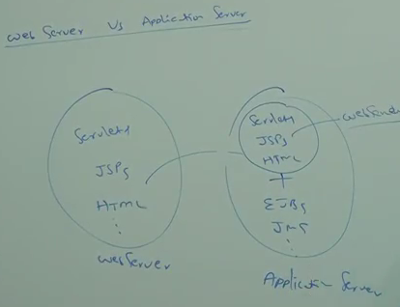
33. what is the purpose of command line arguments in java
    1. to provide variable values to the program
34. Var-arg method (part-1) Introduction and syntax
    1. 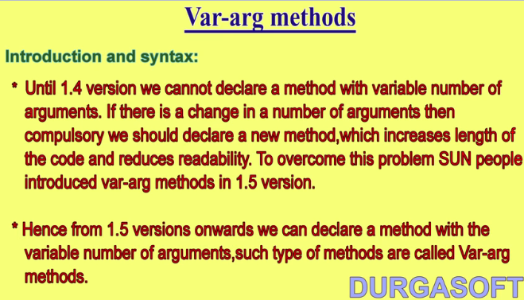
    2. 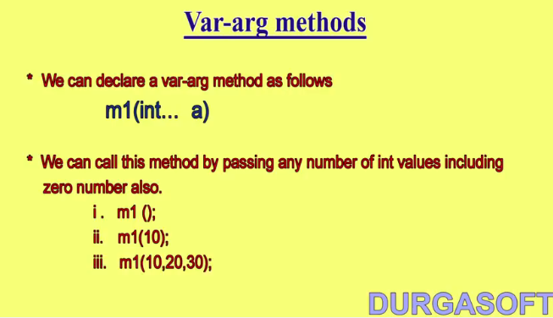
    3. 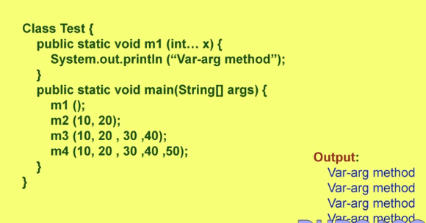
    4. 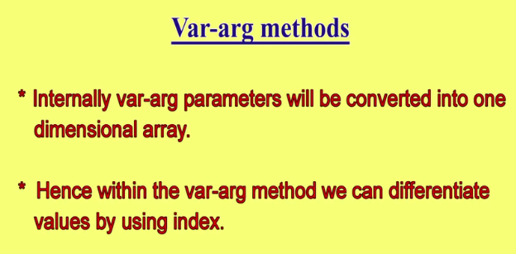
35. Var-arg method (part-2) Syntax Loopholes for SCJP OCJP
    1. 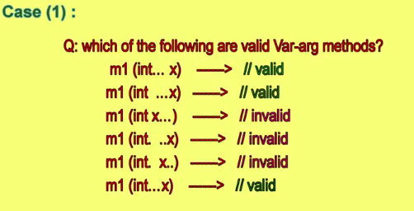
    2. 
    3. 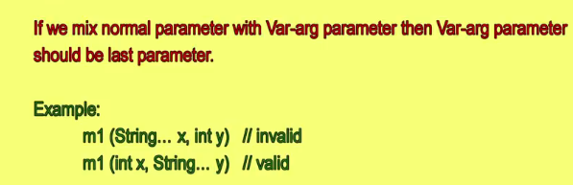
    4. 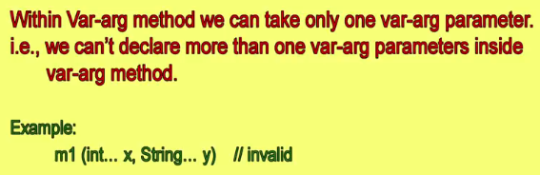
    5. 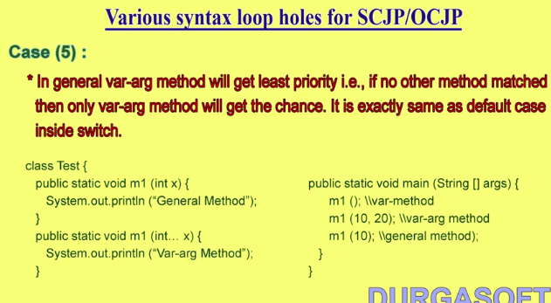
    6. 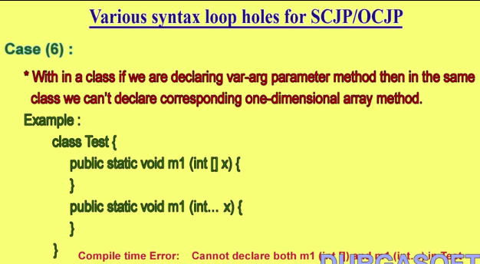
36. Operators & Assignments_ Introduction
37. Java operators _ type cast operators - part -1
    1. Two types
       1. Implicit – If compiler does the casting
       2. Explicit – if we do it manually
    2. 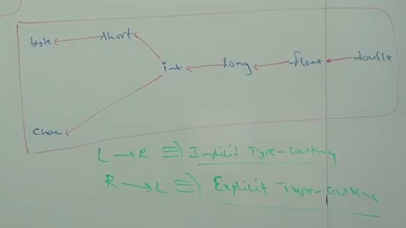
38. Java operators _ type - cast operator - Part 2
    1. How down casting works. It converts the value into the binary value and truncate the most significant bytes and then converts the remaining into two’s complement.
39. Java Operators_ Arithmetic Operators Conclusion 2 - Part 1
    1. Divide by zero and Nan
    2. 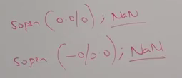
40. Java operators_ Assignment operators
    1. Three types
    2. 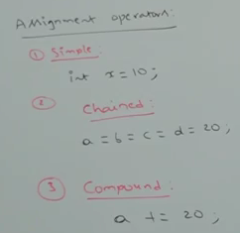
    3. 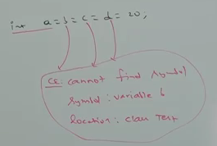
    4. But this one valid
    5. 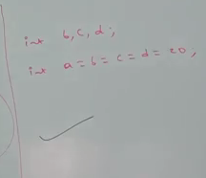
41. Java operators_ short- circuit operators
    1. Diff bet & and &&
    2. 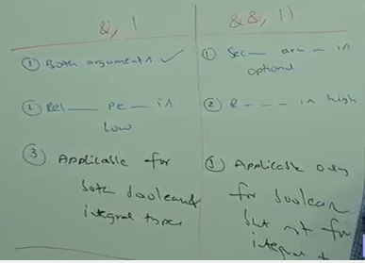
42. Java operators_ String Concatenation operator
    1. 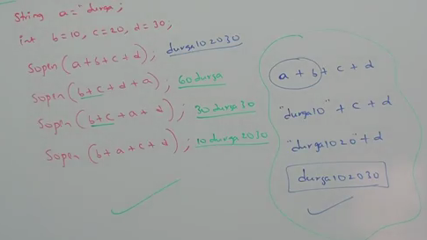
43. Java operators_ Arithmetic Operators Conclusion 1
    1. 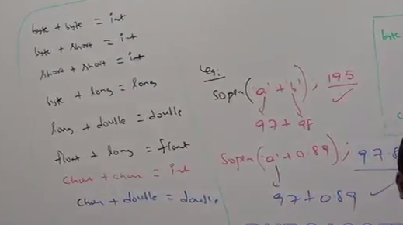
44. Java operators_ Arithmetic Operators Conclusion 2 - Part 2
    1. 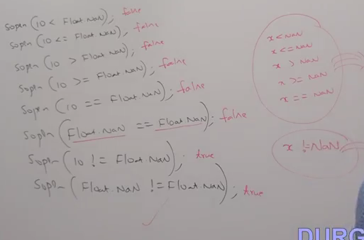
    2. Arithmetic Exception:
    3. 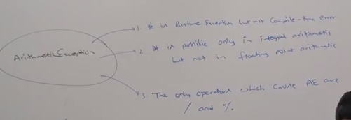
45. Java operators_ Boolean complement operator
    1. 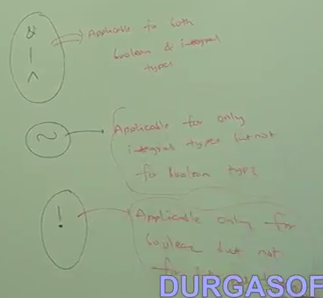
46. Java operators_ Equality operators - Part 1
    1. When comparing small and bigger type smaller type will be converted to larger type.
    2. 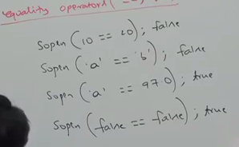
    3. If reference is compared it will return true when both object referring to the dame objects.
47. Java operators_ Equality operators - Part 2
    1. 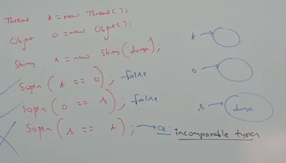
48. Java operators_ Evaluation order of Java operaends
    1. Operator precedence and operands precedence are different.
    2. Operands precedence always form left to right.
49. Java operators_ instanceof operator
    1. 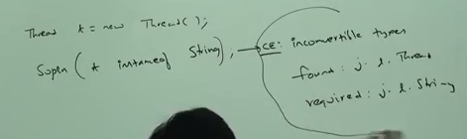
    2. Null instance of any class is false.
50. Java operators_ Operator precendence
    1. 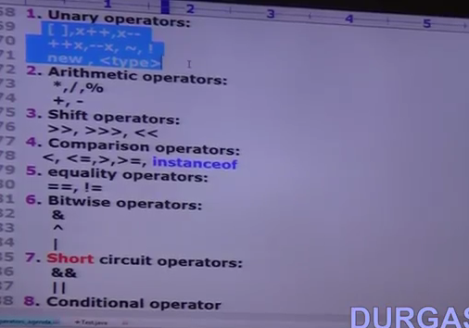
    2. 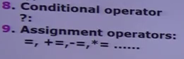
51. Java operators_Conditional operator(__)
    1. ?:
52. Java operators_Relational operators
    1. 
    2. 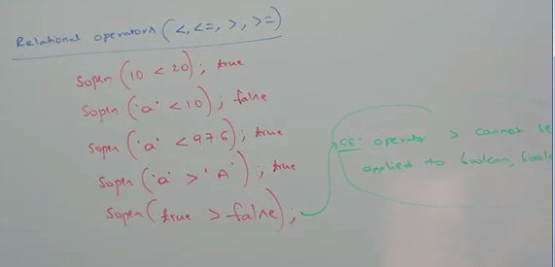
    3. Relational objects cannot be applied to objects
    4. 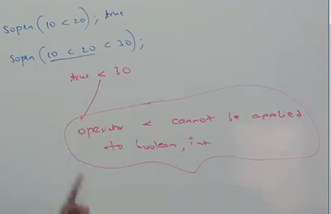
53. Javaoperators_ bitwise operator
    1. 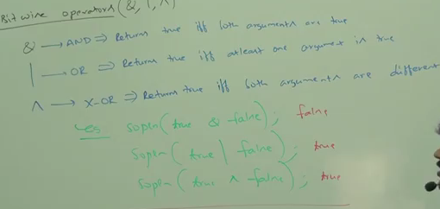
    2. “Tilde” operator - It will change the value of all the bit
       1. 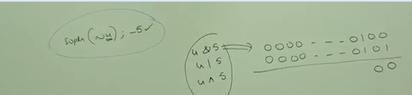
54. What are the various modifiers available in java
    1. 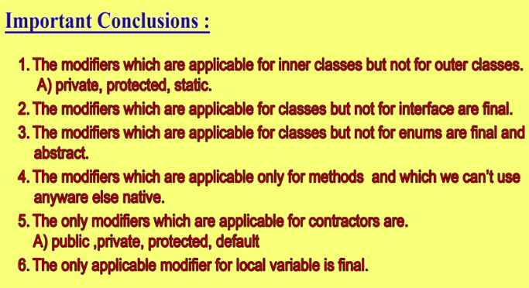
    2. 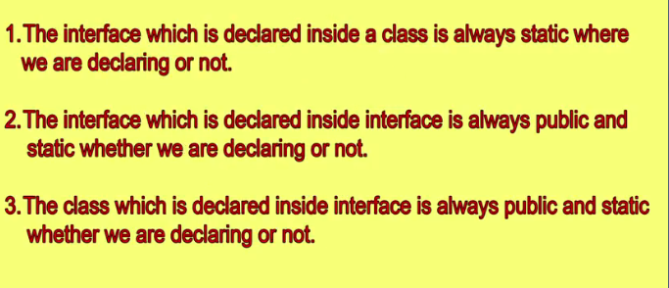
    3. 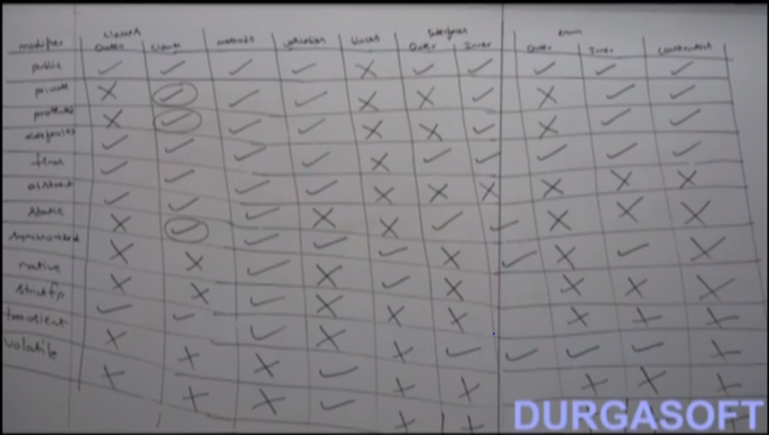
    4. Illegal combinations for methods
    5. 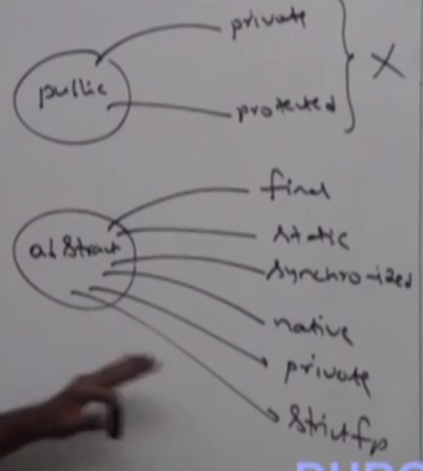
    6. Illegal combinations for Variables
    7. 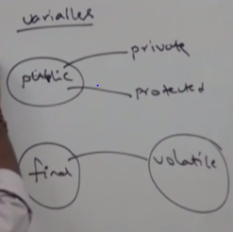
    8. Illegal combinations for Class
    9. 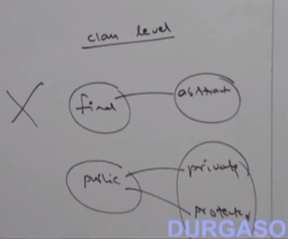
55. various possible combinations of try catch finally
    1. 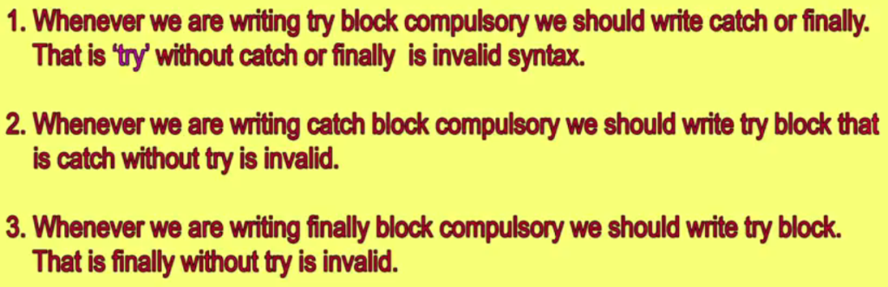
    2. 
    3. 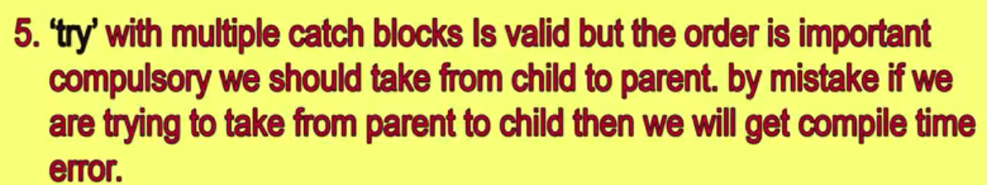
    4. 
    5. 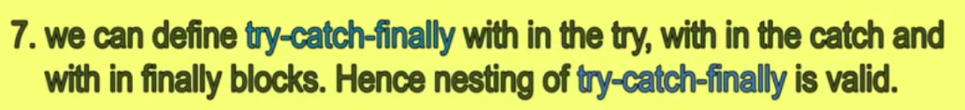
    6. 
    7. All possible combination of try and catch
    8. 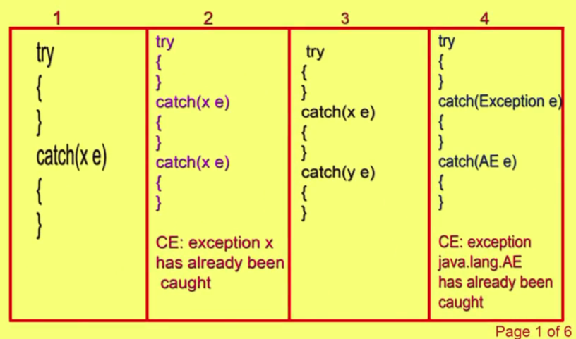
    9. 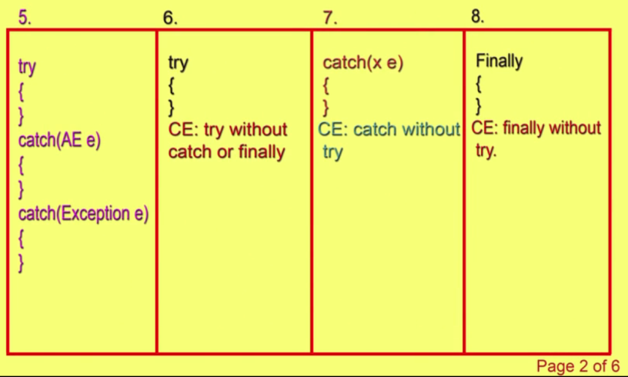
    10. 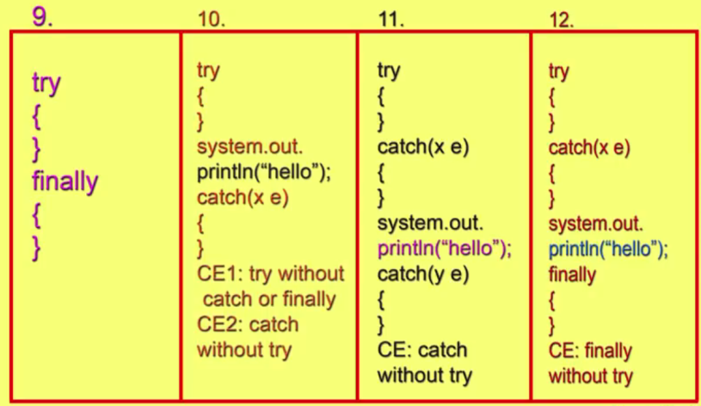
    11. 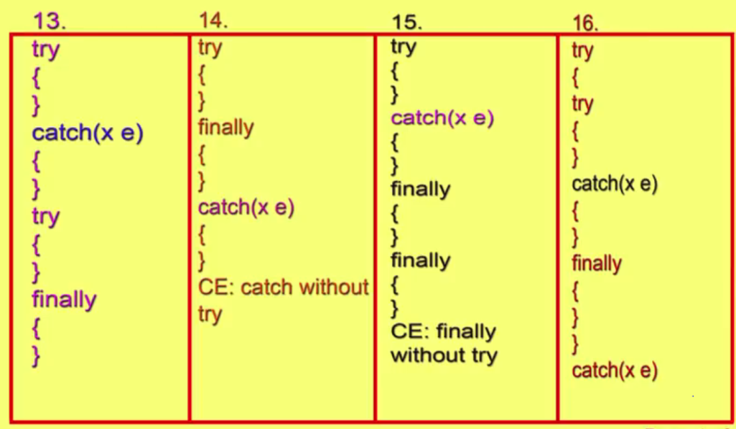
    12. 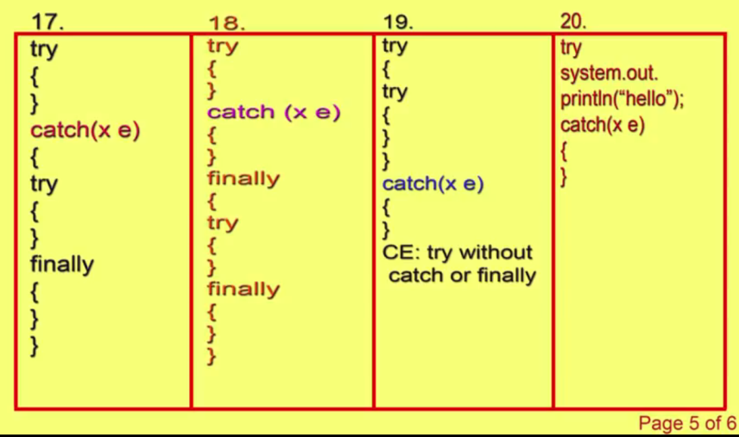
    13. 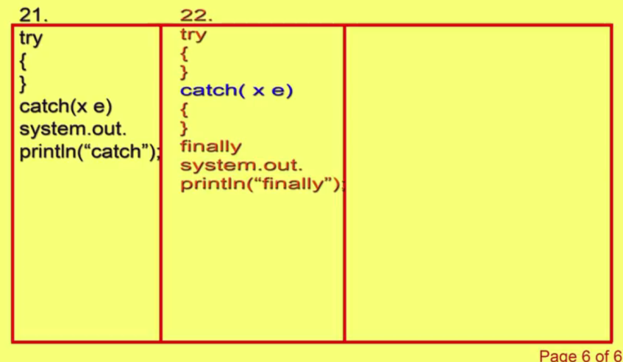
56. Types of Class Loaders
    1. 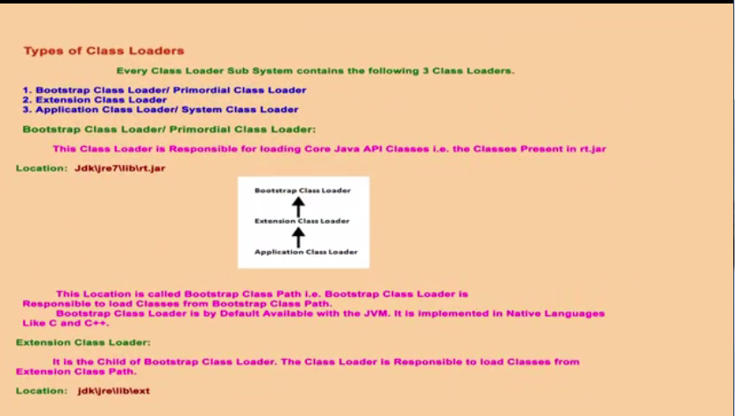
    2. 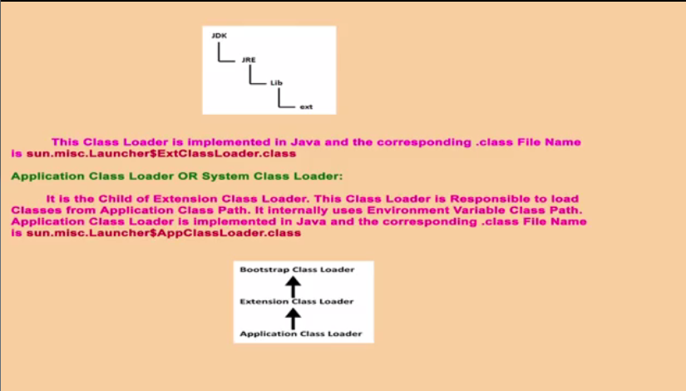
    3. 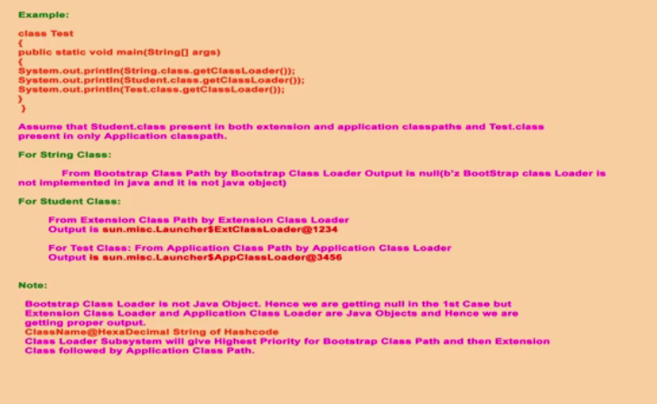
    4. Three types of class loader :
       1. Bootstrap class loader
       2. Extension Class loader
       3. Application class loader
    5. The below path is called bootstrap class loader
    6. 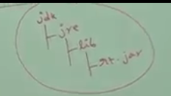
    7. Bootstrap class loader is responsible for loading the this rt.jar and most of its function are native
    8. Extension class loader is a child class of bootstrap class loader and it is responsible to load class from “Extension class path” (the class from ext folder ).
    9. 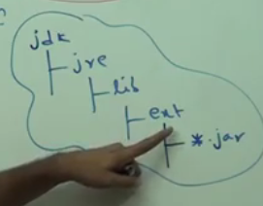 This is extension class path.
    10. Application class loader loads classes from application class path.(current working dir or environmental variable or Application level path)
    11. 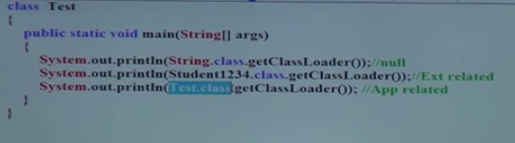
    12. 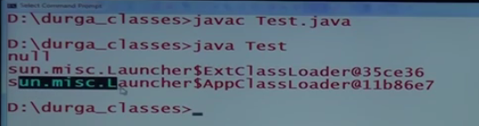
57. JVM Architecture
    1. 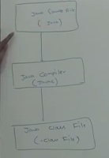 This .class file will sent to JVM. Then JVM will load and execute the file
    2. There are three parts in JVM
       1. Class Loader – Loading and initialization of a class file
       2. Memory area – Stores various data in JVM
       3. Execution Engine - Executes the code
    3. The first part of JVM is Class Loader sub-system
       1. There a three jobs done by Class Loader : Loading, Linking and Initialization
       2. Loading
          1. Bootstrap class loader – load classes from bootstrap classpath (rt.jar).
          2. Extension class loader – loads the classes in Ext folder.
          3. Application class loader – classes from application level.
       3. Linking
          1. Verify – verify the generated byte code
          2. Prepare – static variables memory will be allocated and assigned with default values.
          3. Resolve–All symbolic reference are replaces with original reference in method areas.
       4. Initialization – original values for static values will placed in this session
       5. 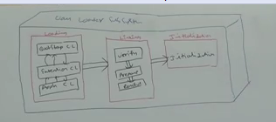
       6. Once initialization is completed, class loading is completed successfully.
       7. The .class file is the input to class loader sub-system.
    4. Various memory present inside JVM
       1. There are 5 memory area in JVM
          1. Method Area – Class level data including static variable
          2. Heap memory Area – Object data and corresponding instance variables.
          3. Stack area – for every thread a separate stack will be there. Every stack frame will have local variable array, frame data and operand stack.
          4. PC register – PC register for every thread to hold the address of next executing instruction.
          5. Native area – for native programs.
       2. 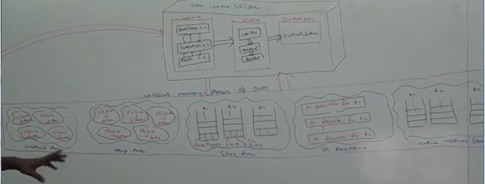
       3. Stack is thread-safe and method area and Heap area are not thread safe.Becz there will be separate stack for every thread but there is only one method and heap area in JVM.
    5. Execution Engine
       1. Three parts
          1. Interpreter – executes the code line by line
          2. JIT compiler- will come to action only if the method is repeatedly used.
             1. Intermediate code generator – produce IC (Intermediate code)
             2. Code optimizer – optimize the code
             3. Target code generator –generates the target code.
          3. Profiler – is responsible to identify the method is repeatedly required or not.
       2. There are also other components like GC
       3. 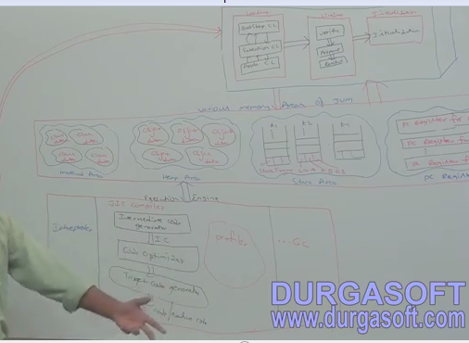
    6. Java native method Interface (JNI)
       1. This interface is used to provide native method information.
       2. 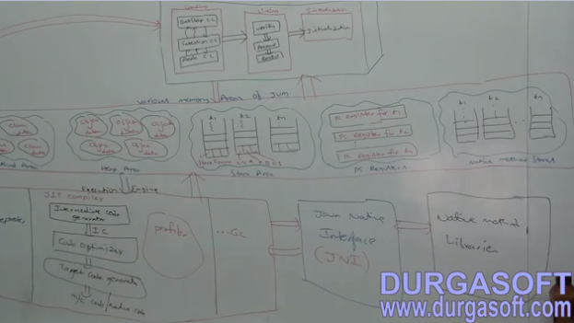

# Assertion:

1. Assert(Exp):”statement”
2. Assertion is disabled in JVM by default.
3. To enable assertion “java –eaClassname” or “java –enableassertionsClassname”
4. To disable assertion “java –da Classname” or “java –disableassertionsClassname”
5. To enable assertion for whole package “java –eaPackagename”
6. Assertion error shouldnot be caught or handled
7. Asset can be used as identifier or variable but not as both

# Wrapper classes:

1. Wraps primitive types into objects.
2. Conversion from one type to Another type
3. Wrapper objects are immutable and they cannot be sub classed, since wrapper classes are Final classes.

# Wildcards

1. The wildcard?in[Java](http://en.wikipedia.org/wiki/Java_%28programming_language%29) is a special actual parameter for the instantiation of [generic](http://en.wikipedia.org/wiki/Generics_in_Java) (parameterized) types. It can be used for the instantiation, not in the definition of a generic unit. Thus, a wildcard is a form of use-site[variance annotation](http://en.wikipedia.org/wiki/Variance_annotation) (contrast this with the definition-site variance annotations found in [C#](http://en.wikipedia.org/wiki/C_Sharp_%28programming_language%29) and [Scala](http://en.wikipedia.org/wiki/Scala_%28programming_language%29)). This article summarizes the most important rules for its use.

# Access Modifiers

1. Four types (Public, private, protected, default)
2. 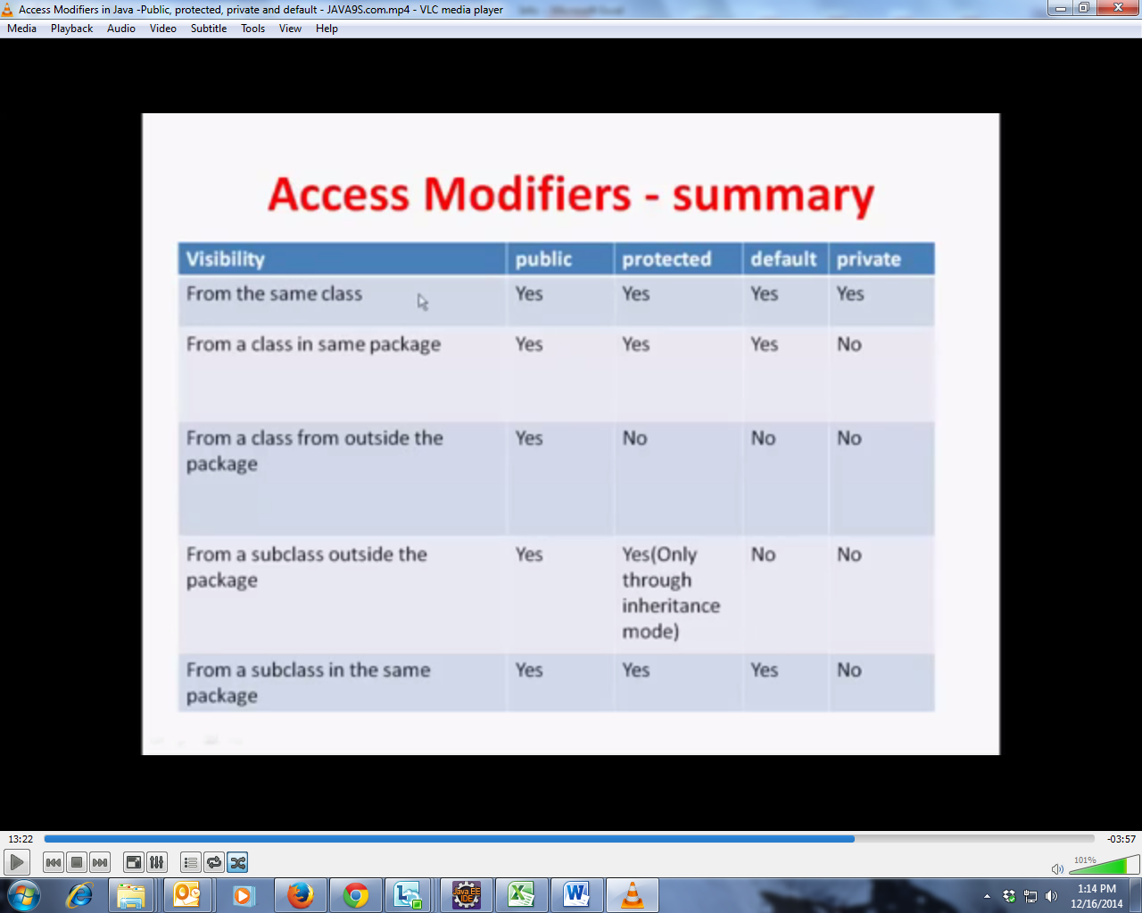
3. 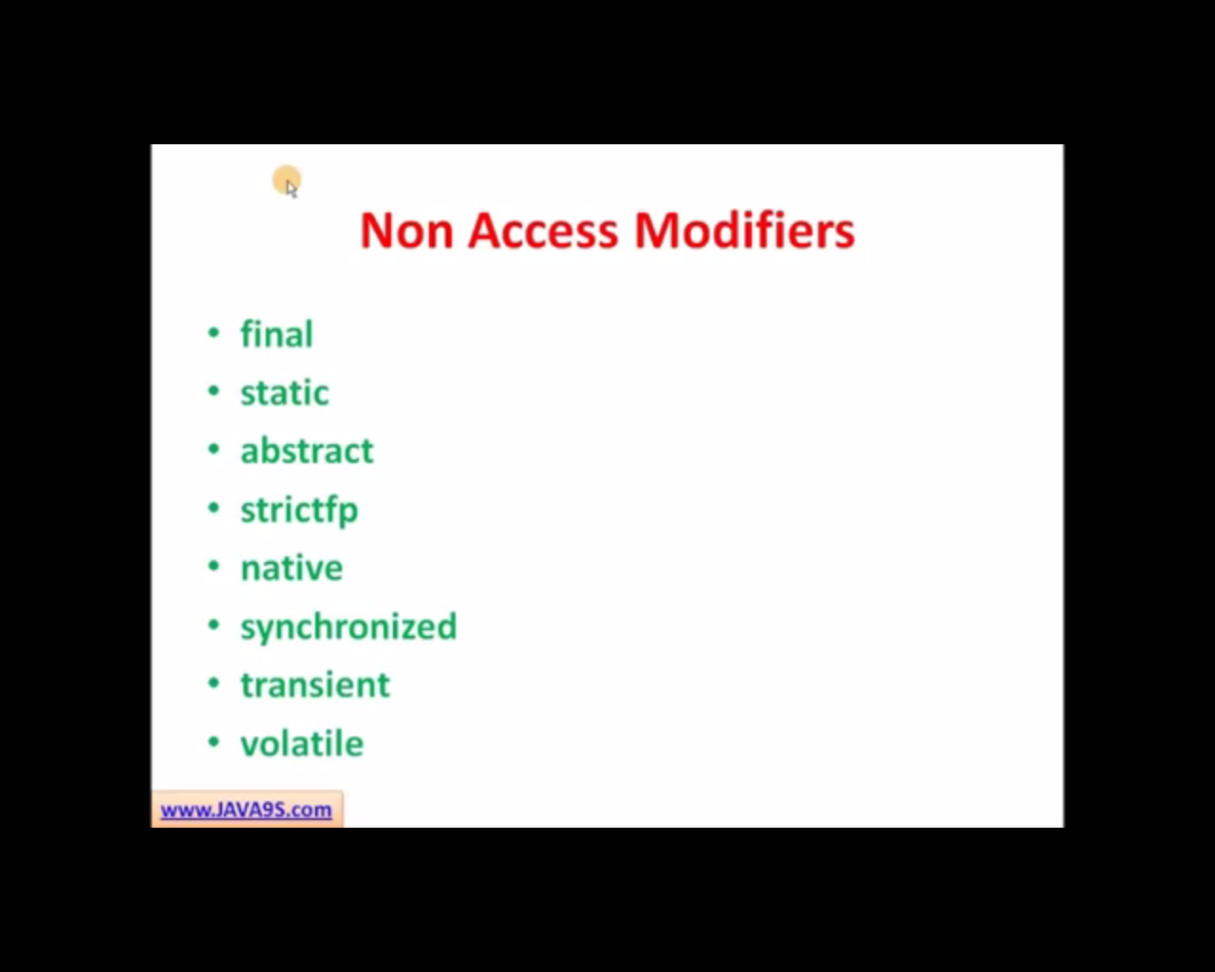
   1. Final
      1. Can be applied to classes, methods, instance variables and local variables.
      2. Class marked as final cannot be extended
      3. Method marked as Final cannot be overridden
      4. Primitive data type or object will not change its value or reference when marked as final
   2. Static
      1. Can be applied for methods and variables
      2. Method or class marked as static belongs to class
      3. Method or class marked as static can be accessed only by using class name
      4. Static rules
         1. Static method and static variable are called class members
         2. Method marked static can access other static method and static variables only
         3. To access instance variables and methods static method should have a instance on which object member should be invoked.
         4. Any instance can change the static variable, but the changes will reflect for all objects.
         5. Members marked as static can also be final
   3. Abstract
      1. Abstract can be applied to classes and methods only
      2. When a method is marked as an abstract it does not have any implementation
      3. Only abstract class can have abstract methods(Zero or more)
      4. Cannot create an instance of an abstract class
      5. Abstract methods should be overridden in sub class or marked as abstract
      6. Abstract method and classes should not be final.
      7. Abstract method cannot be static or private.
   4. Strictfp
      1. Marked for methods and classes
      2. When declared, the method will confirm IEEE754 standard which makes the platform or classes behave in platform independent way regarding the floating point.
      3. StrictFp cannot be abstract
   5. Native
      1. It can be applied only to methods
      2. Native method will have a platform dependent code like C
      3. Native method should not have Implementation
   6. Synchronized
      1. Applied only to methods
      2. Synchronized methods will allow one single thread to execute at a time
      3. It can be used with any modifiers
   7. Transient
      1. Only instance variables can be marked as Transient
      2. Transient variables will not be serialized
   8. Volatile
      1. Can be applied to instance variables only
      2. The Java volatile keyword is used to mark a Java variable as "being stored in main memory" to maintain uniformity across thread using the variables
   9. 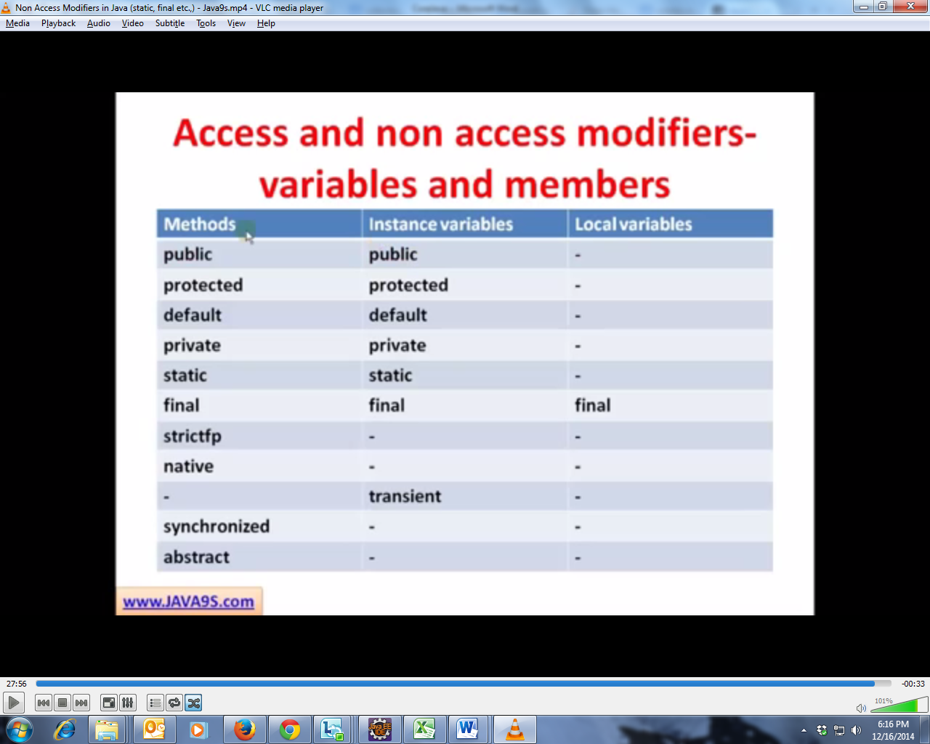
4. Multiple Inheritance
   1. 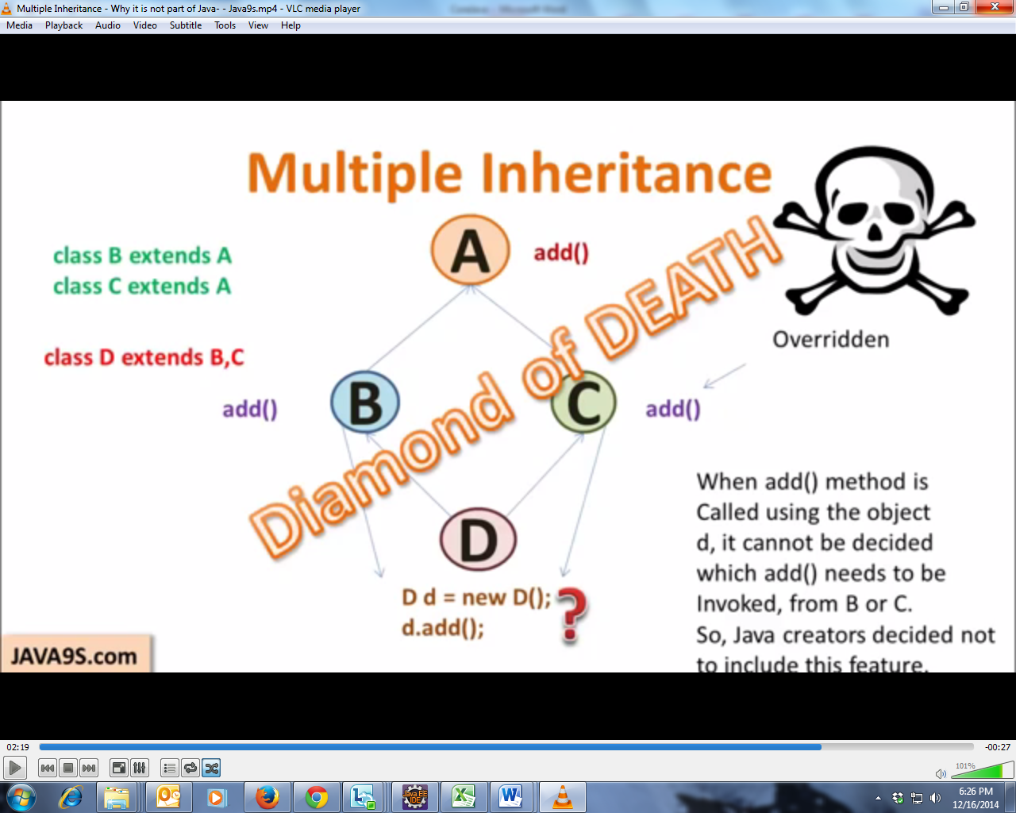
   2. This is why multiple inheritance is not allowed in java.
5. Exception in java
   1. Two types : Checked exception and unchecked exceptions

|  |  |
| --- | --- |
| **Checked** | **UnChecked** |
| Extends java.lang.Exception | Extends Java.lang.runtimeException |
| Handled using try block or throws clause | It cannot be handled |

1. Thread safety and code synchronization
2. Interface
   1. No method implementation(All method are abstract and public)
   2. Interface can extends any number of interface
3. Constructors and Objects
   1. Constructors initializes the object immediately it is created
   2. Constructors is the first block of code that is executed
   3. Constructors is executed only once in its life cycle
   4. It should be the same name of the class
   5. It can be overloaded
   6. There is no return type for constructor, even void
   7. Default constructor is generated only when there is no constructor in the class
   8. Default constructor will have same access as the class
   9. No arguments is present in the default constructor
   10. Super() – used to invoke the super class default constructor
   11. This() - used to invoke the constructor of the same class
   12. Super() – will be injected before every constructor to invoke the super class to initialize the parent class before the object is given to the application
   13. An constructor can have either super() or this() in the constructor and it should be in the first line only.
   14. super and this are used to access the methods and properties of the super class and their own.
4. Introduction to JSF(Java server faces)
   1. Structs –
      1. form bean and action bean
      2. validation in validation in validation.XML and Validation-rules.xml
   2. JSF – \
      1. combined in single POJO class
      2. validation is component based
   3. Life cycle
      1. **Restore View** – Create a tree like structure in memory for the components in the form
      2. **Apply request values** – set the request values to components
      3. **Process validation –** Check the values and proceed to next level
      4. **Update model –** Update the values in manages beans
      5. **Invoke application –** when any action or navigation is performed in the page the relevant action is called.
      6. **Render response –**The response from the action is handled to the user.
   4. Two tag libraries
      1. Faces tag libraries (f)
      2. HTML tag libraries (h)
   5. Faces-config.xml
   6. Components of Faces
      1. Input Text box
      2. outputlabel
      3. outputtext
      4. datatable
      5. selectonemenu
      6. selectoneradio
      7. selectmanycheckbox
   7. Features of JSF 2.0

# Introduction

This tutorial will help you to understand about Java OOP’S concepts with examples. Let’s discuss about what are the features of Object Oriented Programming. Writing object-oriented programs involves creating classes, creating objects from those classes, and creating applications, which are stand-alone executable programs that use those objects.

A class is a template, blueprint,or contract that defines what an object’s data fields and methods will be. An object is an instance of a class. You can create many instances of a class. A Java class uses variables to define data fields and methods to define actions. Additionally,a class provides methods of a special type, known as constructors, which are invoked to create a new object. A constructor can perform any action, but constructors are designed to perform initializing actions, such as initializing the data fields of objects.

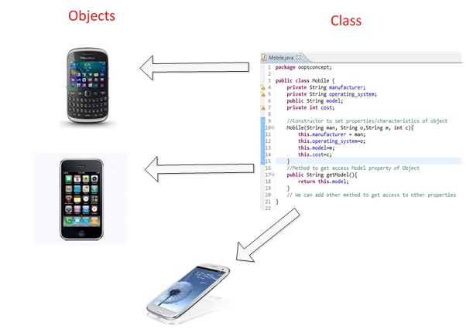

Objects are made up of attributes and methods. Attributes are the characteristics that define an object; the values contained in attributes differentiate objects of the same class from one another. To understand this better let’s take example of Mobile as object. Mobile has characteristics like model, manufacturer, cost, operating system etc. So if we create “Samsung” mobile object and “IPhone” mobile object we can distinguish them from characteristics. The values of the attributes of an object are also referred to as the object’s state.

There are three main features of OOPS.

**1)** Encapsulation

**2)** Inheritance

**3)** Polymorphism

Let’s we discuss about the about features in details.

# Encapsulation

Encapsulation means putting together all the variables (instance variables) and the methods into a single unit called Class. It also means hiding data and methods within an Object. Encapsulation provides the security that keeps data and methods safe from inadvertent changes. Programmers sometimes refer to encapsulation as using a “black box,” or a device that you can use without regard to the internal mechanisms. A programmer can access and use the methods and data contained in the black box but cannot change them. Below example shows Mobile class with properties, which can be set once while creating object using constructor arguments. Properties can be accessed using getXXX() methods which are having public access modifiers.

[viewplainprint?](http://www.w3resource.com/java-tutorial/java-object-oriented-programming.php)

1. package oopsconcept;
2. public class Mobile {
3. private String manufacturer;
4. private String operating_system;
5. public String model;
6. private int cost;
7. //Constructor to set properties/characteristics of object
8. Mobile(String man, String o,String m, int c){
9. this.manufacturer = man;
10. this.operating_system=o;
11. this.model=m;
12. this.cost=c;
13. }
14. //Method to get access Model property of Object
15. public String getModel(){
16. return this.model;
17. }
18. // We can add other method to get access to other properties
19. }

# Inheritance

An important feature of object-oriented programs is inheritance—the ability to create classes that share the attributes and methods of existing classes, but with more specific features. Inheritance is mainly used for code reusability. So you are making use of already written class and further extending on that. That why we discussed about the code reusability the concept. In general one line definition we can tell that deriving a new class from existing class, it’s called as Inheritance. You can look into the following example for inheritance concept. Here we have Mobile class extended by other specific class like Android and Blackberry.

[viewplainprint?](http://www.w3resource.com/java-tutorial/java-object-oriented-programming.php)

1. package oopsconcept;
2. public class Android extends Mobile{
3. //Constructor to set properties/characteristics of object
4. Android(String man, String o,String m, int c){
5. super(man, o, m, c);
6. }
7. //Method to get access Model property of Object
8. public String getModel(){
9. return "This is Android Mobile- " + model;
10. }
11. }

[viewplainprint?](http://www.w3resource.com/java-tutorial/java-object-oriented-programming.php)

1. package oopsconcept;
2. public class Blackberry extends Mobile{
3. //Constructor to set properties/characteristics of object
4. Blackberry(String man, String o,String m, int c){
5. super(man, o, m, c);
6. }
7. public String getModel(){
8. return "This is Blackberry-"+ model;
9. }
10. }

# Polymorphism

In Core Java Polymorphism is one of easy concept to understand. Polymorphism definition is that Poly means many and morphos means forms. It describes the feature of languages that allows the same word or symbol to be interpreted correctly in different situations based on the context. There are two types of Polymorphism available in Java. For example, in English the verb “run” means different things if you use it with “a footrace,” a “business,” or “a computer.” You understand the meaning of “run” based on the other words used with it. Object-oriented programs are written so that the methods having same name works differently in different context. Java provides two ways to implement polymorphism.

# Static Polymorphism (compile time polymorphism/ Method overloading):

The ability to execute different method implementations by altering the argument used with the method name is known as method overloading. In below program we have three print methods each with different arguments. When you properly overload a method, you can call it providing different argument lists, and the appropriate version of the method executes.

[viewplainprint?](http://www.w3resource.com/java-tutorial/java-object-oriented-programming.php)

1. package oopsconcept;
2. class Overloadsample {
3. public void print(String s){
4. System.out.println("First Method with only String- "+ s);
5. }
6. public void print (int i){
7. System.out.println("Second Method with only int- "+ i);
8. }
9. public void print (String s, int i){
11. System.out.println("Third Method with both- "+ s + "--" + i);
12. }
13. }
14. public class PolymDemo {
15. public static void main(String[] args) {
16. Overloadsample obj = new Overloadsample();
17. obj.print(10);
18. obj.print("Amit");
19. obj.print("Hello", 100);
20. }
21. }

## Output :

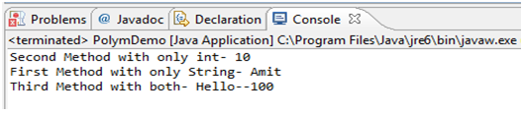

# Dynamic Polymorphism (run time polymorphism/ Method Overriding)

When you create a subclass by extending an existing class, the new subclass contains data and methods that were defined in the original superclass. In other words, any child class object has all the attributes of its parent. Sometimes, however, the superclass data fields and methods are not entirely appropriate for the subclass objects; in these cases, you want to override the parent class members. Let’s take example used in inheritance explanation.

[viewplainprint?](http://www.w3resource.com/java-tutorial/java-object-oriented-programming.php)

1. package oopsconcept;
2. public class OverridingDemo {
3. public static void main(String[] args) {
4. //Creating Object of SuperClass and calling getModel Method
5. Mobile m = new Mobile("Nokia", "Win8", "Lumia",10000);
6. System.out.println(m.getModel());
7. //Creating Object of Sublcass and calling getModel Method
8. Android a = new Android("Samsung", "Android", "Grand",30000);
9. System.out.println(a.getModel());
10. //Creating Object of Sublcass and calling getModel Method
11. Blackberry b = new Blackberry("BlackB", "RIM", "Curve",20000);
12. System.out.println(b.getModel());
13. }
14. }

# Abstraction

All programming languages provide abstractions. It can be argued that the complexity of the problems you’re able to solve is directly related to the kind and quality of abstraction. An essential element of object-oriented programming is abstraction. Humans manage complexity through abstraction. When you drive your car you do not have to be concerned with the exact internal working of your car(unless you are a mechanic). What you are concerned with is interacting with your car via its interfaces like steering wheel, brake pedal, accelerator pedal etc. Various manufacturers  of car has different implementation of car working but its basic interface has not changed (i.e. you still use steering wheel, brake pedal, accelerator pedal etc to interact with your car). Hence the knowledge you have of your car is abstract.

A powerful way to manage abstraction is through the use of hierarchical classifications. This allows you to layer the semantics of complex systems, breaking them into more manageable pieces. From the outside, the car is a single object. Once inside, you see that the car consists of several subsystems: steering, brakes, sound system, seat belts, heating, cellular phone, and so on. In turn, each of these subsystems is made up of more specialized units. For instance, the sound system consists of a radio, a CD player, and/or a tape player. The point is that you manage the complexity of the car (or any other complex system)through the use of hierarchical abstractions.

An abstract class is something which is incomplete and you cannot create instance of abstract class. If you want to use it you need to make it complete or concrete by extending it. A class is called concrete if it does not contain any abstract method and implements all abstract method inherited from abstract class or interface it has implemented or extended. By the way Java has concept of abstract classes, abstract method but a variable can not be abstract in Java.

Lets take an example of Java Abstract Class called Vehicle. When I am creating a class called Vehicle, I know there should be methods like start() and Stop() but don't know start and stop mechanism of every vehicle since they could have different start and stop mechanism e.g some can be started by kick or some can be by pressing buttons.

Advantage of Abstraction is if there is new type of vehicle introduced we might just need to add one class which extends Vehicle Abstract class and implement specific methods.  Interface of start and stop method would be same.

[viewplainprint?](http://www.w3resource.com/java-tutorial/java-object-oriented-programming.php)

1. package oopsconcept;
3. public abstract class VehicleAbstract {
5. public abstract void start();
7. public void stop(){
8. System.out.println("Stopping Vehicle in abstract class");
9. }
10. }
12. class TwoWheeler extends VehicleAbstract{
14. @Override
15. public void start() {
16. System.out.println("Starting Two Wheeler");
17. }
18. }
19. class FourWheeler extends VehicleAbstract{
21. @Override
22. public void start() {
23. System.out.println("Starting Four Wheeler");
25. }
27. }

[viewplainprint?](http://www.w3resource.com/java-tutorial/java-object-oriented-programming.php)

1. package oopsconcept;
3. public class VehicleTesting {
5. public static void main(String[] args) {
6. VehicleAbstract my2Wheeler = new TwoWheeler();
7. VehicleAbstract my4Wheeler = new FourWheeler();
9. my2Wheeler.start();
10. my2Wheeler.stop();
12. my4Wheeler.start();
13. my4Wheeler.stop();
14. }
15. }

## Output :

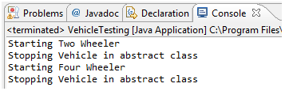

# Summary

* An object is an instance of a class.
* Encapsulation provides the security that keeps data and methods safe from inadvertent changes.
* Inheritance is parent-child relationship of class which is mainly used for code reusability.
* Polymorphism definition is that Poly means many and morphos means forms.
* Using abstraction one can simulate real world objects.
* Abstraction provides advantage of code reuse
* Abstraction enables program open for extension

- See more at: http://www.w3resource.com/java-tutorial/java-object-oriented-programming.php#sthash.r2VLvnGU.dpuf

# Multi Threading

1. Part 1
   1. 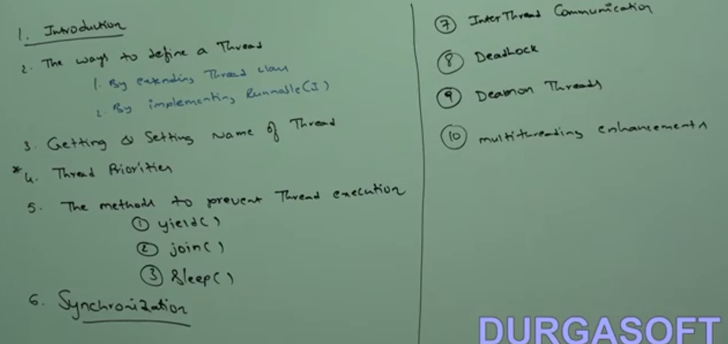
   2. Multi tasking - executing several process simultaneously is called multi-tasking
      1. process based multi tasking - executing several task simultaneously where each part belongs to a different program. best at OS level
      2. thread based multi tasking - executing several task simultaneously where each part is separate part of the same program and independent of each other. best at program level
   3. Whether it is process based or thread based the main objective of the multitasking is to reduce the response time of the system and improve performance.
   4. To develop multimedia application, web servers and application server.
   5. Java provides in build supporting API for multithreading.
   6. The API are : thread, runnable, ThreadGroup
2. Core Java with OCJP SCJP Multi Threading Part-2 The ways of defining a Thread Part-1
   1. Thread is light weight process
   2. define a thread using two way:
      1. Extending Thread class
      2. Implementing Runnable Interface.
   3. 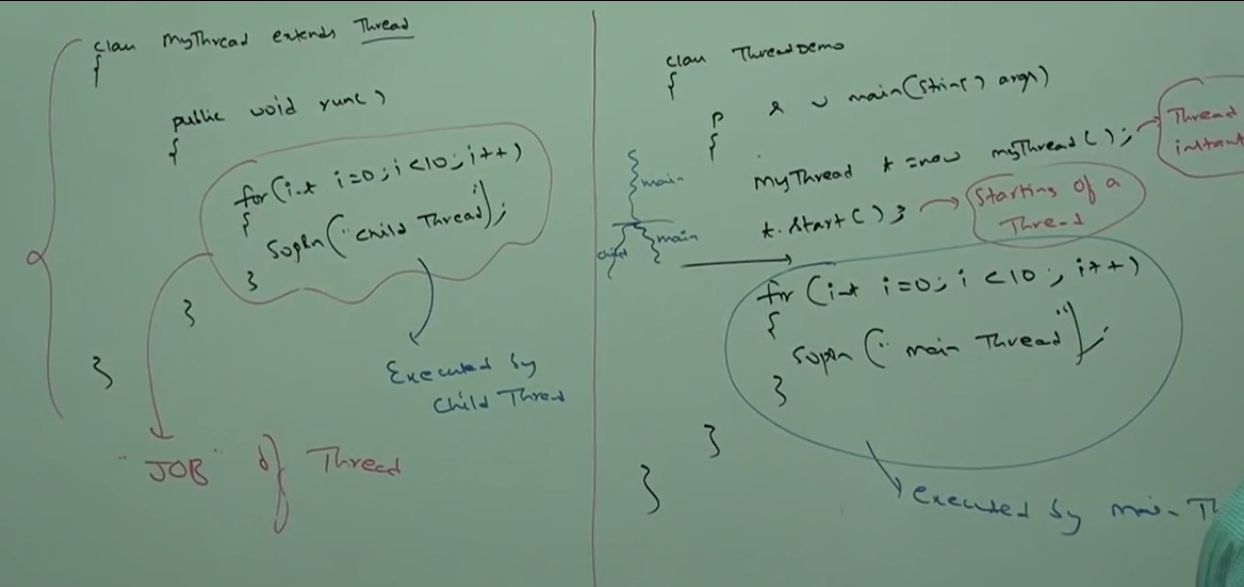
   4. Thread scheduler
      1. it is a part of JVM
      2. schedule the threads execution orders
   5. Diff bet thread.start() and Thread.run()
      1. T.start() - A New thread will be created to execute the statements inside run
      2. T.Run() - A new thread will not be created
   6. 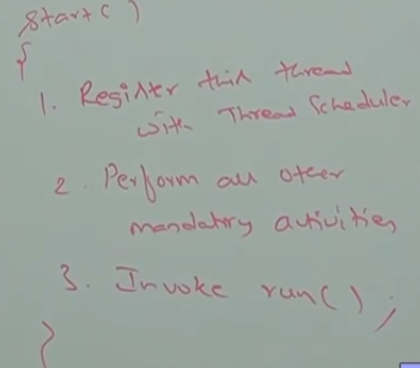
   7. Importance of thread.start()
      1. It is responsible to register the thread schedular and all other mandatory activity. hence without executing Thread .Start() there is no chance of starting new thread in java. Due to this, Thread.start() is considered as heart of multi threading.
   8. Overloading of thread run method
      1. Over loading is always possible, but Thread.Start() will always invoke No-Args run method only. The other overloaded method we have to call explicitly like normal method call.
      2. 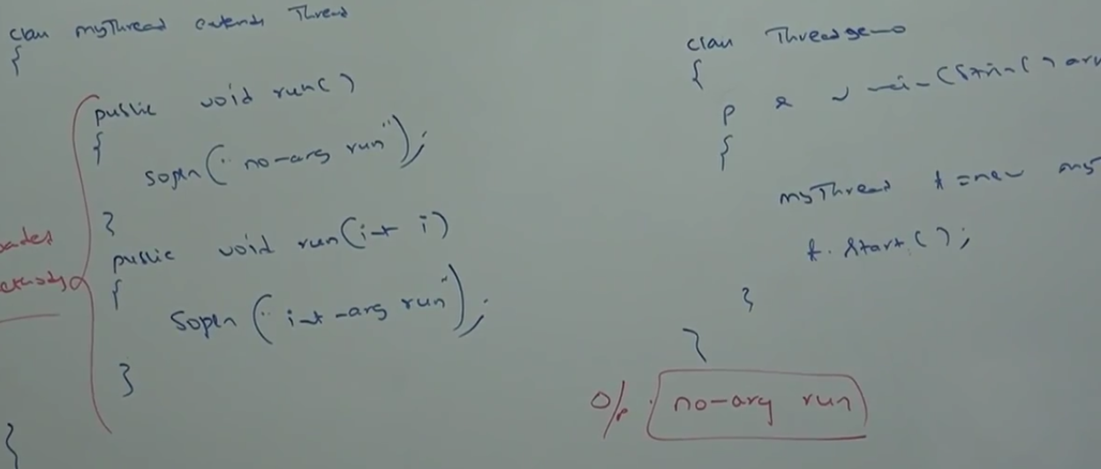
   9. If we not Overriding of Thread.Run() method
      1. It is valid and does not throw any exception. but is not recommended
   10. Overriding of Thread.Start() method
       1. It will execute like a normal method and new thread won't be created.
       2. It is not recommended to override start method
   11. Thread Life cycle
   12. 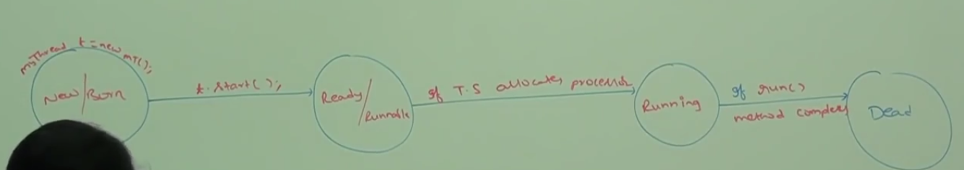
   13. IllegalThreadStateException- whenever a thread is started and once again thead.Start() is called once again then this exception is called.
3. Core Java with OCJP SCJP Multi Threading Part-3 -- The ways of defining a Thread Part-2
   1. Defining a thread by implementing Runnable interface
   2. 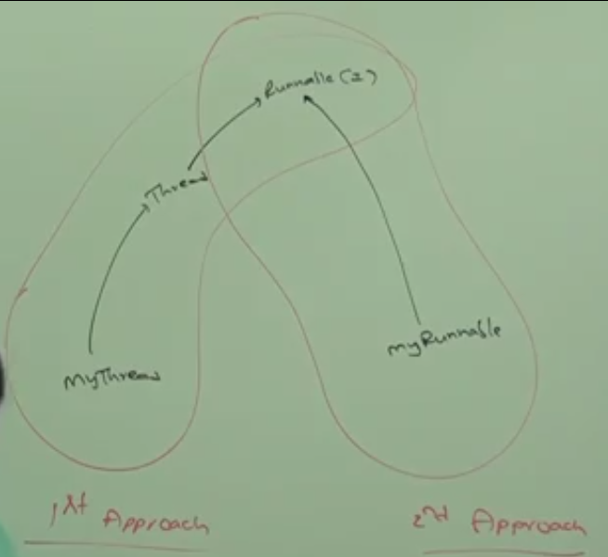
   3. Runnable interface present in java.lang package and it has only one method (run).
   4. 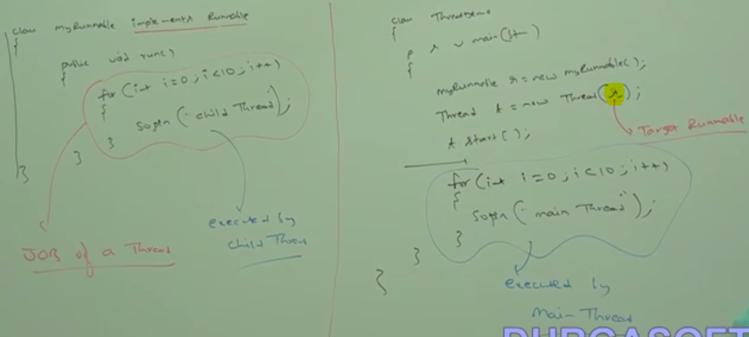
   5. 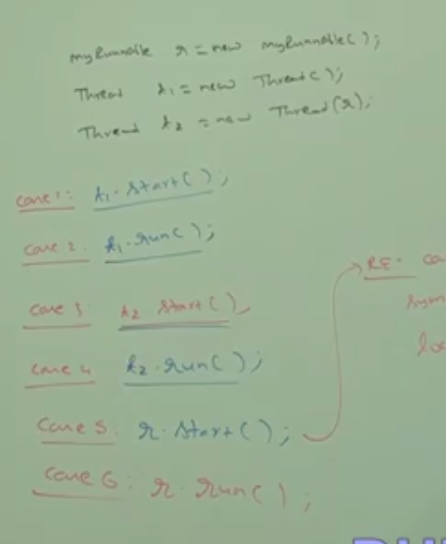
   6. 
      1. Case 1 : t1.Start() - A new thread will be created and it is responsible for the execution of thread class run method, which has empty implementation.
      2. Case 2 : t1.run() - A new thread will not be created and the thread.run() will be executed as a normal method.
      3. Case 3 : t2.start() - A new thread will be created and it is responsible for execution of myRunnable run().
      4. Case 4 : t2.run() - A new thread will not be created and MyRunnable.run() will be executed as a normal method.
      5. Case 5 :r.start() - A complile time exception will be thrown stating, cannot find symbol method start() inlocation myRunnable.
      6. Case 6 :r.run() - A new thread will not be created and myRunnable.run() will be executed as normal method.
   7. Diff between Thread and Runnable
      1. Among two ways implements runnable is recommended.
      2. in the first approach our class always extends thread class, there is no chance of extending any other class. Hence we are missing inheritance benefit.
      3. But in the second approach while implementing runnable interface we can extend any other class. Hence we won't miss any inheritance benefit.
      4. because of above reason implementing runnable is recommended than extending thread class.
   8. Thread class constructor
      1. 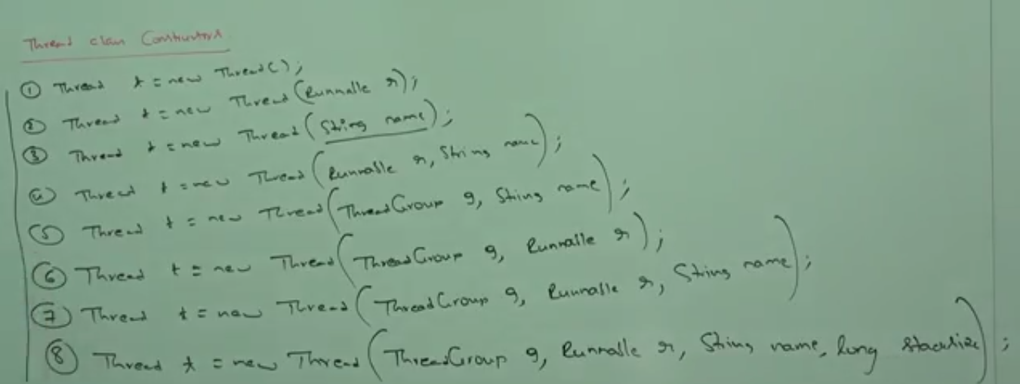
   9. 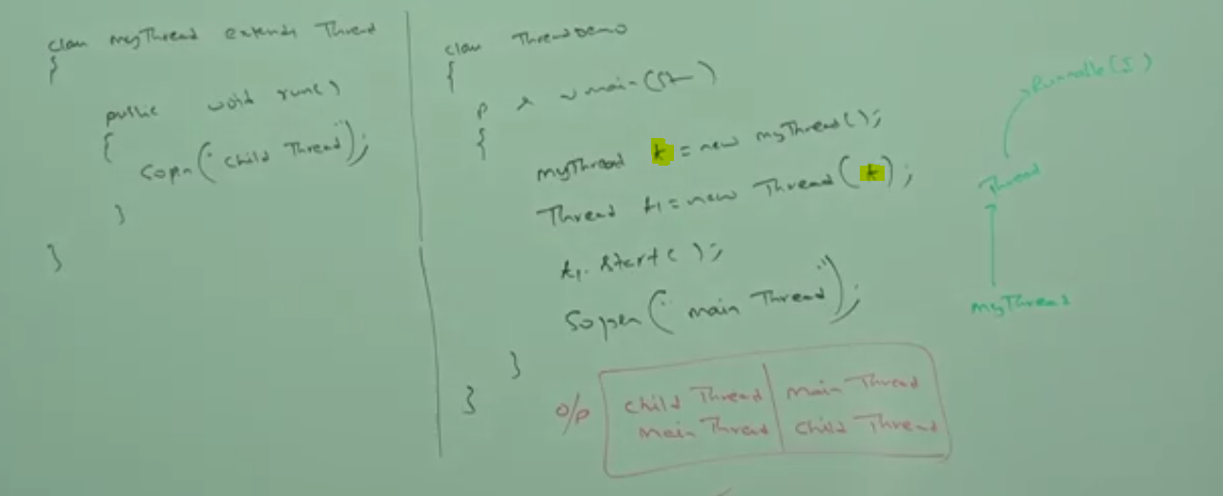
   10. Getting and setting a name of the thread
   11. 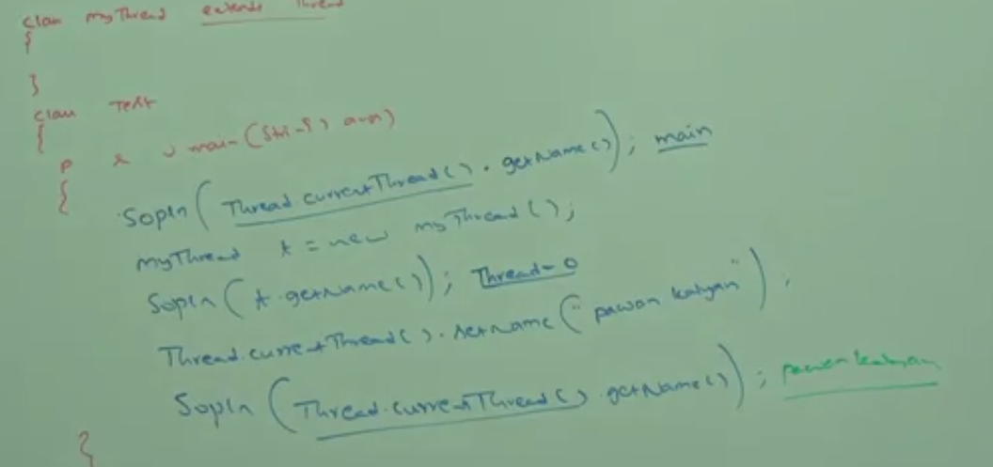
   12. 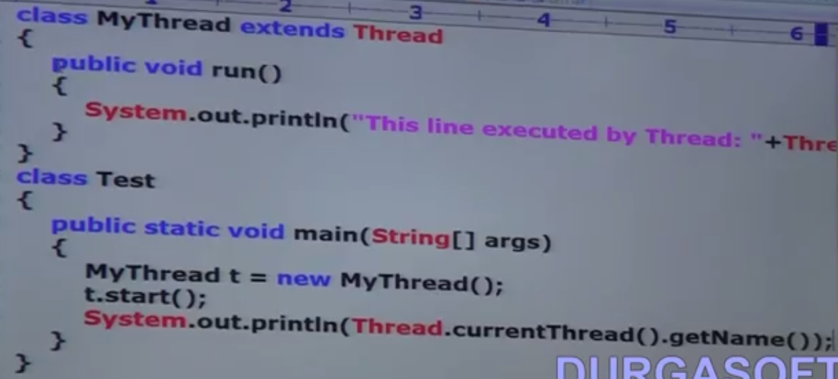
   13. Current Executing thread object we can get using thread.currentThread().
4. Core Java with OCJP SCJP Multi Threading Part-4 -- Thread Priorities
   1. Each thread has its own priority. Default priority set by JVM or customized priority is set by programmer.
   2. The Priority varies from 1 to10
   3. Min priority : 1 and Max priority : 10
   4. Thread class defines the following constants to represent standard priority given as below:
   5. 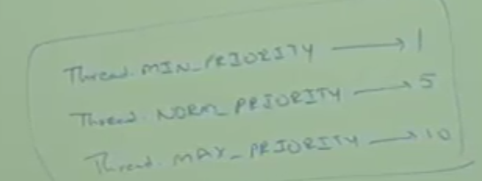
   6. If two thread having same priority then we can't expect exact execution order. it depends on thread scheduler.
   7. get and the set the priority of a thread:
      1. getPriority()
      2. setPriority(int p)
   8. In setPriority(int) the int value should be between 1 to 10. if the value the set to any other the it will throw a run time exception.
   9. Default priority of main thread is 5. for all other thread it will inherited for the main thread.
   10. 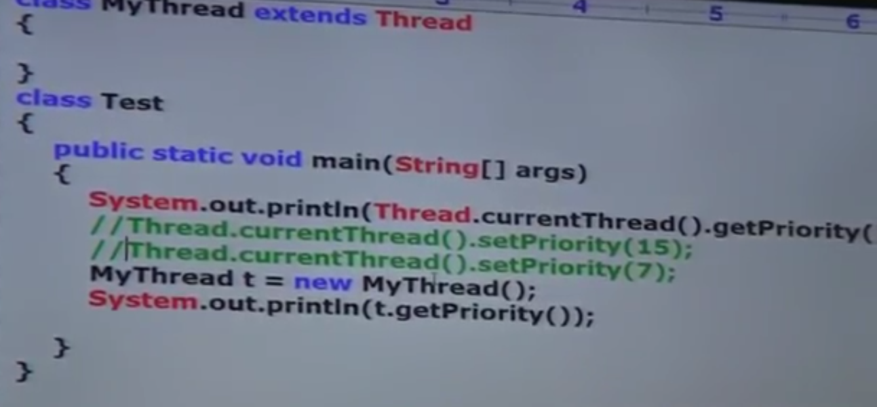
   11. 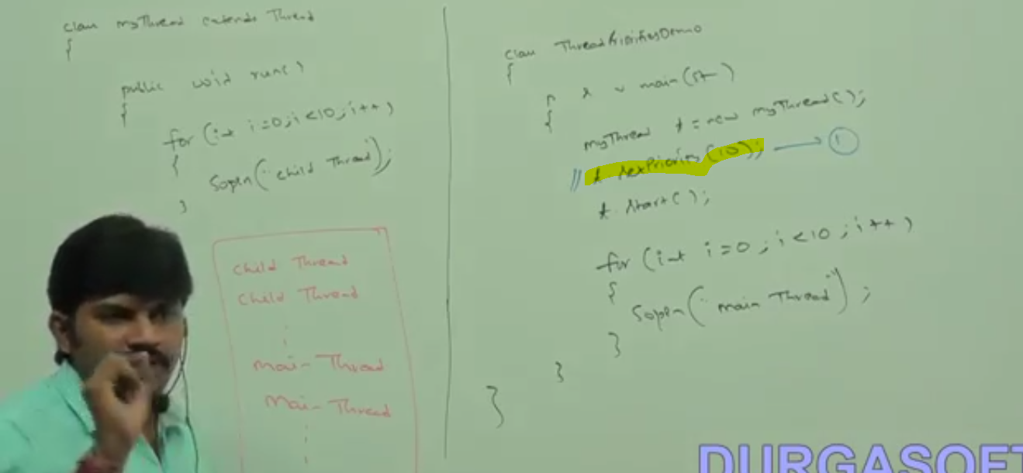
   12. Some platform won't provide proper support for thread priorities.
5. Core Java with OCJP SCJP Multi Threading Part-5 -- yield() -- join()
   1. There are three method to prevent execution.
      1. Yield()
      2. Join()
      3. Sleep()
   2. Yield()
      1. this method causes to the pause the current executing thread and to give the chance for the waiting threads of same priority
      2. if there is no waiting thread or all waiting thread have low priority then same thread can continue its execution.
      3. if multiple thread is waiting of same priority, then which waiting thread will get a chance depends on thread scheduler.
      4. The thread which is yielded, when it will get the chance once again depends on JVM.
      5. yield method is a native method.
      6. 
      7. 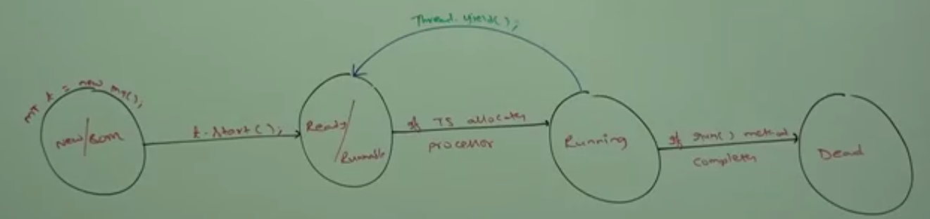
      8. 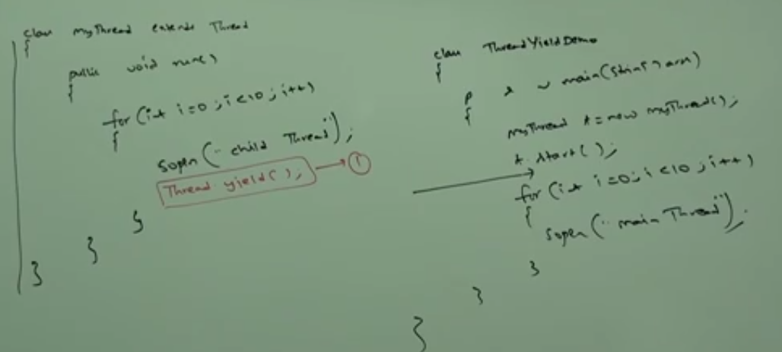
      9. Some platform won't provide support yield() too.
   3. Join()
      1. If a thread wants to wait until completing some other thread then we should go for join method
      2. for example: if a thread t1 wants to wait until completing t2 then t1 has to call t2.join().
      3. if t1 executes t2.join() then immediately t1 will be entered into waiting state until t2 completes
      4. once t2 completes, then t1 can continue its execution.
      5. 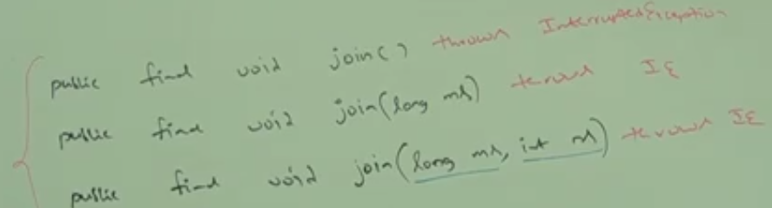
      6. Every join() throws interupted exception which is checked exception. Hence we should compulsory we should handle this using try/catch or throws.
      7. 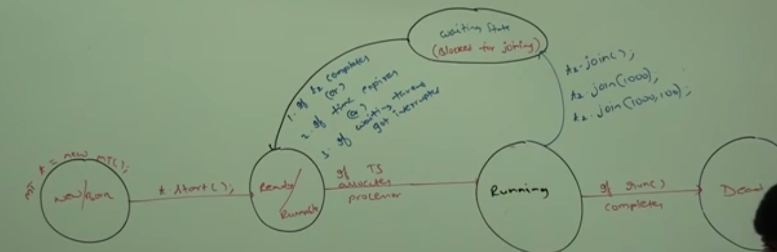
      8. 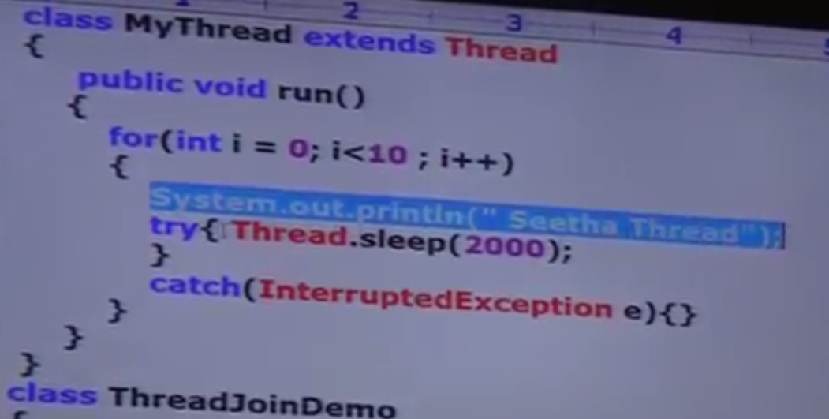
      9. 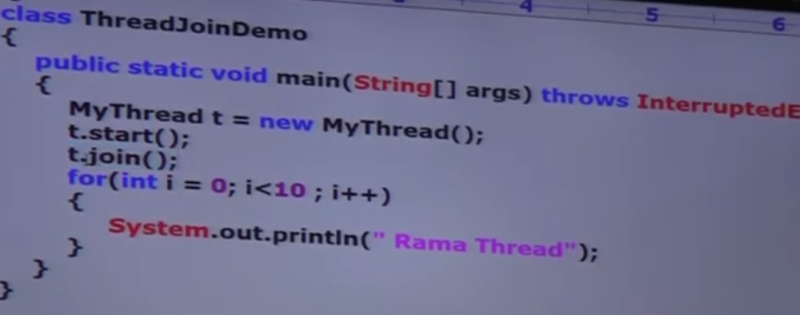
      10. 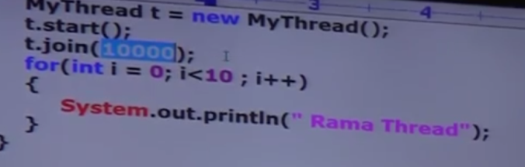
6. Core Java with OCJP SCJP Multi Threading Part-6 join() sleep() Thread Interruption
   1. Thread.Join()
      1. 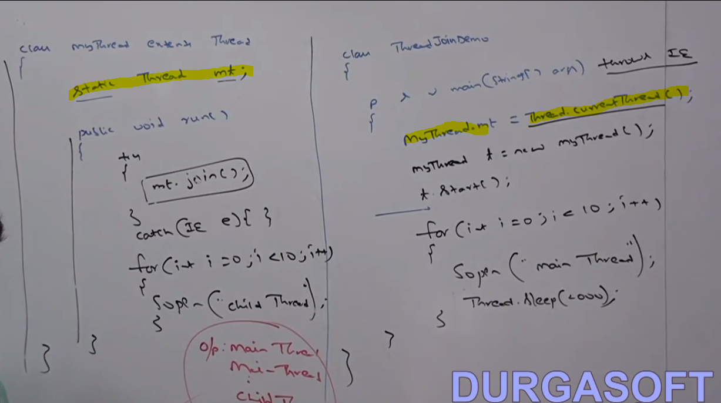
      2. here child thread has to wait till main thread executes.
      3. here if main thread after t.start(), if t.join() is called then there happens a deadlock
      4. 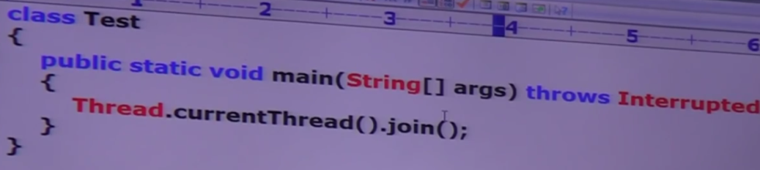
      5. The above also has deadlock situation
   2. Thread.Sleep()
      1. Where ever temporary pausing is required then we need to go for thread.sleep().
      2. Sleep is a native method
      3. 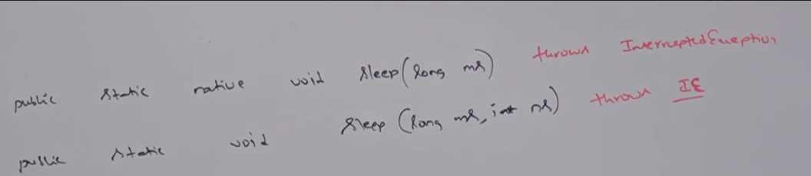
      4. 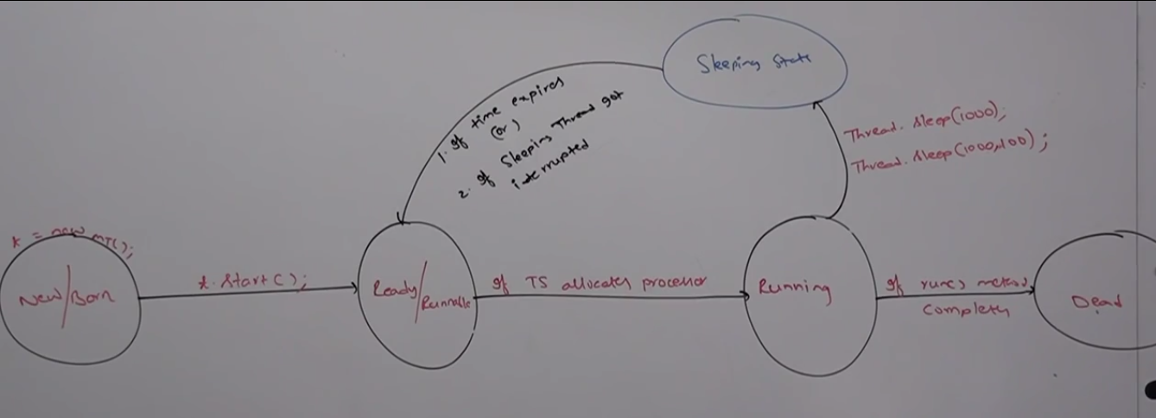
      5. 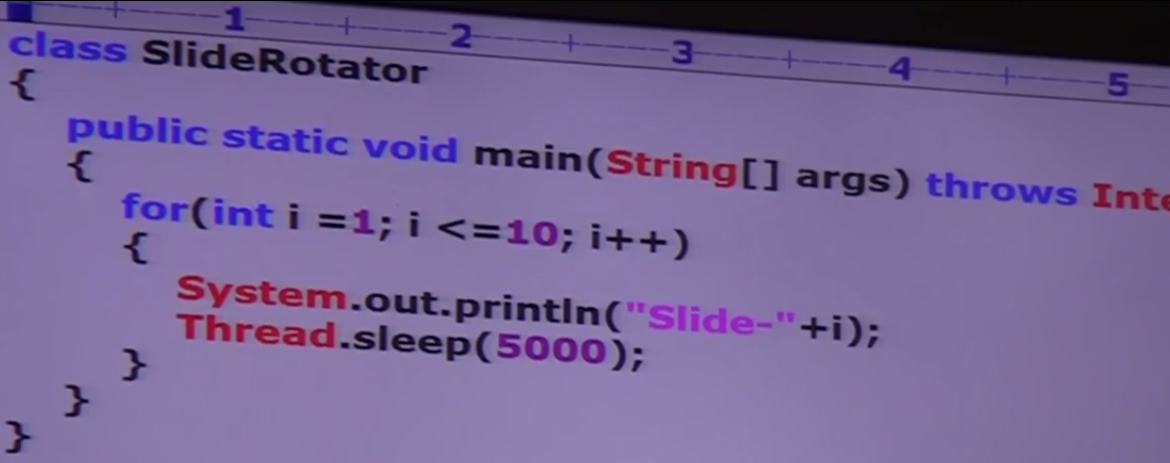
   3. Interrupting a thread
      1. A thread can interrupt a sleeping or waiting thread using interrupt method of thread class.
      2. 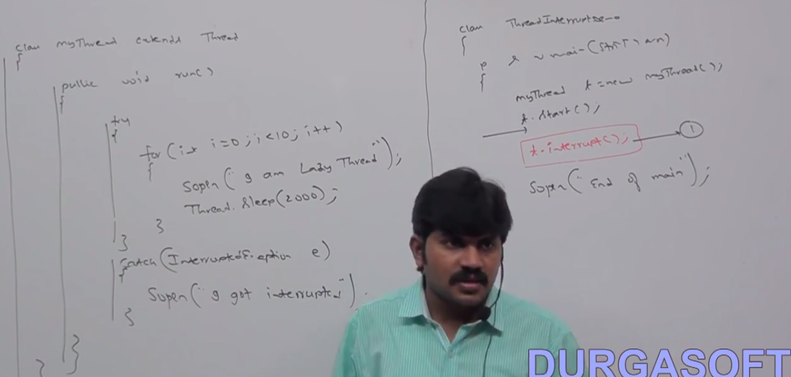
      3. 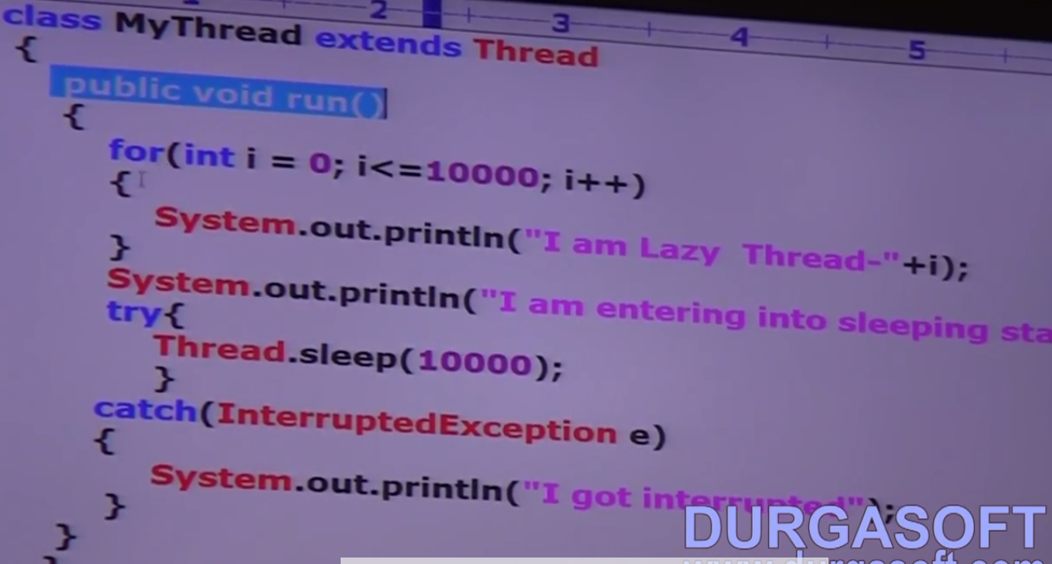
      4. 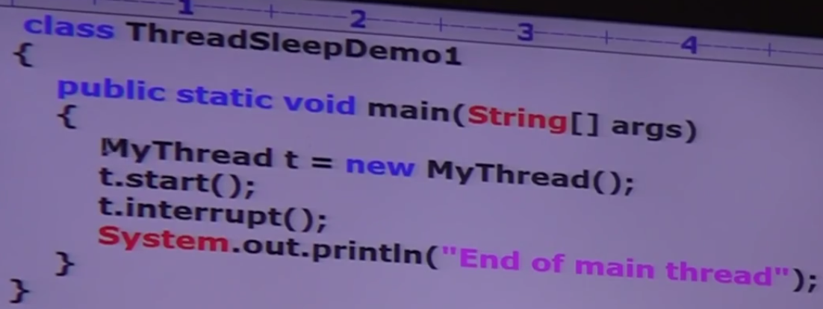
      5. **whenever we are calling interrupt() if the target thread is not in sleeping state or waiting thread then there is no impact of interrupt call immediately. interrupt call will be waited until the target thread will enter into sleeping or waiting state. then immediately interrupt call will interrupt the target thread**
      6. If the target thread never entered into sleeping or waiting state in its lifetime there is no impact of interrupt call. This is the only place where interrupt call will be wasted.

|  |  |  |  |
| --- | --- | --- | --- |
| **Property** | **Yield** | **Join** | **Sleep** |
| **Purpose** | If a thread wants to pause its execution to give chance for remaining thread of same priority | If a thread wants to wait for other thread completion | If a thread wants don't want to perform any operation for a particular amount of time |
| **Overloaded** | No | Yes | Yes |
| **Is it Final** | No | Yes | No |
| **Throws InteruptedException** | No | Yes | Yes |
| **Native** | Yes | No | Sleep (long) - native Sleep(L,Int) - not native |
| **Static** | Yes | NO | Yes |

1. Core Java with OCJP SCJP Multi Threading Part-7 synchronization part-1
   1. Synchronized is a modifier applicable only for methods and blocks but not for classes and variables.
   2. If multiple threads are trying to operate simultaneously on the same java object then there may be a chance of data inconsistency problem
   3. to overcome this problem we should go for synchronized keyword
   4. if a method or a block is declared as synchronized then at a time only one thread is allowed to execute that method or block on the given object so that data inconsistency problem will be resolved.
   5. The main advantage of synchronized keyword is we can resolve data inconsistency problems but the main disadvantage of synchronized keyword is it increases waiting time of threads and creates performance problems. Hence if there is no specific reasons then it is not recommended to use synchronized keyword.
   6. Internally synchronization is implemented by using lock.
   7. every object in java has a unique lock.
   8. whenever we are using synchronized keyword then only lock concept will come into the picture.
   9. if a thread wants to execute a synchronized method on a object first it has to get the lock of the object, once the thread get the lock then it allows to execute any synchronized method on the object.
   10. once the method execution completes, automatically thread releases the lock. acquiring and releasing a lock takes care by JVM and programmer not responsible for it.
   11. While a thread executing a synchronized method on given object the remaining thread are not allowed to execute any synchronized method on the object. But remaining threads are allowed to execute non synchronized method simultaneously.
   12. Lock concept is implemented based on object and not on method.
   13. 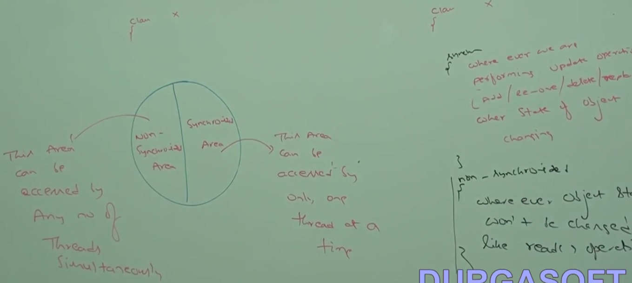
   14. 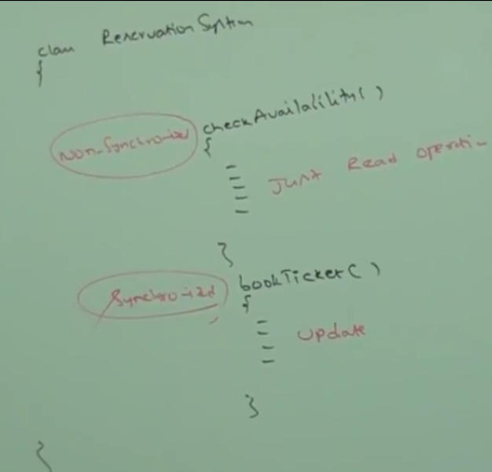
   15. 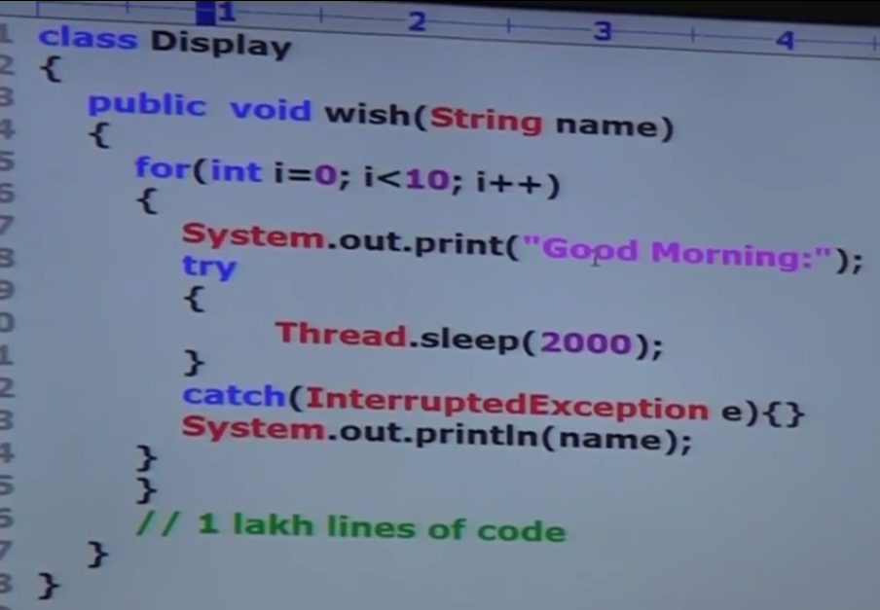
   16. 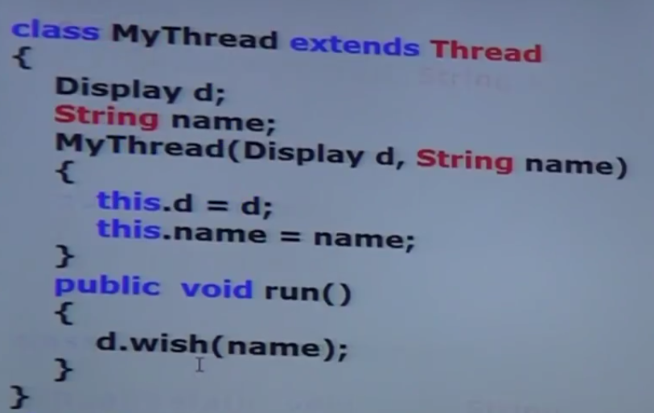
   17. 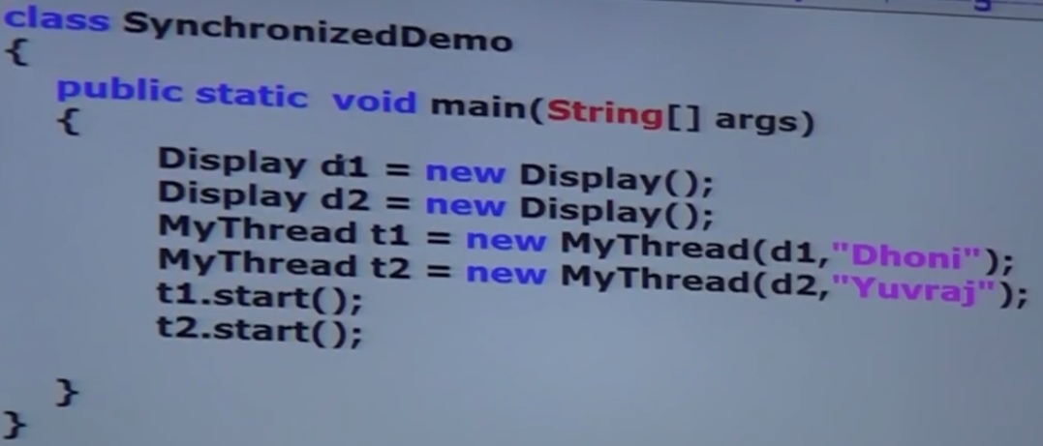
   18. with single thread it work fine. but with multiple threads, we will get a mixed output. So we need to synchronize the method to get a proper output.
2. Core Java with OCJP-SCJP- Multi Threading Part-8 -- synchronization part-2
   1. 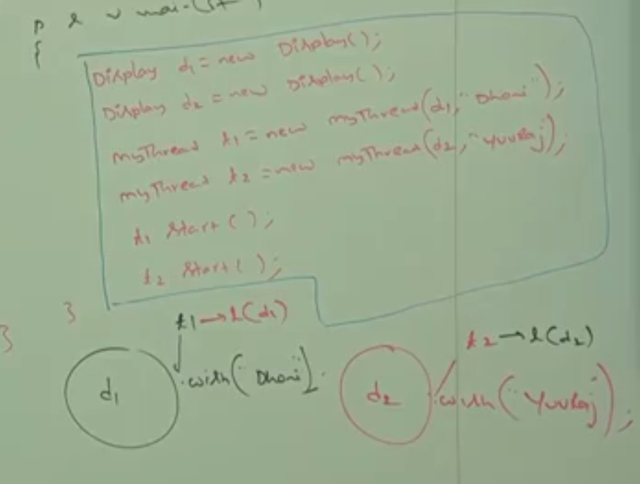
   2. If multiple thread are operation on multiple java objects then synchronization in not required.
   3. Static Synchronization
   4. If a thread want to execute a static synchronized lock it will acquire a class level lock. And every class in java has unique lock for a class.
   5. While a thread executing a static synchronized method the remaining are not allowed to execute any static synchronized method of that class simultaneously
   6. But remaining thread are allowed to execute the following method:
      1. Normal static methods
      2. Synchronized instance method
      3. Normal instance method
   7. 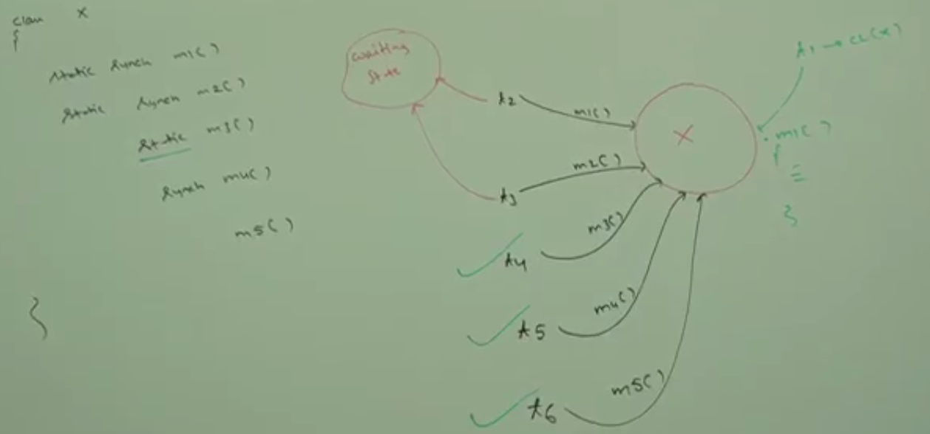
   8. 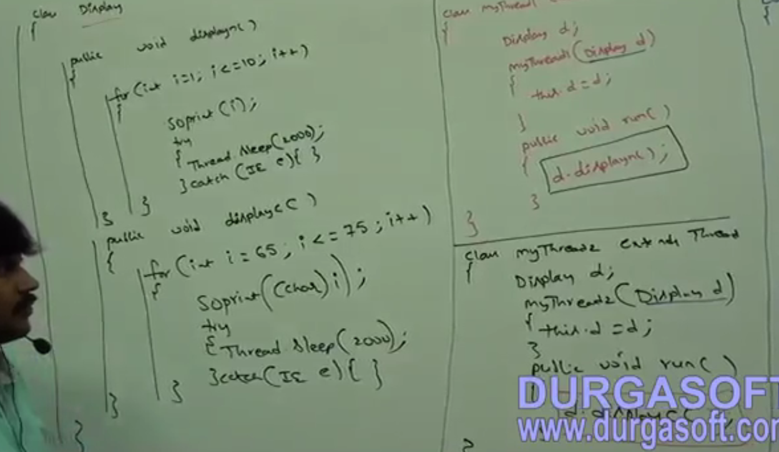
   9. 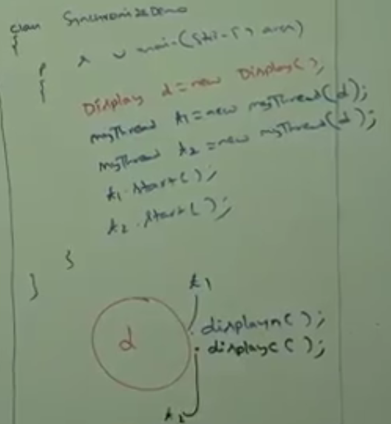
3. Core Java with OCJP-SCJP- Multi Threading Part-9 -- synchronized block
   1. If very few lines of the code require synchronization, then it is not recommended to synchronize the entire method as synchronized.
   2. We have to enclose those few lines of the code by using synchronized block.
   3. The main advantage of synchronized block over synchronized method is, it reduces waiting time of the thread and improves the performance of the system.
   4. We can declare synchronized block, as follows
   5. 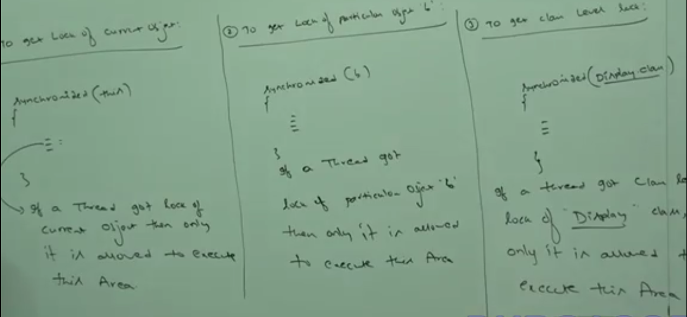
   6. 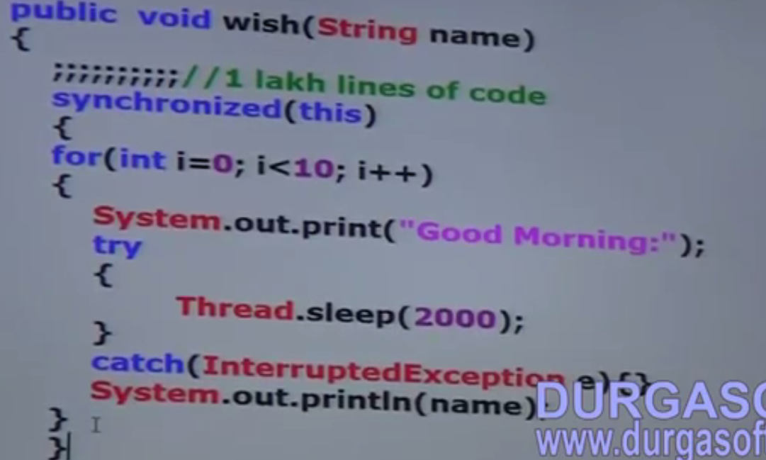
   7. To get class level lock.
   8. 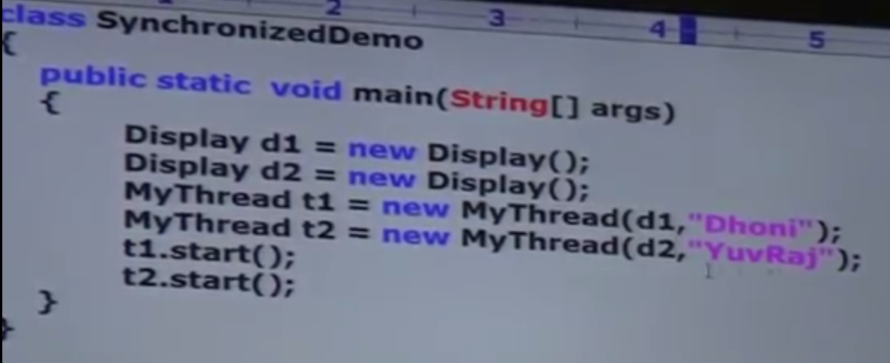
   9. 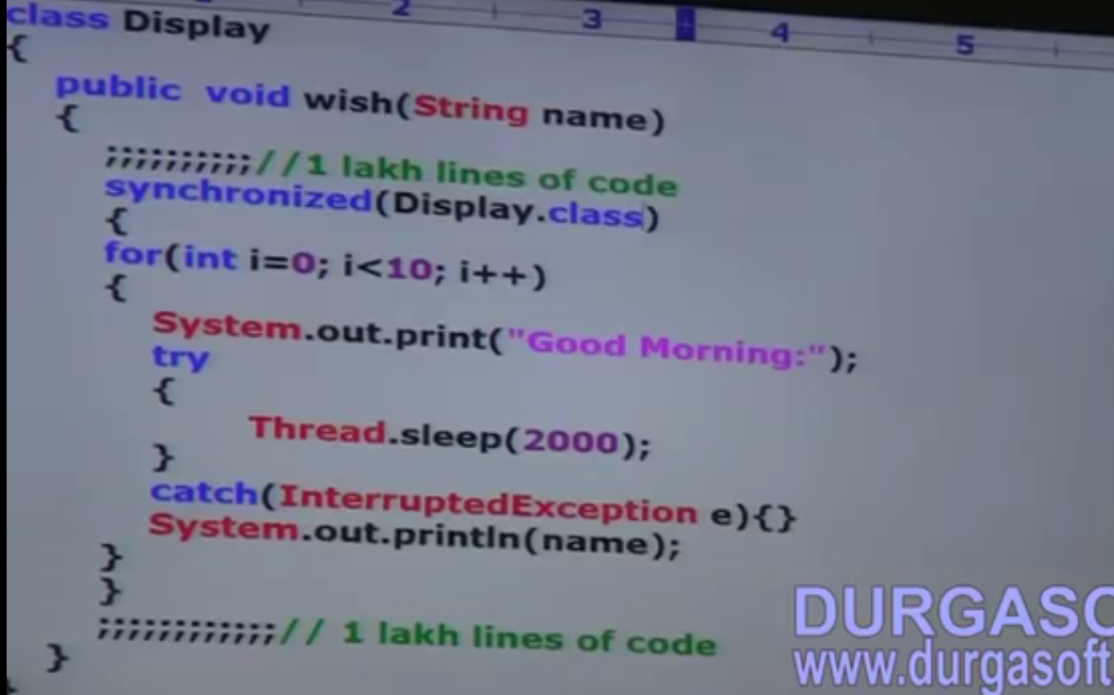
   10. Lock concept is applicable only for object types and class types only, But not for primitives. If we pass primitive type we will get compile time error stating that “Unexpected type found”.
   11. FAQ’s
       1. 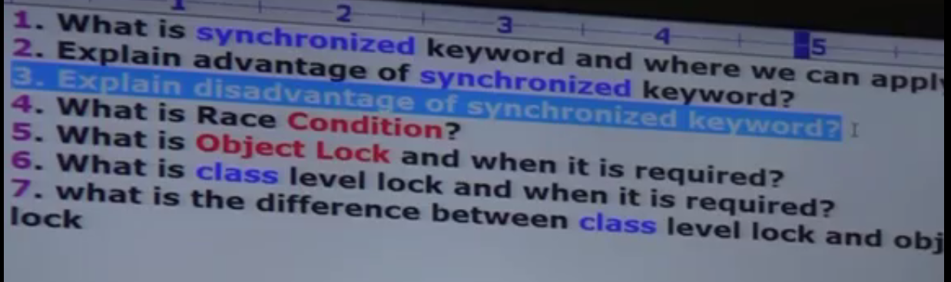
   12. If multiple thread acting on a same object, then there may me be data inconsistency problem which is called race condition. We can overcome this problem by using synchronized keyword.
   13. A thread can acquire multiple lock simultaneously.
   14. The statement present in synchronized method and synchronized block are called synchronized statements.
4. Core Java with OCJP-SCJP- Multi Threading Part-14 -- Green Thread,stop(),suspend(),resume()
   1. Green thread
      1. Java multi threading concept is implemented by using two models
         1. Green thread model
         2. native OS model
      2. The thread which is taken care by only JVM without using underlying OS layer support is called green thread model. Very few OS like SUn Solaris provide support for Green thread model. any way green thread is depreciated and not recommended to use.
      3. The thread which is taken care by JVM with the help of underlying OS layer support is called native OS model. All windows based OS provide support for native OS model.
   2. How to stop a thread?
      1. T.stop().
      2. it is a depreciated and not recommended to use
   3. How to suspend and resume a thread
      1. T.suspend() T.Resume()
      2. it is a depreciated and not recommended to use
   4. Life cycle of a thread

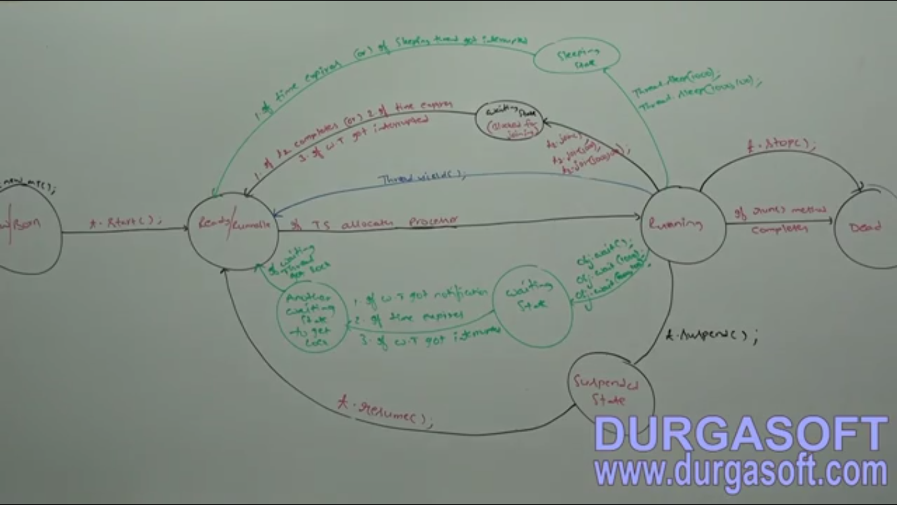

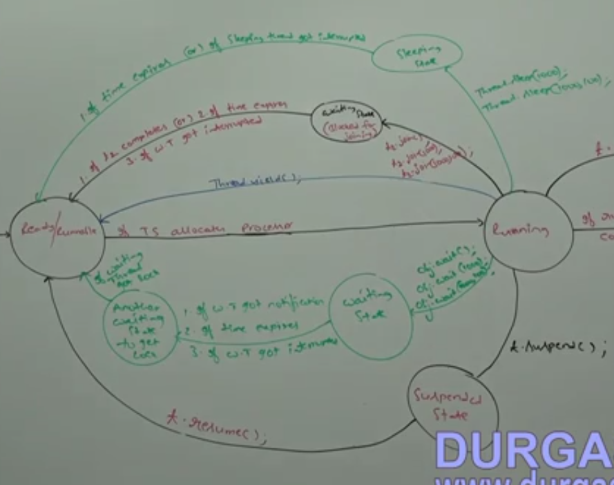

1. Advanced Java Multi-threading Part 1 -- Starting Threads
   1. 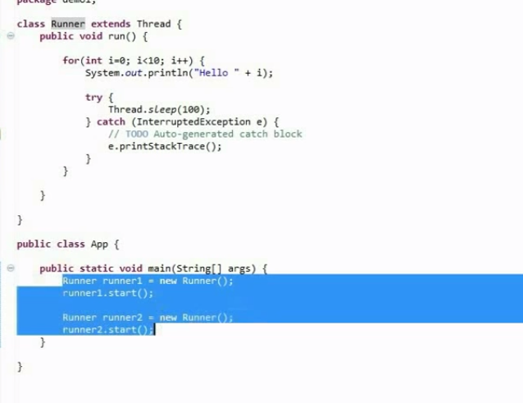
   2. 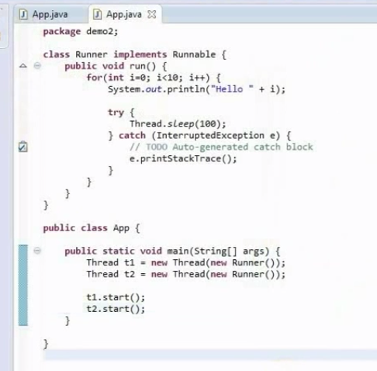
2. Advanced Java Multi-threading Part 2 -- Basic Thread Synchronization
   1. 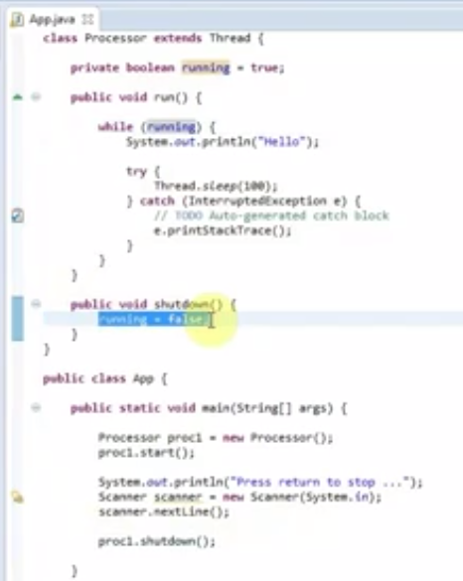
3. Advanced Java Multi-threading Part 3 -- The Synchronized Keyword
   1. 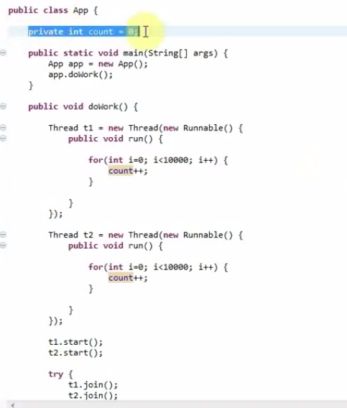
   2. The problem with this method is we will not get 20000 value of count since while incrementing the value by one thread the value incremented by other thread will be updated. so the incrementing method should be synchronized. This is shown as below.
   3. 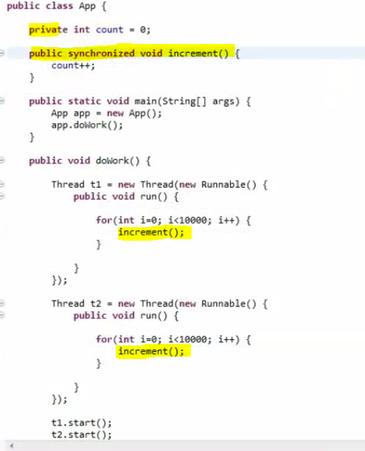
4. Advanced Java Multi-threading Part 4 -- Multiple Locks; Using Synchronized Code Blocks
   1. 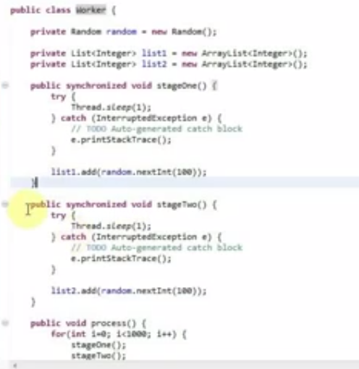
   2. 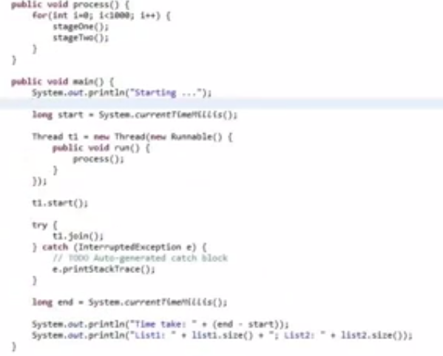
   3. 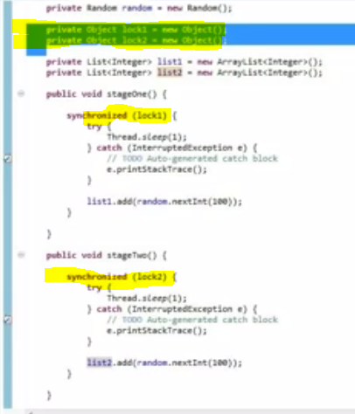
5. Advanced Java Multi-threading Part 5 -- Thread Pools
   1. 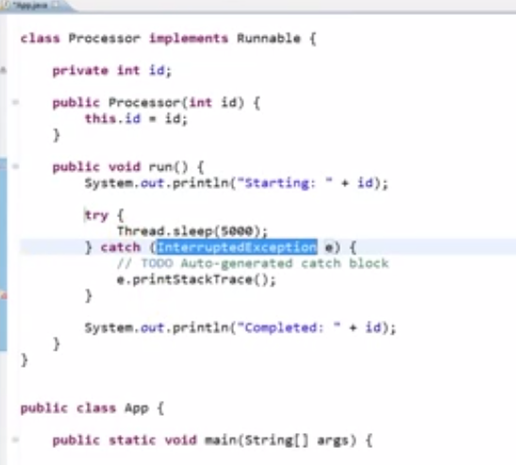
   2. 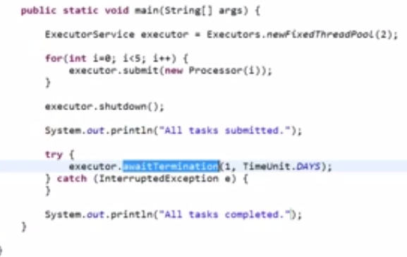
6. Advanced Java Multi-threading Part 6 -- Countdown Latches
   1. 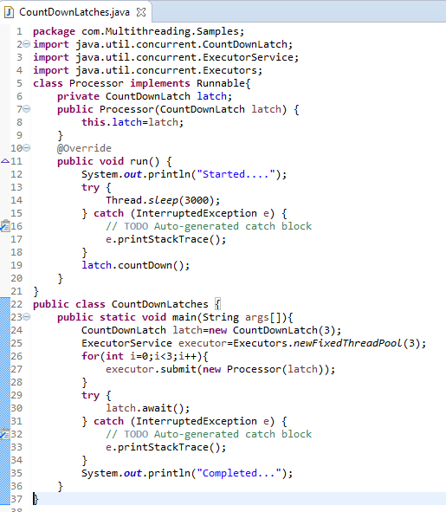
7. Advanced Java Multi-threading Part 7 - Producer-Consumer
   1. 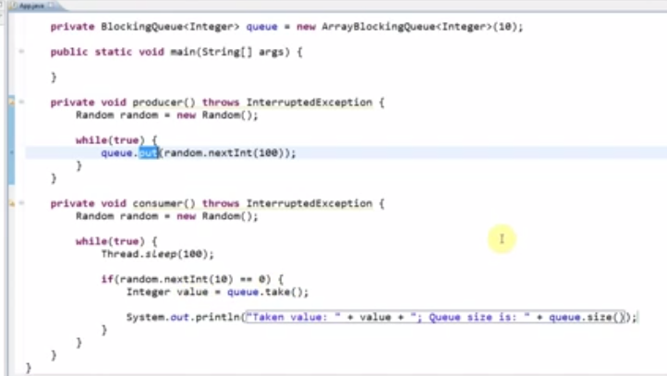
   2. 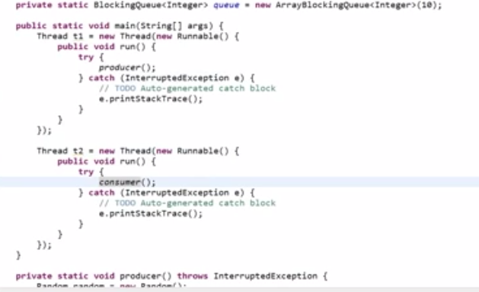
8. Advanced Java Multi-threading Part 8 - Wait and Notify
   1. 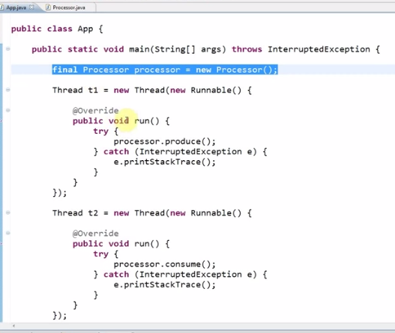
   2. 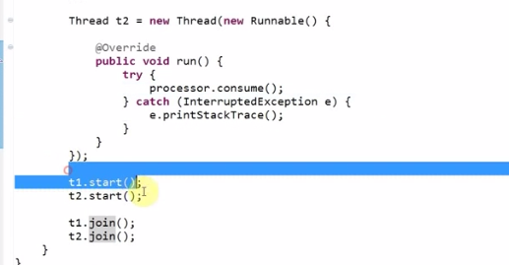
   3. 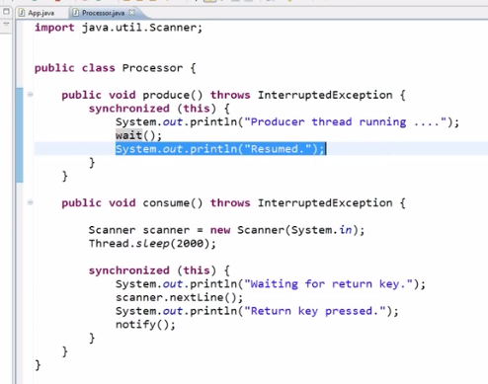
9. Advanced Java Multi-threading Part 9 - A Worked Example Using Low-Level Synchronization
   1. 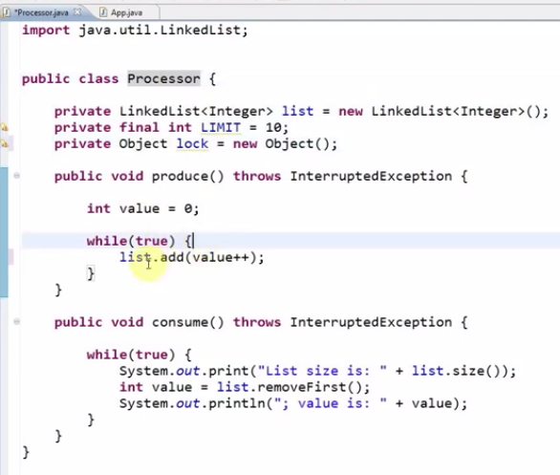
   2. 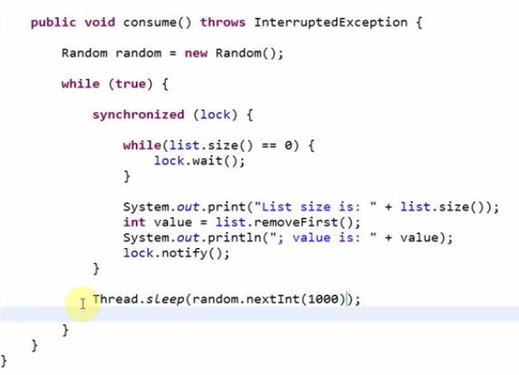
   3. 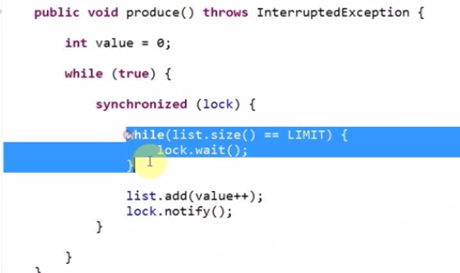
10. Advanced Java Multi-threading Part 10 - Re-entrant Locks
    1. 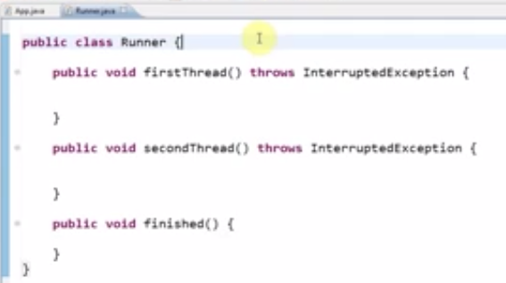
    2. 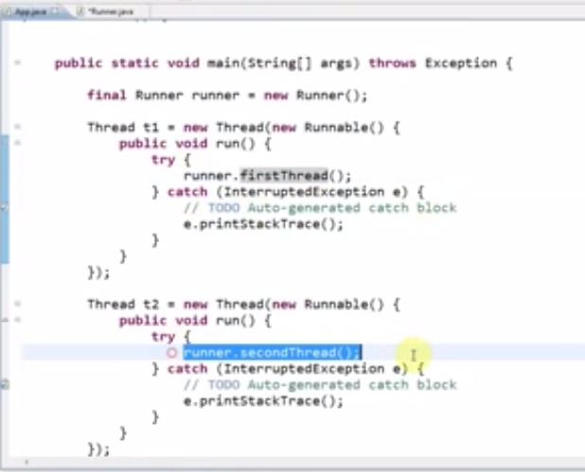
    3. 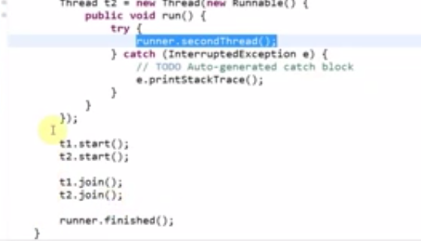
    4. 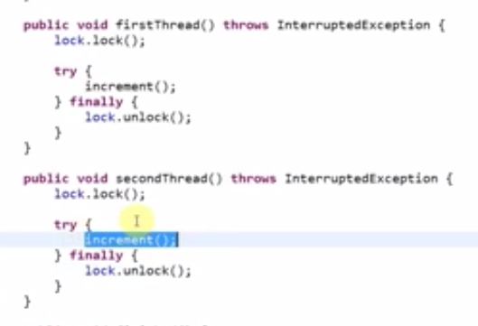
11. Advanced Java Multi-threading Part 11 - Deadlock
    1. 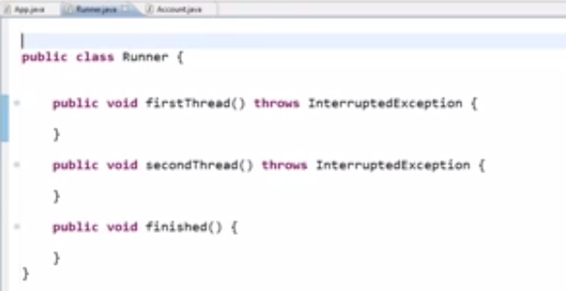
    2. 
    3. 
    4. 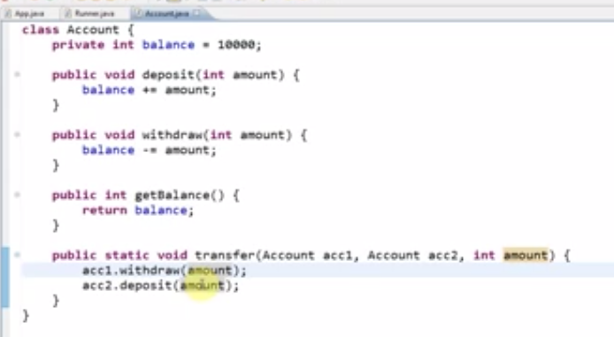
    5. 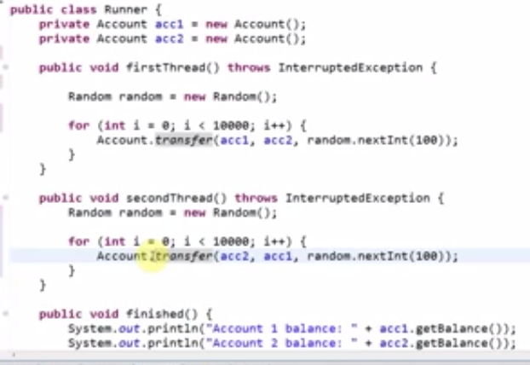
    6. 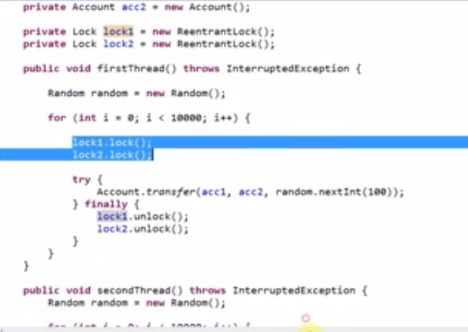
12. Advanced Java Multi-threading Part 12 - Semaphores
13. Advanced Java Multi-threading Part 13 - Callable and Future
    1. 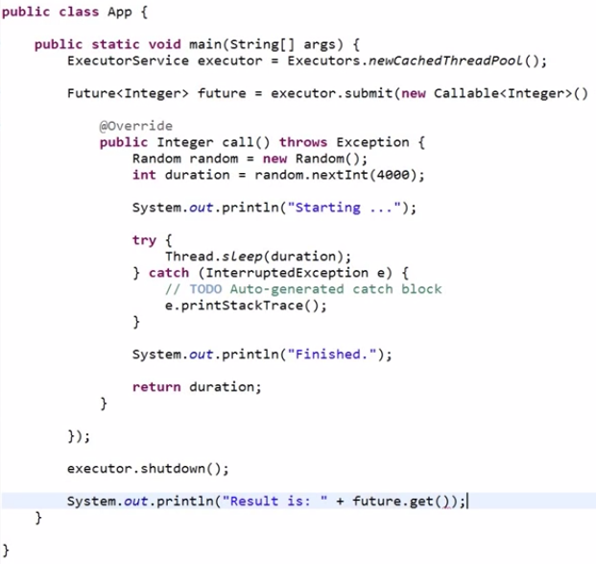
    2. 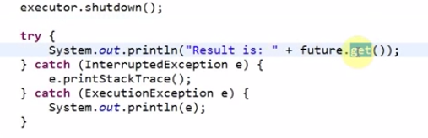
    3. 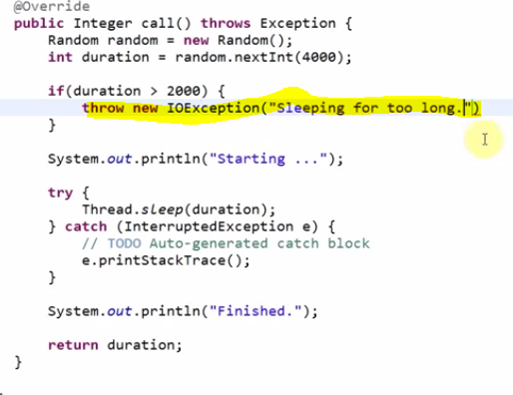
14. Advanced Java Multi-threading Part 14 - Interrupting Threads
    1. 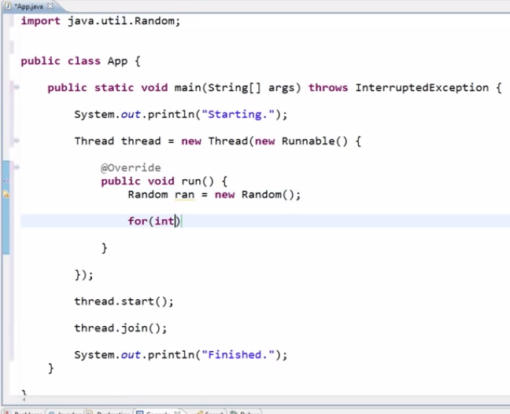
    2. 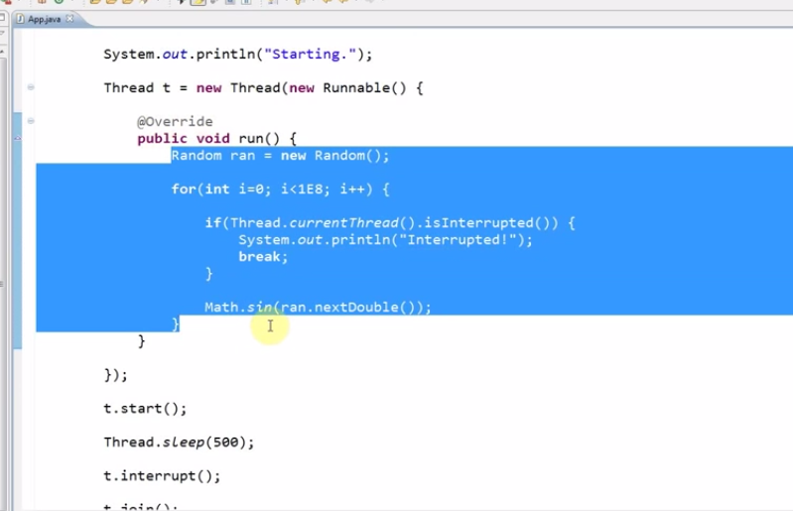

# Serialization

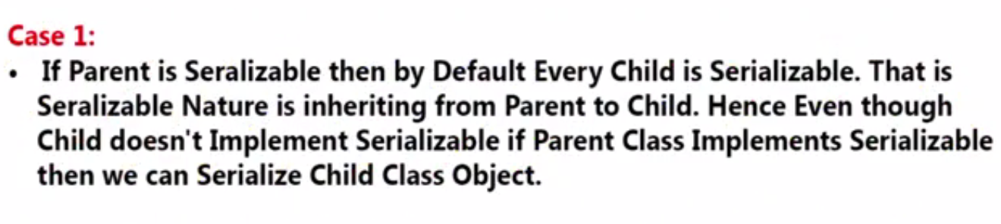

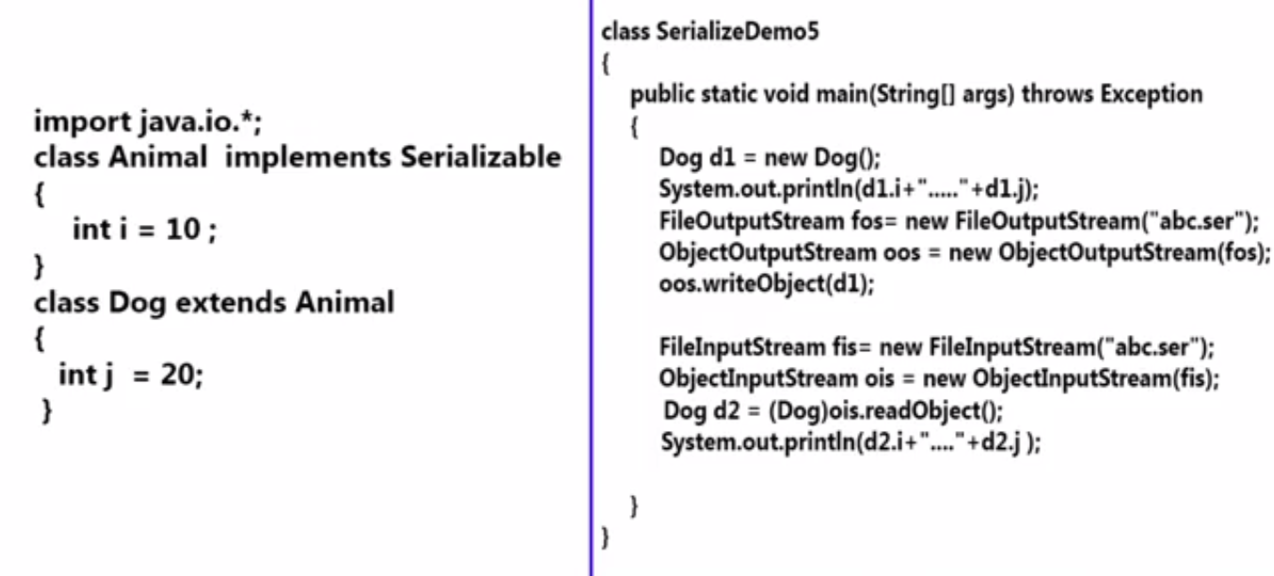

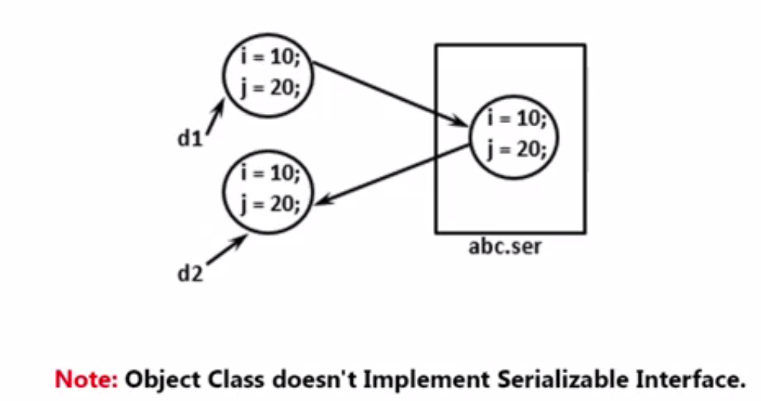

1. Part 1
   1. 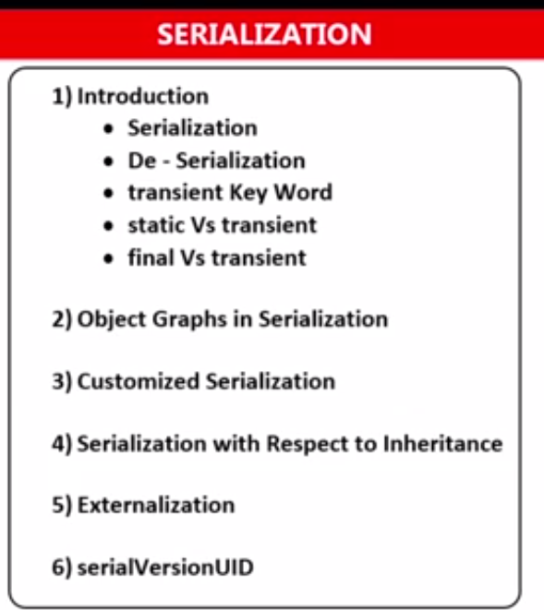
   2. 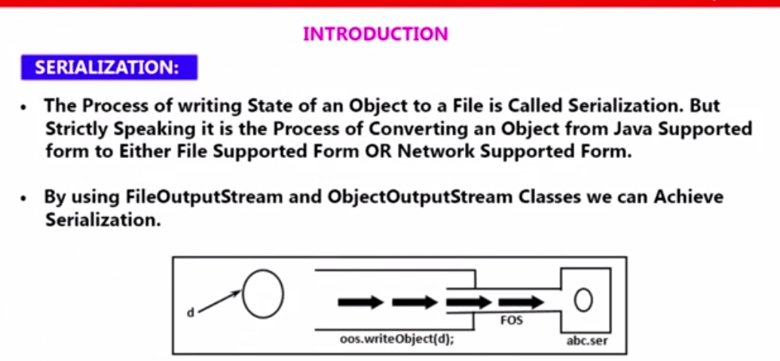
   3. 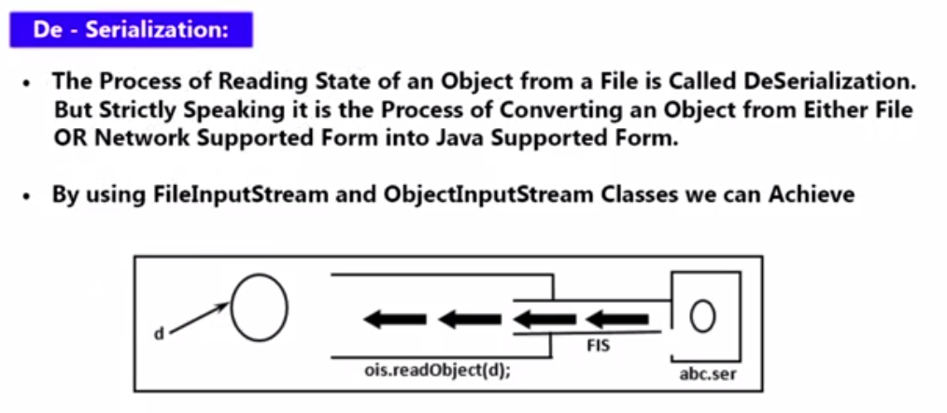
   4. 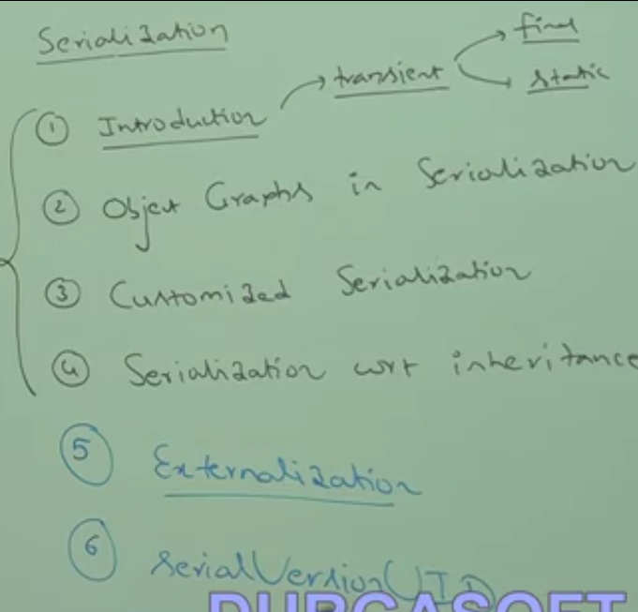
   5. The process of saving a state of object to a file is called serialization and the reverse is called De- serialization
   6. Using FileOuputStream and ObjectOutputStream we can achieve serialization.
   7. Using FileInputStream and ObjectInputStream we can achieve de-serialization.
2. Part 2
   1. 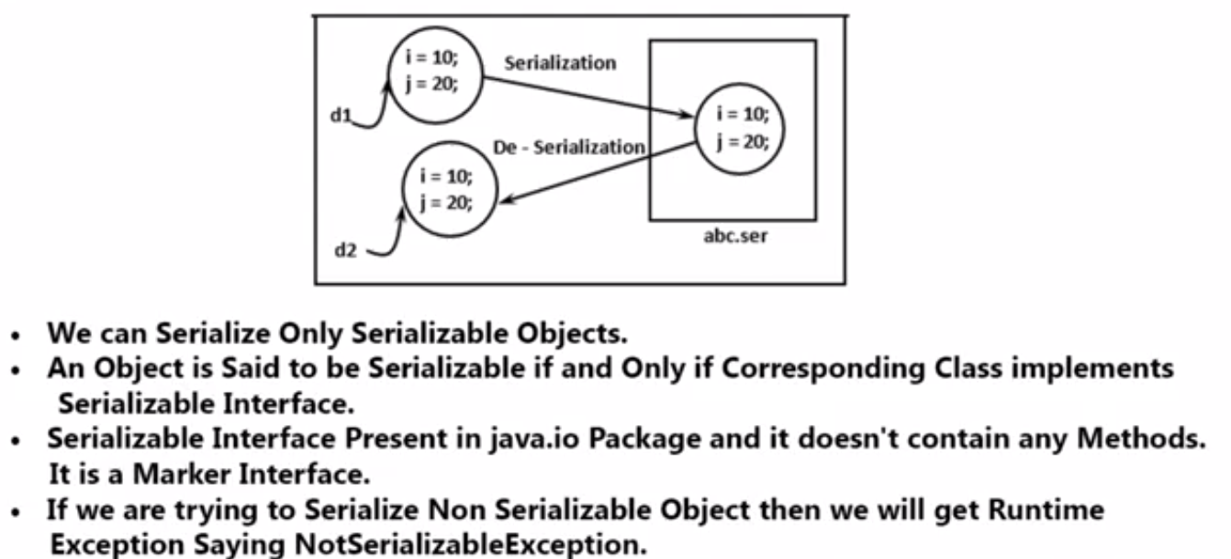
   2. 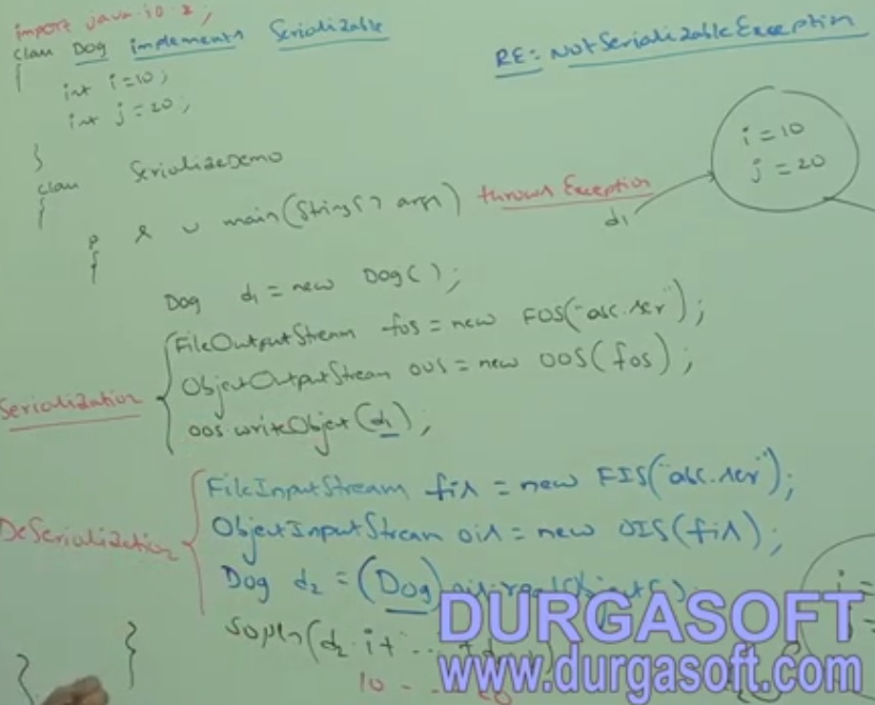
   3. 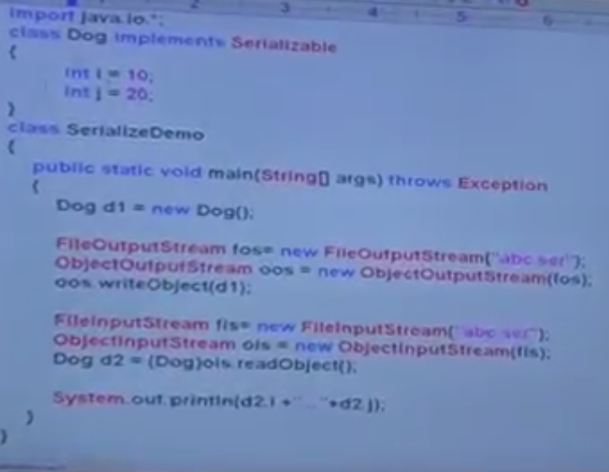
3. Part 3
   1. 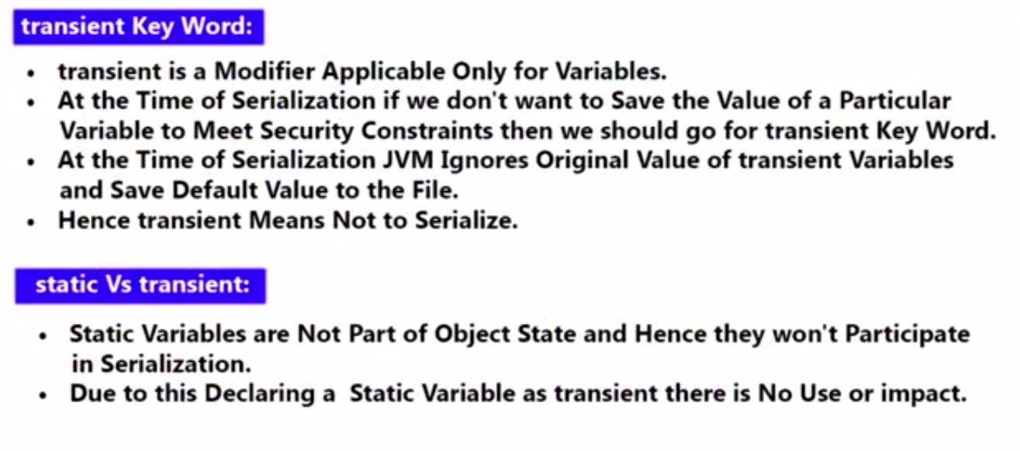
   2. 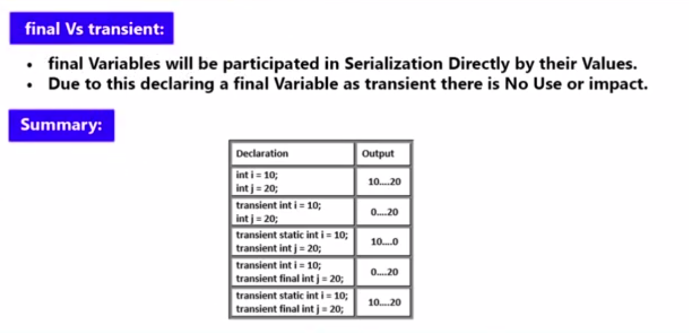
4. Part4
   1. 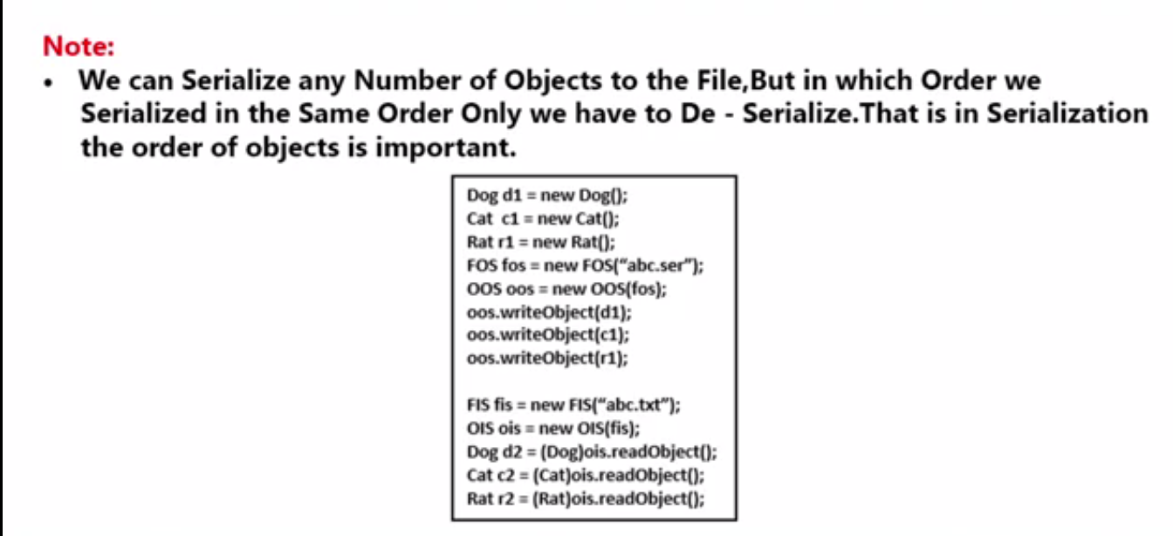
   2. 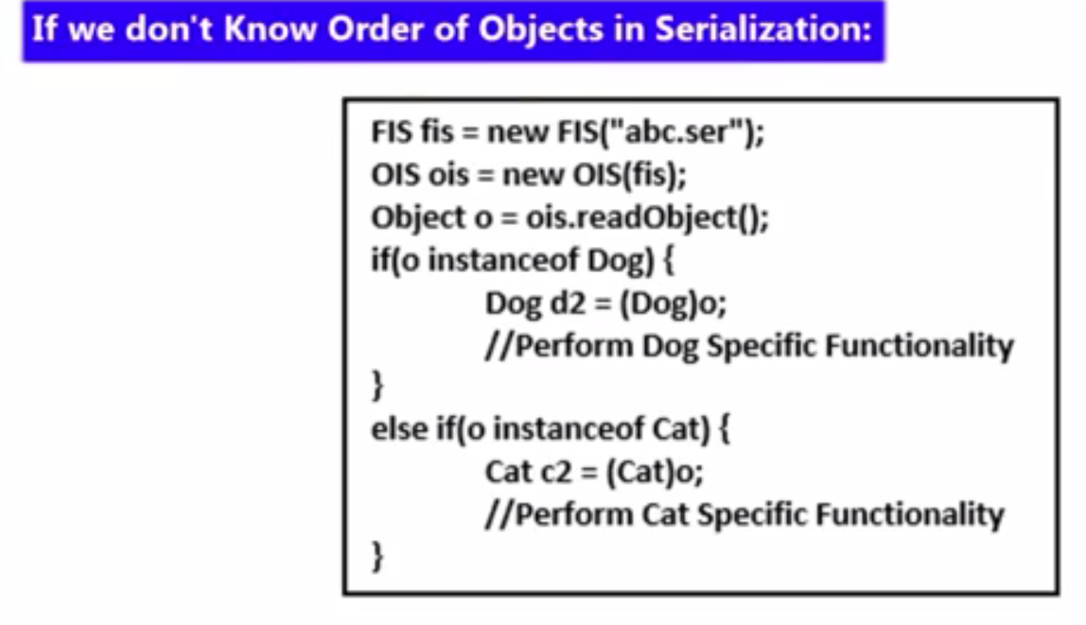
5. Part 5
   1. 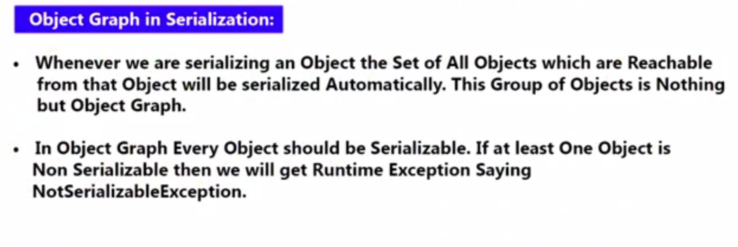
   2. 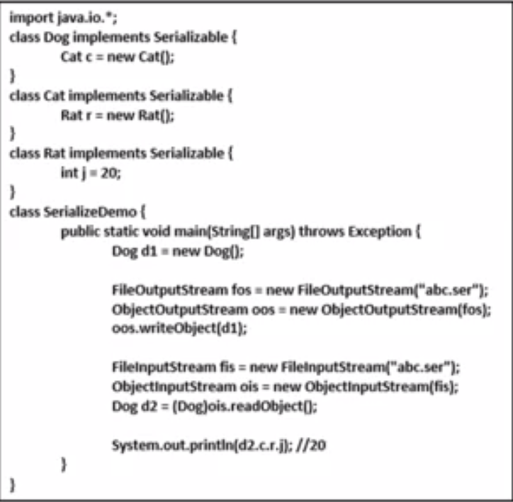
   3. 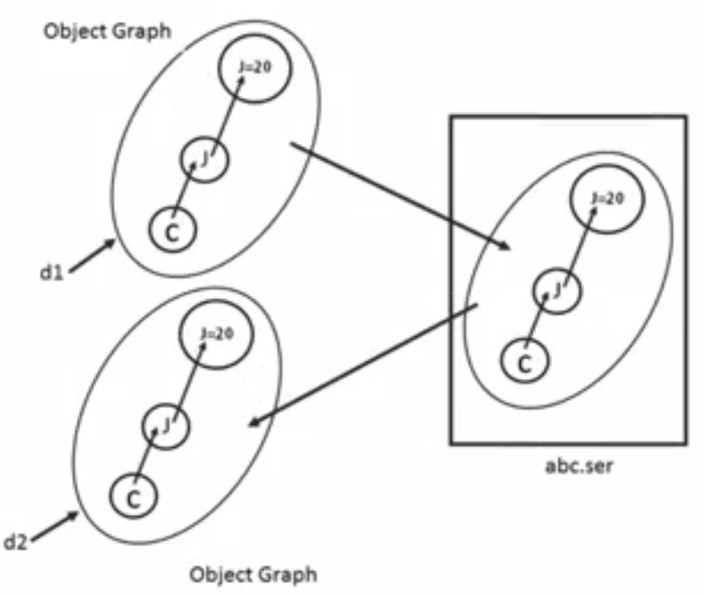
   4. 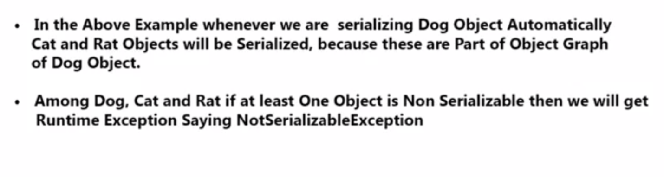
6. Part 6
   1. 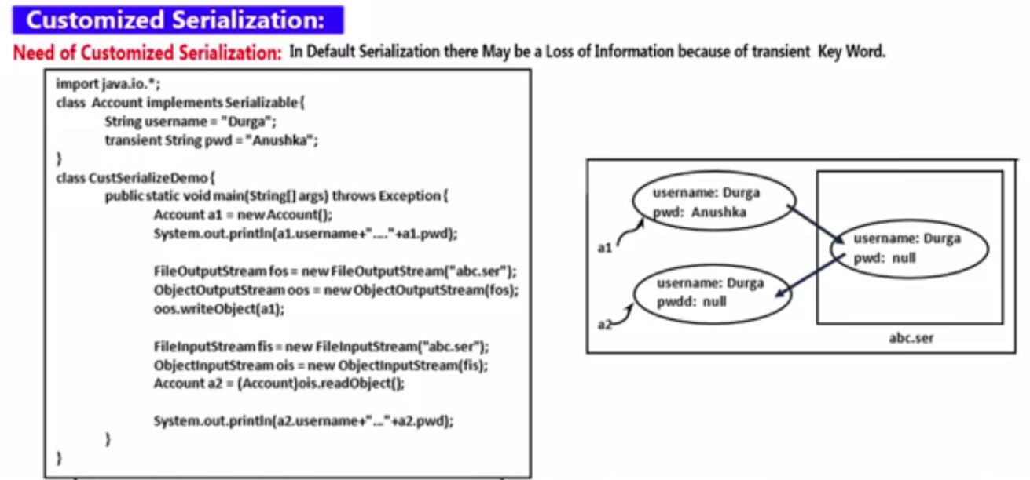
   2. 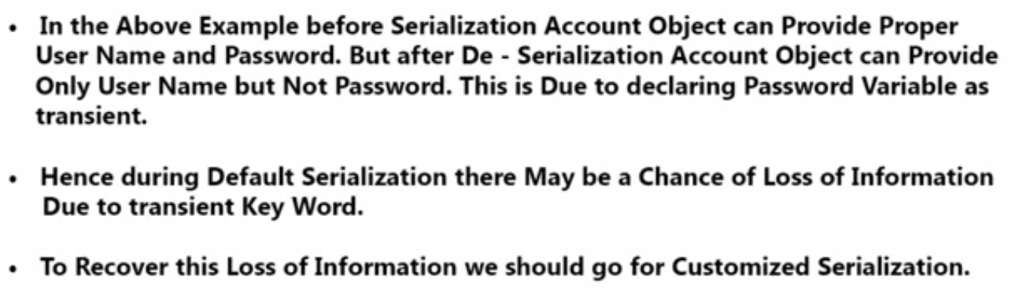
7. Part 7
   1. 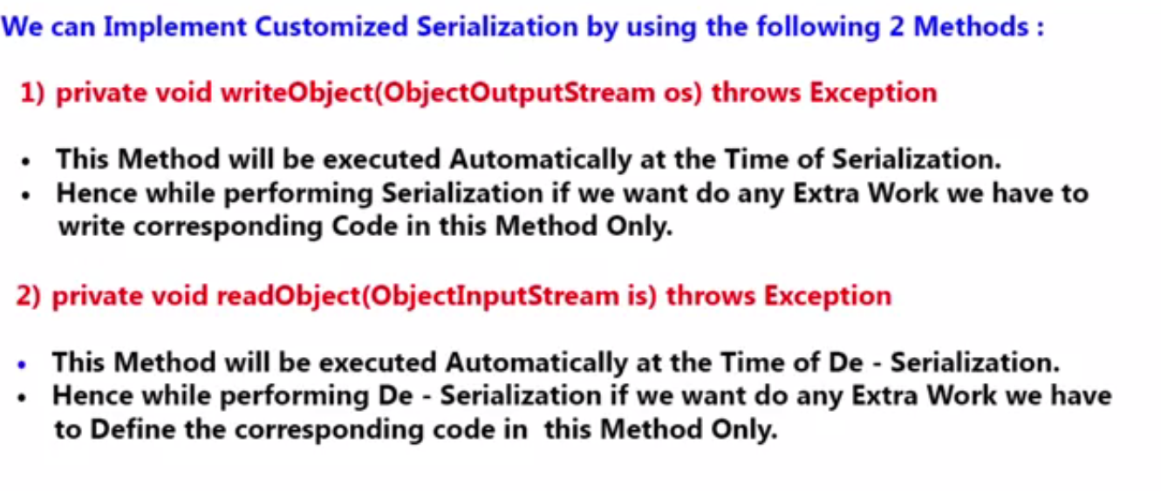
   2. 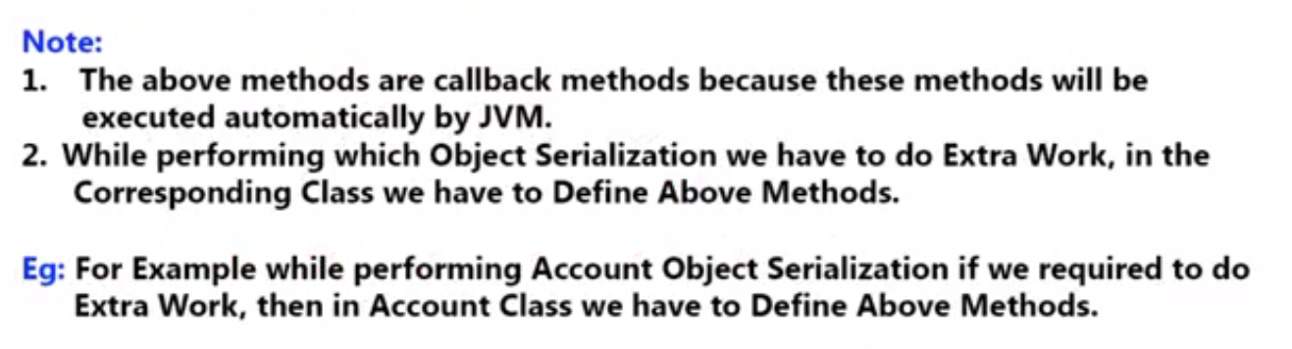
8. Part 8
   1. 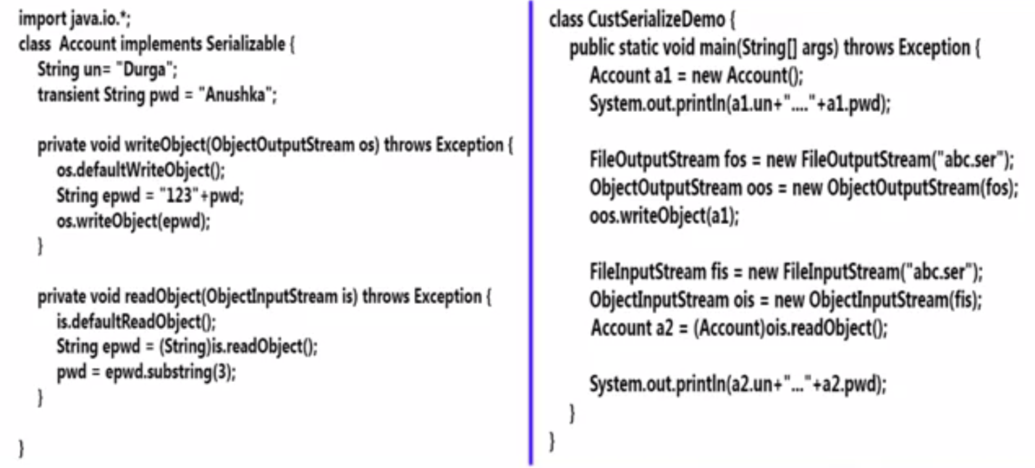
   2. 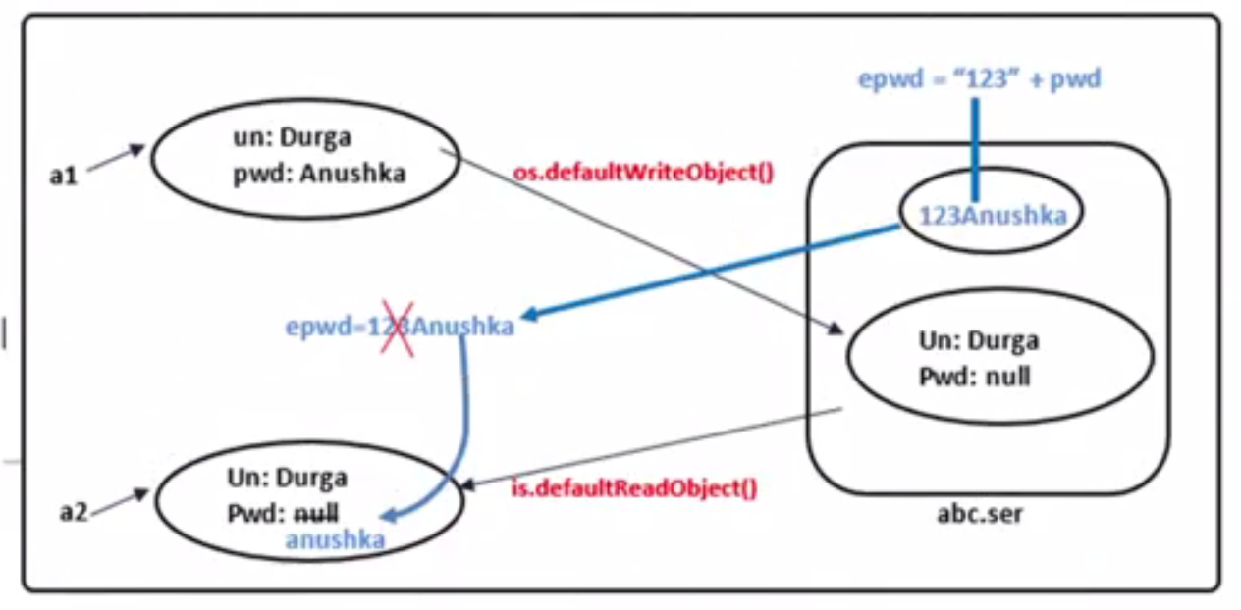
9. Part 9
   1. 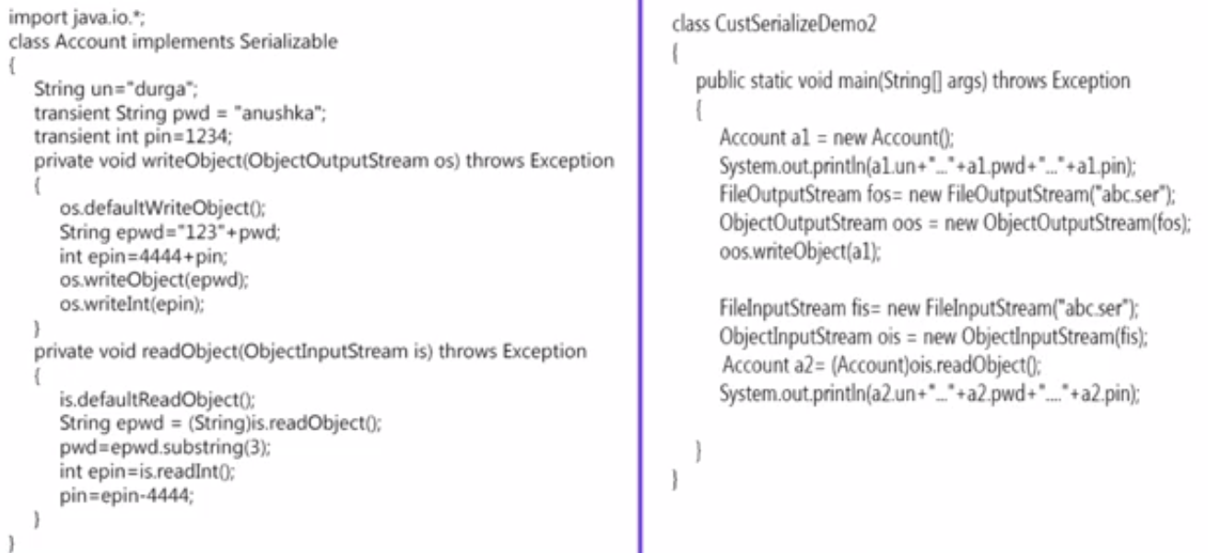
   2. 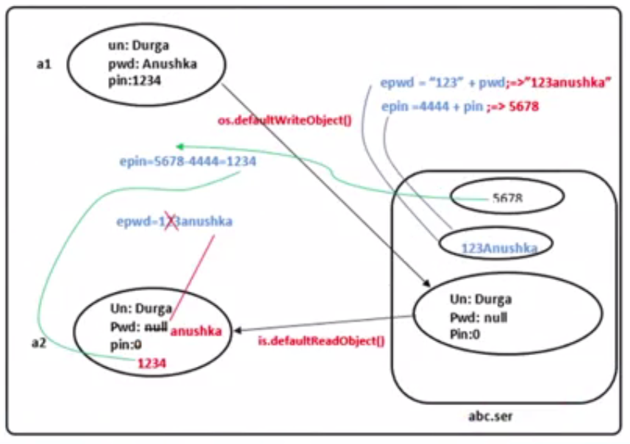
10. Part 10
    1. 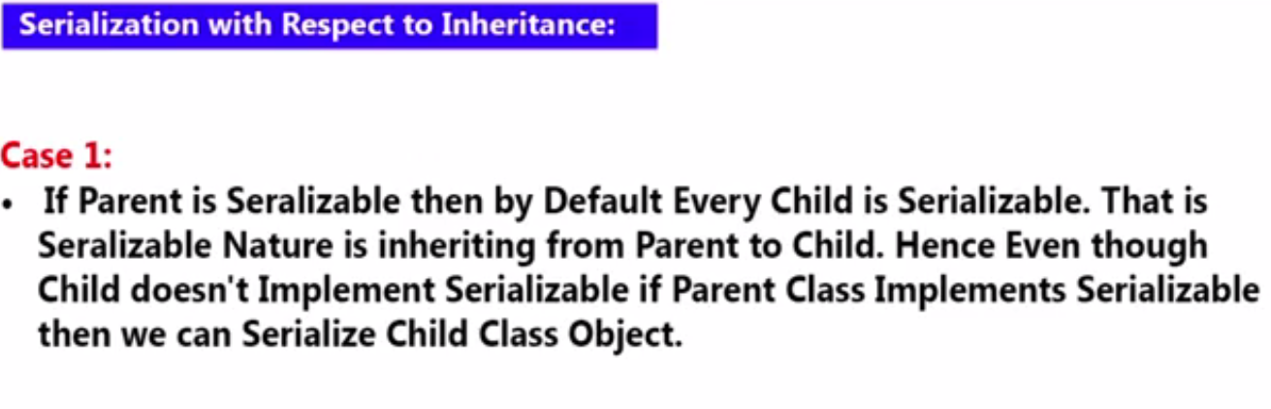
    2. 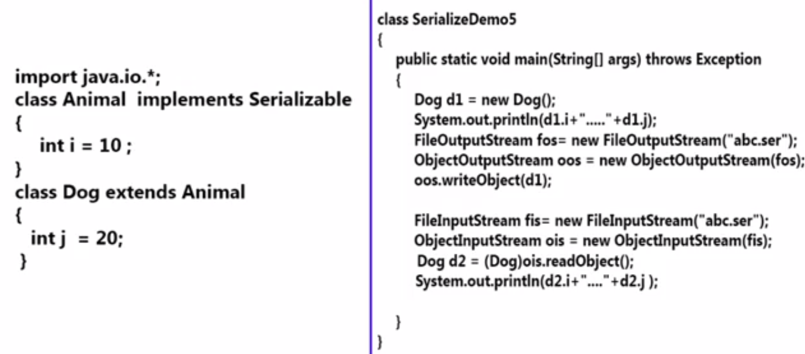
    3. 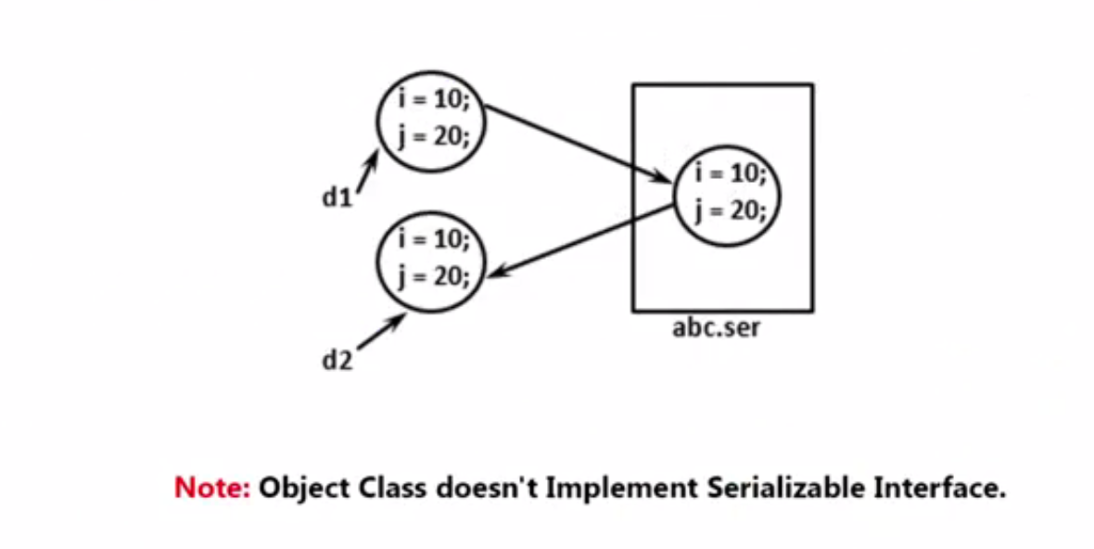
11. Part 11
    1. 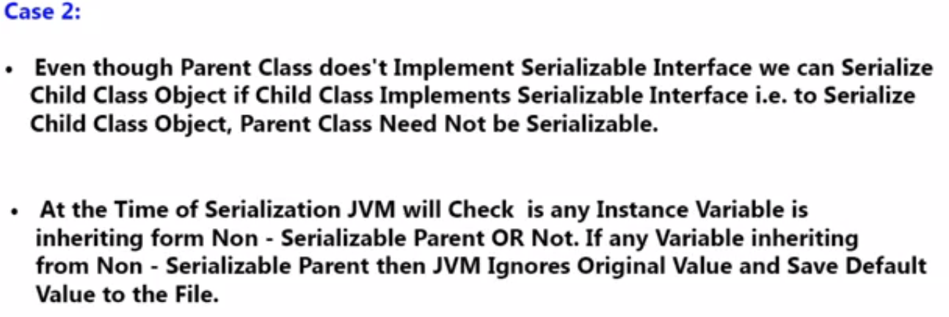
    2. 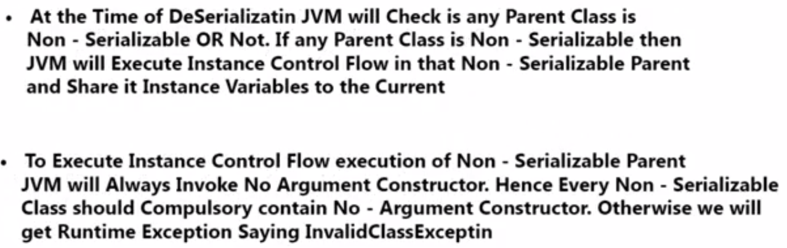
    3. 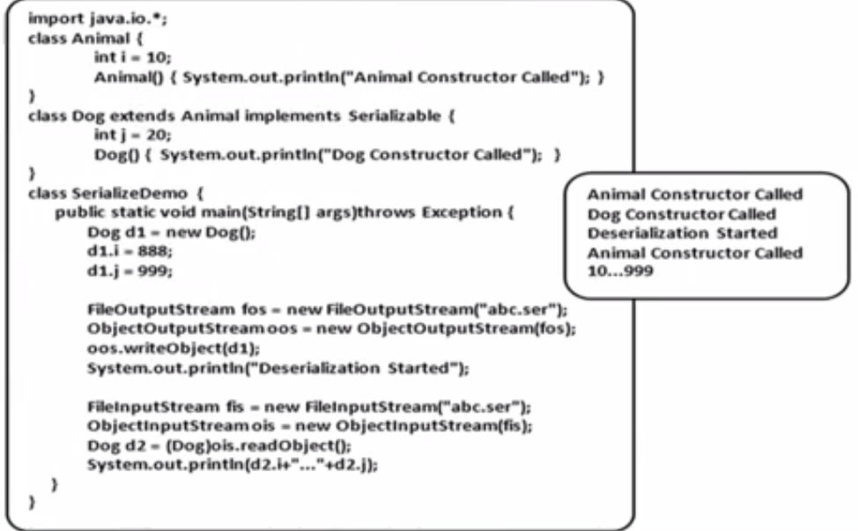
    4. 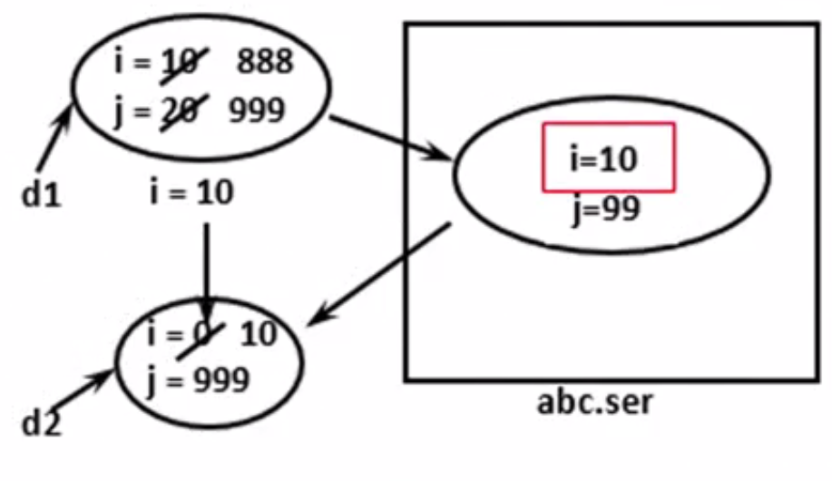
12. Part 12
    1. 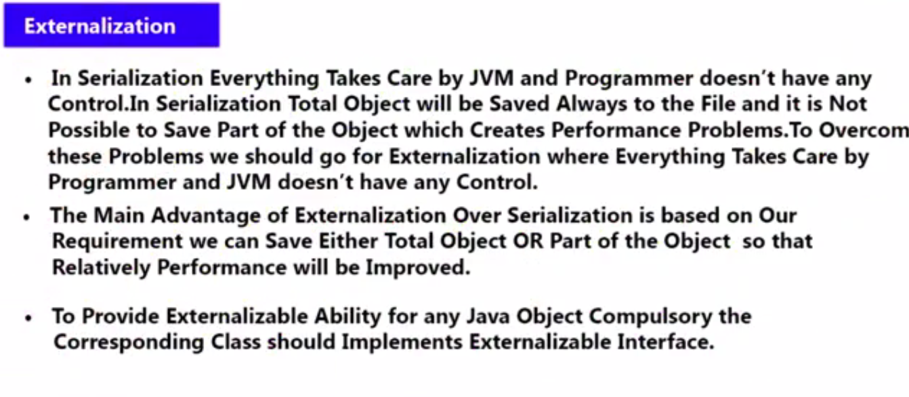
    2. 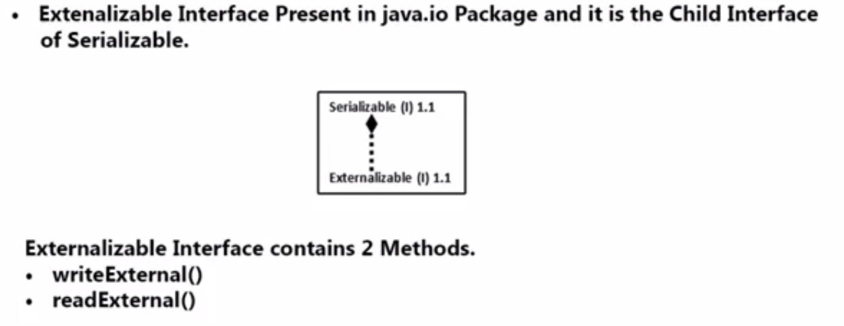
    3. 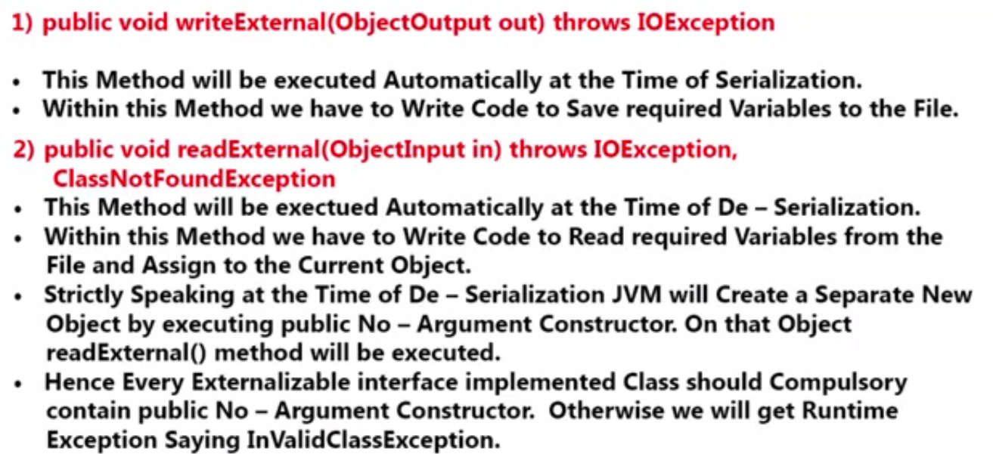
13. Part 13
    1. 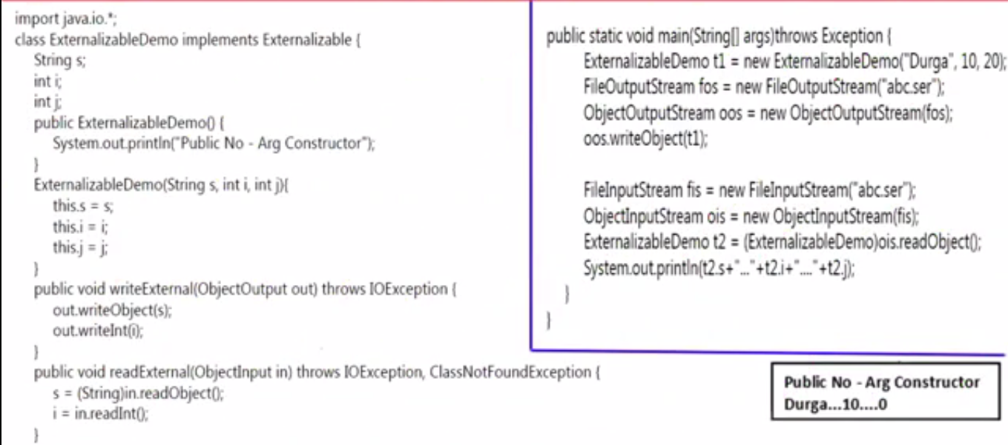
    2. 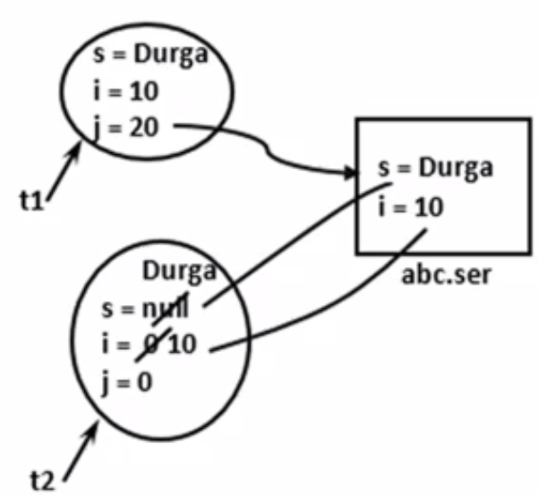
    3. 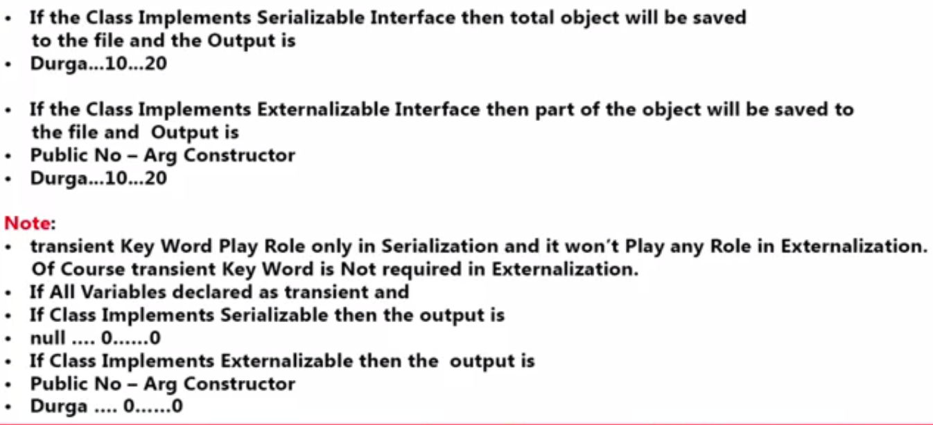

1. Part 14
   1. 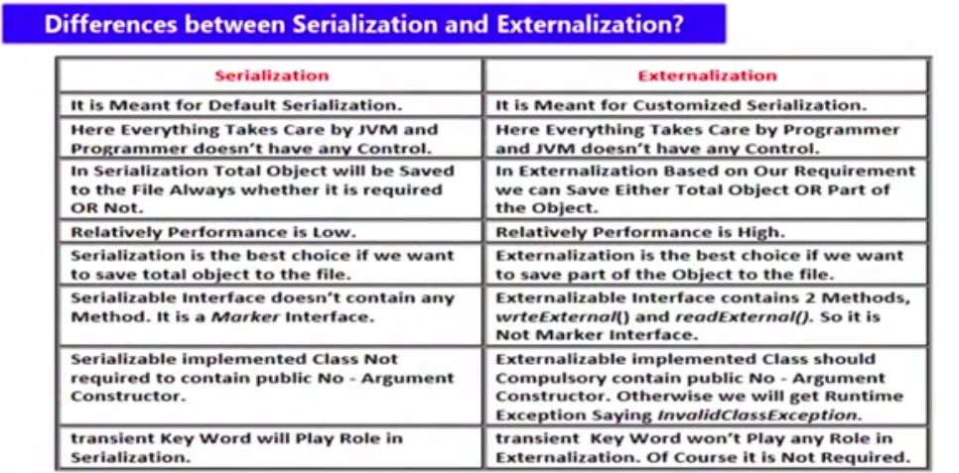
2. Part 15
   1. 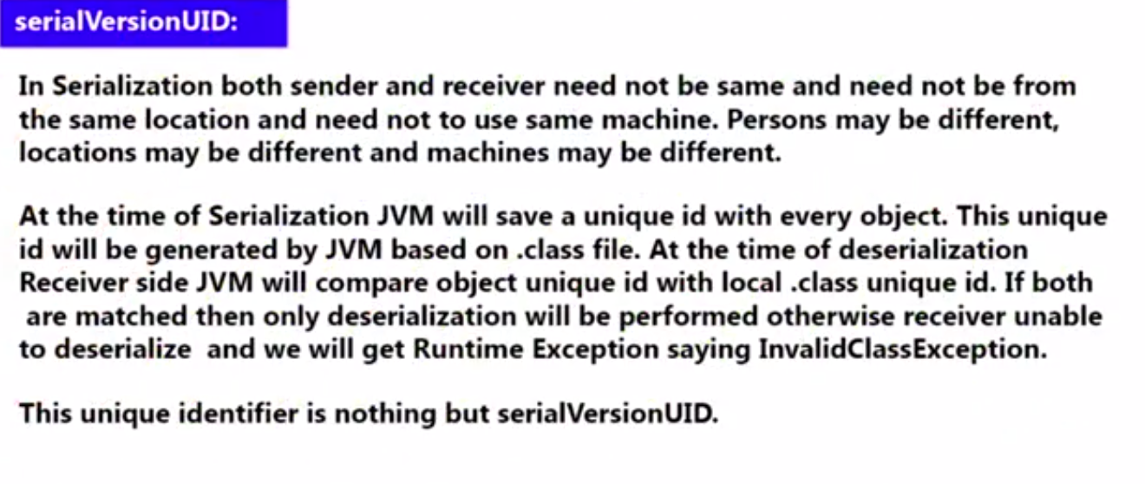
   2. 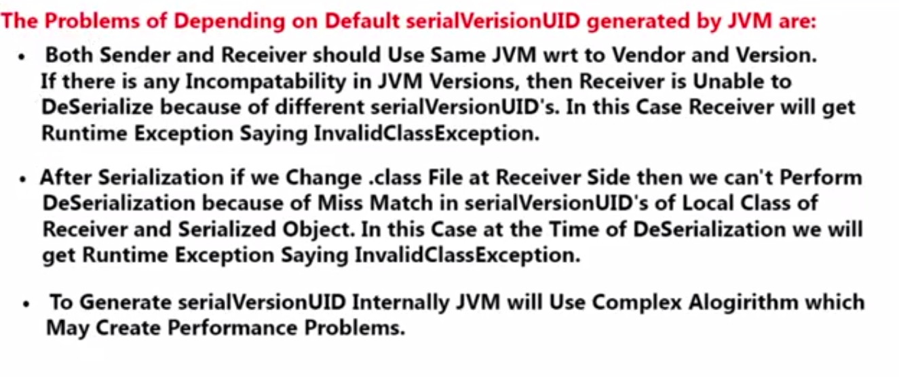
   3. 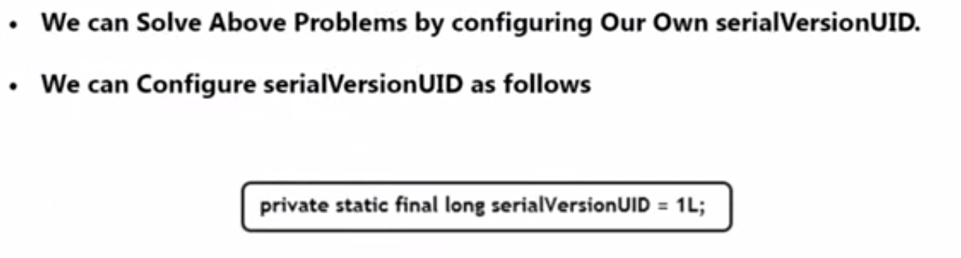
3. Part 16
   1. 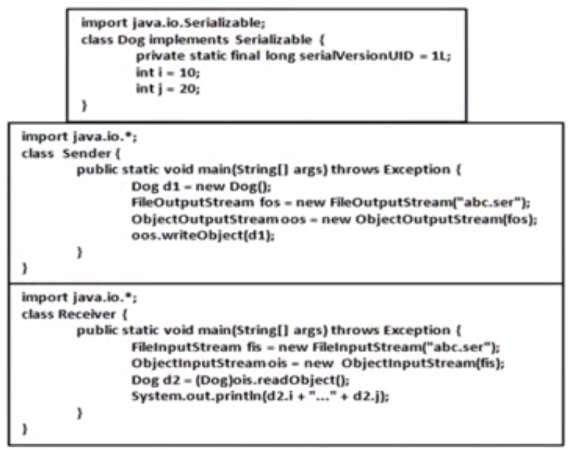
   2. 